Service and job specific context statement
Directorate: | Business and Environmental Services
Service: | Growth, Planning and Trading Standards
Post title: | Business Engagement Officer
Grade: | K
Responsible to: | Growth & Heritage Services Manager
Staff managed: | None
Date of issue: | March 2019
Job family: | P&T - Professional & Technical
Job context
This is a new and exciting role and the post holder will be responsible for ensuring that the County Council can effectively deliver on this commitment. The Business Engagement Officer is responsible for the delivery of the High Growth SME Programme covering the North Yorkshire and wider area. The post holder will work with, at any one time, up to 50 businesses across the County including multinationals, larger companies as well as those SME and micro companies exhibiting signs of rapid growth.

Key areas for the job holder are providing investor development and aftercare services to existing companies and promoting North Yorkshire key sectors with the aim of attracting further investment to these supply chains.

Senior level relationship building with stakeholders is key across all sectors:
- York, North Yorkshire & East Riding Local Enterprise Partnership
- The Growth Hubs in North Yorkshire & West Yorkshire
- Skills Funding Agency and Young Peoples Learning Agency
- National Apprenticeships Service
- Department for International Trade & Investment
- Chambers of Commerce and other business associations
- Universities and colleges within the College Consortium

Work with partners and appropriate sub regional and national agencies to develop marketing ideas around events, e-communications and direct mail to support the promotion of the High Growth SME Programme, specific business sectors, specialised business support programmes and new products.

There will be a need for close engagement with the private sector, consultants, Government and local planning authorities. The post holder will be focused on North Yorkshire and will therefore need to work in partnership with the District Councils, the National Parks and other key stakeholders. There will also be a need to liaise closely with the City of York Council, East Riding of Yorkshire Council and the York, North Yorkshire and East Riding Local Enterprise Partnership and Leeds City Region LEP.

The post holder will need to develop a delivery plan and ensure that the actions within it are implemented to improve business engagement with North Yorkshire high growth companies, this will include oversight and development of business cases to support investment as appropriate.

Structure
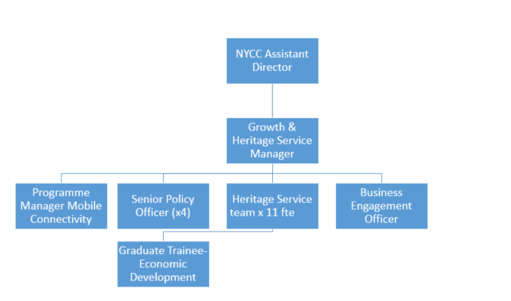
Wide range of external stakeholders
Job Description
Job purpose | Account manage existing SME investors in a professional manner, providing the highest level of service and support in order to secure further growth, focusing on face to face business support.  Maintain a CRM system to record enquiries, visits, outputs and referrals. Negotiate and develop a network of high level contacts at a senior and strategic level to engage with businesses so as to analyse and then deliver on their priorities.  Undertake assessment of the business needs; identify barriers to growth and suitable business support products. To co-ordinate and manage the delivery of the High Growth SME Programme across North Yorkshire and the wider area working with SMEs with high growth potential to encourage business growth and to promote job creation.  The core focus of this job is to be responsible for the development and implementation of a delivery plan working in partnership with a wide range of external stakeholders.
Operational management | - To develop and oversee an annual programme of 50 key account management relationships with target businesses across North Yorkshire.  - To develop and manage investor relations ensuring co-operation and coherence of approach with a wide range of external stakeholders.  - Oversee four annual business dinners across North Yorkshire, linked to thematic and sector specific priorities.  - Support the delivery of the annual Economic Growth Conference within North Yorkshire  - To represent the County Council at meetings with external stakeholders, businesses, Government agencies and local communities.
Communications | - To liaise and negotiate with the district councils and other key stakeholders to ensure that outcomes are delivered.  - To engage effectively with Businesses, LEPs, County Council & District Councils and MPs.  - To communicate ideas, research and business intelligence effectively both orally and in writing.
Partnership / corporate working | - To proactively develop effective external relationships with North Yorks Businesses, Government departments, district councils, planning authorities and other key stakeholders.  - To actively contribute to the County Council’s Plan for Economic Growth.  - To work with other internal service units as required ensuring delivery of outcomes.
Resource management | - To report on budget expenditure throughout the year.  - To matrix manage and co-ordinate teams made up of a range of external stakeholders.  - To develop key performance indicators and robustly manage performance associated with the investor relations programme
Systems and information | - Support the management and delivery of the key account management programme.  - Ensure that analysis of data and information is carried out to ensure an evidence led approach to intervention.
Strategic management | - To work with senior managers to develop and implement the key account management delivery plan.  - Seek to position North Yorkshire businesses towards external funding, business support finance and assistance with planning and development matters.  - Review best practice models for business improvement solutions and the business support landscape

Person Specification
Essential upon appointment | Desirable on appointment
Knowledge  - Developed knowledge of business support services across Yorkshire & Humber  - Demonstrable understanding of business support finance products available with Yorkshire & Humber  - Good knowledge and understanding of current legislation and Government interventions with respect to economic development  Understanding of data protection, freedom of information and confidentiality requirements | - Understanding of the enterprise and investor development agenda  - Demonstrable understanding and practical application of business management methodologies.
Experience  - Experience of partnership working with a wide range of stakeholders. Strong working knowledge and experience of business support, mentoring, coaching and finance products.  - Proven experience of building effective relationships working with senior managers, elected members and external stakeholders.  - Experience of producing high quality written reports, business cases, briefings and other documents. | - Commercial acumen and experience of working within the private sector  - Experience and knowledge of UK planning system
Occupational Skills  - Exercises professional judgement to make clear business-focused decisions.  - Ability to develop deliverable solutions to problems and strong networking skills to secure buy-in from stakeholders.  - Developed interpersonal and communication skills, including the ability to write reports and present these to a wide range of stakeholders  - High level partnership management skills in a complex multi-agency environment  - Ability to interpret information and data to reach well-reasoned conclusions and recommendations.  - Good IT skills including Microsoft packages  - The ability to converse at ease with customers and provide advice in accurate spoken English is essential for the post | - Confidently uses persuasion and negotiation techniques to influence others in complex and difficult situations.
Professional Qualifications/Training/Registrations required by law, and/or essential for the performance of the role  - Relevant Degree or Equivalent Level Qualification | - Recognised Management Qualification  - Evidence of Continued Professional Development  - Recognised professional qualification  - Recognised project management qualification or demonstrable practical experience
Other Requirements
- Flexible approach to work, including working evenings occasionally and weekends as required
- Willingness and ability to travel throughout the County & UK
Behaviours | Link
NB – Assessment criteria for recruitment will be notified separately.
Optional - Statement for recruitment purposes: You should use this information to make the best of your application by identifying some specific pieces of work you may have undertaken in any of these areas. You will be tested in some or all of the skill specific areas over the course of the selection process.

