Service and job specific context statement
Directorate: | Business and Environmental Services
Service: | Highways and Transportation Service
Post title: | Highways Customer Communications Officer
Grade: | I
Responsible to: | Area manager
Staff managed: | None
Date of issue: | 6th August 2014
Job family: | C&A - Customer & Administration
Job context
The Highway Operations Unit is responsible for the implementation of highway improvement and maintenance schemes, routine highway maintenance activities, delivery of the winter maintenance service, local network management and liaison with the public at a local level.
- Maintenance and improvement scheme design and implementation
- Customer liaison and response at a local level
- Local highways development control
- Traffic management including TROs
- Highway maintenance
- Highway inspections
- Winter maintenance service
- Emergency response
- Enforcement of highways legislation
- This role involves spoken communications so a confident use of English language is required.
Structure
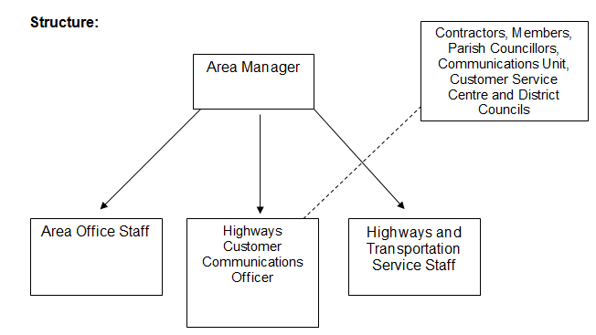

Job Description
Directorate: | Central Services
Service: | Highways and Transportation Service
Responsible to: | Area Manager
Staff managed: | None
Job purpose | The core focus of this job is to undertake a lead role in all tasks associated with communication and performance management and the political process, providing a focus for communication within the Area structure and ensuring the performance targets are met. The post holder will do this by providing professional and organisational support to the Area Manager and the Area Management Team.
Operational management | - Carry out research and analysis in a range of issues/case work, to lead on such matters at an appropriate level and to prepare reports.  - Prepare timely briefing notes as required by the Area Manager/Area Management Team.  - Arrange and ensure routine and non-routine correspondence is dealt with on behalf of the Area Manager/Area Management Team.  - Provide advice, guidance and support in response to telephone queries (including from Members) and brief the Area Manager/Area Management Team as appropriate.  - Collate and coordinate information for the Area Manager/Area Management Team.  - Initiate, develop and maintain systems associated with performance targets.  - Under the direction of the Area Manager participate in or undertake specific projects with the Service Unit.  - Contribute, collate and assist in the implementation of ideas to improve quality of service.  - Represent the Area Manager at meetings as appropriate and provide timely and accurate feedback.  - Evening and Weekend working may sometimes be required.
Communications | - Establish and maintain clear lines of communication with colleagues, agencies and with partners of the Authority.  - Represent the Service at appropriate Corporate/Directorate Communications Meetings, and take a lead role in undertaking actions resulting from those meetings.  - Maintain regular contact with the local Area Business Support Team in relation to correspondence, filing systems and the Area Office commitments.  - Initiate, develop and maintain systems associated with the delivery of the directorate communications strategy.  - Initiate, develop and maintain systems associated with effective communication with Members.
Partnership / corporate working | - To provide local highways input into the Communication Plan in liaison with the NYCC Communications Unit.  - To liaise with Members, Parish Councils and District Councils.
Resource management | - Produce a local publicity plan in conjunction with the NYCC Communications Unit.
Systems and information | - Monitor performance information and produce reports for the Area Manager including the local Team Plan and customer service requests performance information.  - To perform the ‘Champion role’ for the Highways Management Information System (Symology) for the local area office.

Person Specification
Essential upon appointment | Desirable on appointment
Knowledge  - Practical and procedural knowledge of administrative policies and processes  - Knowledge and understanding of the Directorate and Services key priorities.  - Knowledge of the Data Protection and Freedom of Information legislation.  - Good general education showing experience of literacy and numeracy skills | - Knowledge and understanding of Local Government political processes and procedures.  - NVQ Level 4 qualification or equivalent  - Education to first degree level or equivalent
Experience  - Can demonstrate recent experience of working in a customer orientated environment.  - Working in a high performance related environment.  - Working effectively under pressure. | - Working in Local Government or similar organisation.  - Working in a project environment.  - Working in research.
Occupational Skills
- Monitors performance against deadlines and milestones and delegates effectively to ensure targets are met.
- Written and Verbal Communication Skills
- The ability to converse at ease with customers and provide advice in accurate spoken English is essential for the post.
- Analytical Skills
- Advanced ICT skills in Microsoft Office, Word, Excel, Power Point.
- Works productively in a pressurised environment. Acts calmly and recovers quickly from setbacks.
- Project Working Skills
- Uses a range of techniques to successfully persuade, influence and/or negotiate with others in a range of situations.
Other Requirements  - This is a politically restricted post as defined by the Local Government and Housing Act 1989  - Must, as required, be prepared to travel to other offices around the County.  - Current driving licence | - Access to a vehicle for work purposes
Behaviours | Link
NB – Assessment criteria for recruitment will be notified separately.
Optional - Statement for recruitment purposes: You should use this information to make the best of your application by identifying some specific pieces of work you may have undertaken in any of these areas. You will be tested in some or all of the skill specific areas over the course of the selection process.

