Service and job specific context statement
Directorate: | Central Services
Service: | Technology & Change
Post title: | Technology Lead
Grade: | M
Responsible to: | Technology Group Manager
Staff managed: | Manages a team of specialist professionals
Date of issue: | June 2020
Job family: | P&T - Professional & Technical P&T - Professional & Technical
Job context
Technology Services is the technical and service delivery arm of Technology and Change (T&C); its products under-pin all the council’s services and some of its partner’s services. The role includes working with regional and national partnerships on shared technology infrastructure and services.

The T&C Technology Leads are specialist subject matter experts who have responsibility for specified sets of the technical components and products that underpin all of T&C’s Services. Working with T&C Product Owners and Enterprise Architects, the Technology lead will supervise, direct, mentor and coach teams of technicians at various levels to ensure the continued availability and correct performance of the critical technical components within their portfolio. Faced with rapid changes in technology the Technology Lead to continually update their skills and knowledge in order to review their portfolio of specialist technologies and keep them up to date, secure and available.

They are required to negotiate and meet Operational Level Agreements; working closely with colleagues both internal and external to North Yorkshire County Council, in particular service owners, product owners, customers and suppliers. The Technology Lead also manages technical work packages with IT related projects to support the business; these can be small work packages or full scale implementations. The current user base is approximately 7000 NYCC staff. This also includes support for the IT Infrastructure & systems at Selby District Council, plus elements of support for Ryedale District Council and Richmondshire District Council.

The post holder is required to utilise industry standard processes and functions detailed in the ITIL Service Management framework and ISO 20000 service management. They must ensure compliance with the policies and standards outlined in the Council’s Information Security Management System (ISMS) to ensure the integrity, confidentiality and availability of the Council’s information assets is maintained and accreditation to ISO 27001 is retained.

The post holder is responsible for reading, understanding and complying with the Councils Policies, especially IT related policies and legislation such as, but not limited to; Information Security, GDPR, Computer Usage, Internet usage and Software policy.

Occasional out of hours working is required. The role does require the post holder to occasionally travel for work purposes.

The job specifics are aligned with the Skills Framework for an Information Age (SFIA).

Structure
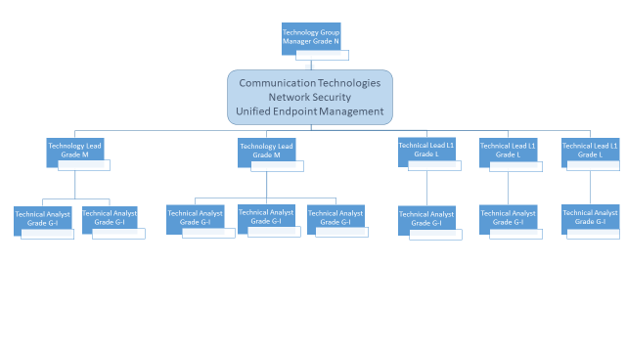
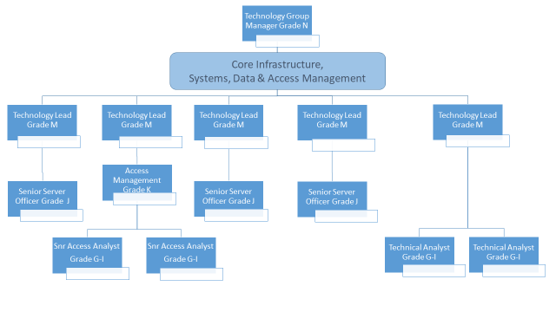
Job Description
Job purpose | Responsible for specialist technology areas (domains) within T&Cs’ ICT infrastructure. Leading a specialist team to ensuring the continued availability and performance of key products and components. To research and develop in line with emerging technologies, planning and implementing new and changed products and components. As subject matter expert, contribute and maintain Technical Architecture standards.
Operational management | - Lead research and development (R&D) into new products and features to enhance the performance, functionality, security and reliability of the environment (including joint working with other teams).  - Identify and implement service packs, patches and ‘bug’ fixes to optimise system performance, security and reliability.  - Define standards for the design and implementation of technology products and components.  - Attend training courses where appropriate.  - Project work on secondment or as a work-package lead.  - Attends Enterprise Architecture Board producing technical design proposals and documentation as required  - Lead on technical escalations with other team members, acting as a point of escalation within specialist area.  - Perform third-line support activities and problem solving.  - Competent in the use of analytical toolsets and any test equipment to identify root cause.  - Raise Requests for Change to address root cause.  - Ensure adherence to NYCC Security Policies  - To monitor and update the incident and service management system as required.  - Contributes towards the continued improvement of T&C specialist components, products & services identifying opportunities for new service capability.  - Proactively monitor and apply strategies to maintain availability.  - Plan adequate technical capacity.  - Adhere to NYCC’s Health & Safety policies ensuring third parties adhere to these with particular attention to asbestos related issues  - Manage the staff and technology required to enforce confidentiality, integrity and security of all Information assets.  - Support all elements within the scope of the specialist area.  - Be proactive in supporting other members of the team in all technical issues  - Monitor and troubleshoot service problems  - Operate at the effective SFIA levels – All specialisms:  - Availability Management – Level 5  - Capacity Management – Level 4  - Incident management – Level 4  - Problem Management – Level 4  - Change Management – Level 4  - IT Infrastructure – Level 4  - Penetration testing - Level 4  - Security Admin – Level 2  - Specialist advice – Level 4  - System Software – Level 5  - Systems Installation / Decommissioning – Level 4  - Continuity Management – Level 4  - Operate at the effective SFIA levels – Specific to the specialism:  - Database Administration – Level 4  - Network Support – Level 5  - Storage Management – Level 4
Communications | - Ability to communicate effectively by relaying technical terms in plain English.  - General communication with ICT colleagues, senior management, customers, suppliers and partners.  - Present R&D findings, proposals and technical roadmap to senior management.
Partnership / corporate working | - Assist the Technology Group Manager in ensuring that third party service providers meet or exceed SLA targets.  - Ensure OLAs for components supporting commercial services are achieved.  - Assist in designing service and products for new and changed services.  - Promote the role of Technology & Change throughout the business.
Resource management | - Deputise for the Technology Group Manager  - Propose objectives and contribute to annual appraisal and development of specialist team members.  - Ensure the specialism is adequately resourced avoiding single points of failure.  - Supervise operational workload of team including regular 1-1s, PPD and IPM.  - Organise and chair regular specialist team meetings.  - Ensure team have documented procedures so that they can provide adequate support for the specialist area.  - Represent specialist area and contribute to Team and Services Planning.  - Allocate resources to Product Design Workshops as required.
Systems and information | - Develop, maintain and ensure the team have documented procedures so that they can provide support for the specialist area.  - Develop, maintain, and implement disaster recovery test plan for the specialist area.  - Ensure knowledge base articles are available, relevant and up to date to support the Service Desk and service users.  - Ensure the highest standards of documentation and change control.  - Ensures that KPIs and reports on performance against Operational Level Agreements, Team Plan and for Contract Management purposes are produced.

Person Specification
Essential upon appointment | Desirable on appointment
Knowledge  - Full ICT infrastructure understanding with subject matter expertise in one or more relevant ICT technical specialism.  - Understanding of IT infrastructure requirements, dependencies and deliverables needed to provide a secure portfolio of services.  - Project management small- to medium-scale projects.  - Problem and Incident Management Techniques  - An excellent understanding of current and emerging IT technologies.  - A good understanding of IT industry best practises and procedures  - Advanced knowledge of current software relating to specialism.  - Experience of working within an enterprise computing environment, both on premise and /or cloud based computing.  - Expert working knowledge of application technologies, security management techniques, deployment tools and configuration management. | - Technical change management  - ICT Security practises  - Knowledge of ISO27001 and ISO20000  - Awareness of project management processes  - Knowledge of Operating system technologies.  - Coaching / Mentoring
Experience  - Significant ICT industry experience in specialist area.  - Proven experience of operating systems in ICT specialism.  - Problem ownership and resolution  - Supervision of staff  - Demonstrable experience of  - Maintaining IT Services and applications in an enterprise environment.  - Using a Configuration Management system.  - Using a Security Management suite. | - Experience of using change, incident and problem management system  - Experience implementing capacity planning
Occupational Skills  - Excellent communications skills both oral and written  - Demonstrable problem solving skills  - Able to work on own initiative and as a part of a team  - Problem ownership, irrespective of the resolving agency  - Ability to absorb new concepts and technologies with the minimum of support  - Willing to work flexible hours to meet the customer's requirements  - Excellent organisational and administrative skills  - Ability to prioritise workloads and delegate effectively  - Good interpersonal skills | - Report writing skills
Professional Qualifications/Training/Registrations required by law, and/or essential for the performance of the role  - Cisco CCNP or Microsoft MCSE in a relevant subject pertaining to the post or equivalent.  - A level 4 qualification, equivalent technical qualification or demonstrable relevant experience in a managed enterprise IT environment  - Can demonstrate a good standard of education | - Prince 2  - ITIL Service Management qualification
Other Requirements
- Ability to travel across the County
- Ability to attend meetings, support and upgrade work outside
of normal business hours.
Behaviours | Link
NB – Assessment criteria for recruitment will be notified separately.
Optional - Statement for recruitment purposes: You should use this information to make the best of your application by identifying some specific pieces of work you may have undertaken in any of these areas. You will be tested in some or all of the skill specific areas over the course of the selection process.

