Service and job specific context statement
Directorate: | Central Services
Service: | Technology and Change
Post title: | Senior Developer
Grade: | L
Responsible to: | Lead Developer
Staff managed: | Manage staff on a project/matrix basis (not direct line management)
Date of issue: | April 2022
Job family: | P&T - Professional & Technical
Job context
Technology and Change provide technology and change services across the authority and increasingly to others through partnership or commercial arrangements. The Development team is one of the teams in the Technology and Change Service that forms part of the Digital Transformation Team.

The post holder will work within the Development Team providing consultancy, analysis, design, development, testing and implementation, support services and documentation for the development of information and integration systems and customer facing products and services.

The post holder will contribute to and work within a strategy to meet the requirements of the organisation now and in the future to meet the challenges the authority will face. This will include following policies and working within strategies and standards for the technologies used, development methodologies and testing strategies.

The post holder will work closely with other teams in the service to ensure software products are built and delivered to time, within budget and to the agreed quality.

Structure
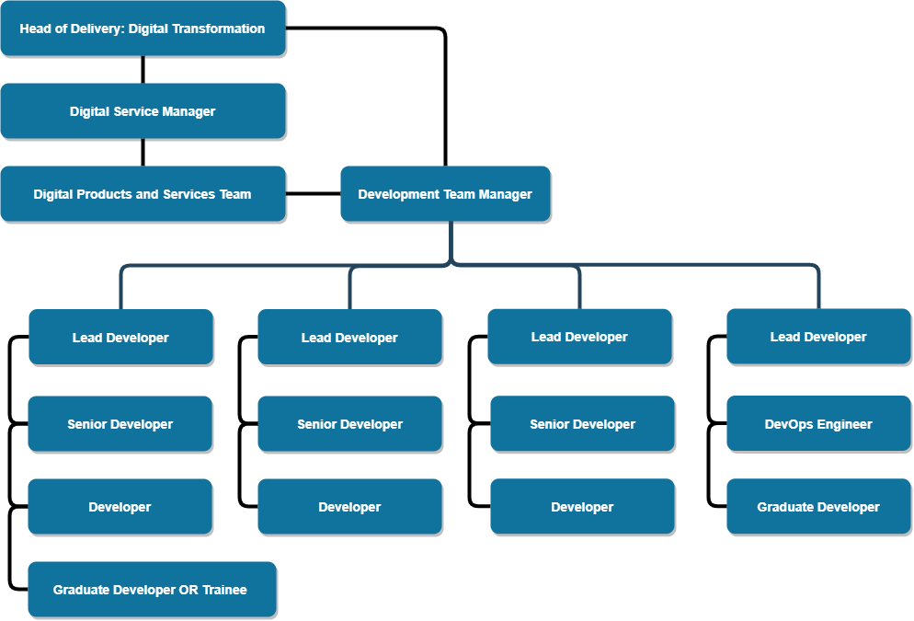

Job Description
Job purpose | The purpose of this job is to provide software development products to the organisation, ensuring maximum benefit from that investment within the development strategy, specifications and standards.  The post holder will work closely with the Development Team Manager, customers, colleagues within T&C, Business Partners and other strategic business areas and working groups.  Lead and task manage Developers in the delivery of projects where required.
Operational | - Support the Development Team Manager by contributing to the Service Plan and Team Plan, by working in a way that delivers the Objectives, Actions and Performance Measures.  - The design, creation, coding, testing and documenting, of complex programs and scripts of new and amended software products and integrations from supplied specifications in accordance with agreed development and security standards and processes to achieve a well-engineered result.  - Identify process improvements, and contribute to Development Team standards for the design, development and implementation of information systems based on corporate requirements and best business practice  - Maintain an in-depth knowledge of specific programming and development specialisms, and provide expert advice regarding their application.  - Co-ordinate and manage the full testing of all work, including functional and security testing, and take responsibility for the integrity of testing and acceptance activities, within deadlines, to ensure that the product meets customer requirements and Development standards.  - Create test cases and define test conditions, create test scripts and supporting data using own in-depth technical analysis of both functional and non-functional specifications (such as reliability, efficiency, usability, maintainability and portability)  - Ensure that work adheres to appropriate current NYCC policies and standards. (Such as, but not limited to, design, development, security and quality standards).  - Maintain application support processes, and check that all requests for support are dealt with in a timely manner according to agreed procedures and response SLA’s.  - Resolve Support Issues within the procedures and Development Team standards and where necessary in collaboration with colleagues specialising in different technical disciplines, such as Database administration, Server Administration or Network support.  - Ensure that all programming code is maintained in a controlled code management system to promote collaborative working and safe change management for the full life cycle of the assets.  - Manage configuration items and related information. Investigate and implement tools, techniques and processes for managing assets (such as documentation, software and service assets, including information relating to those assets) and verify that related information is complete, current and accurate.  - Asses, analyse, plan and design release packages with the DevOps Engineer, including assessment of risk. Follow the processes, systems and functions to package, build, test and deploy changes and updates (which are bounded as “releases”) into a production environment.  - Advise on application of standards and methods and ensure compliance.  - Specifies and designs large or complex systems, using appropriate design standards, methods and tools Consistent with agreed enterprise and solution architectures.  - Reviews others' systems designs to ensure selection of appropriate technology, efficient use of resources, and integration of multiple systems and technology.  - Translates logical designs into physical designs, and produces detailed design documentation to detail physical data flows, file layouts, common routines and utilities, program specifications or prototypes.  - Evaluates and undertakes impact analysis on major design options and assesses and manages associated risks. Ensures that the system design balances functional, service quality, security and systems management requirements.  - Undertake the specification, design and maintenance of mechanisms for storage and access of data in compliance with legislative requirements.  - Liaise with business and T&C colleagues specialising in different areas, such as Database administration or Network support, on release scheduling and communication of progress.  - Conducts post release reviews. Ensure that release processes and procedures are applied to enable controlled and effective handover to the customer.  - Engage with solutions analysts and product managers to ensure correct products are produced, in a timely fashion. Ensuring that created or modified products meet the defined service requirements.  - Provide and accept peer support and promote best practice as required.
Communications | - Provide technical expertise to development team members across a broad spectrum of technologies.  - Provide advice and guidance to customers in the use of software to ensure continued system effectiveness against a background of changing business requirements and technological improvements.  - Promote best practice in the use of technology throughout the Authority, including the identification of improved business processes.  - Liaise with other teams within Technology and Change to provide an effective and efficient service to customers.
Partnership / corporate working | - Strive to be fully aware of the customer’s current and future technology requirements.  - As appropriate, act as a technical expert for other Technology and Change staff and customers.  - Support Solution Analyst in identifying technical solutions and options, the production of estimates and in identifying benefits, risk and costs
Resource management | - Give advice on training and development requirements to Development Team Manager.  - Provide mentoring to team members.  - Train new personnel in appropriate skills.  - Work with other members of the team to broaden knowledge and technical expertise and to keep up to date with changes in technology assessing potential benefits and promoting awareness.  - Actively promote a culture of exceptional customer care.  - Assist in the process of recruitment and selection of staff where required.
Systems and information | - Provide, or assist in, the delivery of second line support to users of information systems supported by the team.  - Ensure that agreed SLA’s and OLA’s for support or other services are adhered to. Providing timely information and updates on progress and resolution to the Development Team Manager.  - Provide advice and guidance to the Development Team Manager and Lead Developer.  - Provide details of progress of tasks/projects to the Development Team Manager and Lead Developer.  - Maintain high standards of documentation and change control.
Strategic management | - Be aware of Technology and Change business goals and assist in implementing of Technology and Change strategy as appropriate.  - To keep abreast of emerging technologies, standards and management methods.

Person Specification
Essential upon appointment | Desirable on appointment
Knowledge  - Extensive knowledge of object oriented programming languages, design patterns and development environments.  - Extensive knowledge of trends and developments in information systems hardware and software.  - Detailed knowledge of current guidance and best practice in relation to software development particularly in respect of data security.  - Extensive knowledge of Office Systems in a development context.  - Extensive understanding of the business and technical issues associated with development and support of information and integration systems in a network environment and across multiple domains  - Extensive knowledge of operating systems and internet technologies.  - Good knowledge of testing best practices | - Good understanding of the roles and functions of local government.  - Extensive knowledge of project estimating, planning and management.  - Awareness of Remote Process Automation and AI technology with respect to software development  - Awareness of Business Intelligence  - Awareness of cross-platform, multi-device development
Experience  - Extensive experience of analysing, designing, developing and testing information system applications using Web or database technologies.  - Extensive experience of managing information system projects within a multi-user enterprise scale environment.  - Comprehensive experience of developing within a test driven framework | - Experience of Cloud Platform technologies and frameworks such as Microsoft Azure  - Experience of source control and management platforms such as GitLab and GitHub.  - Significant experience of managing analysis projects.
Occupational Skills
- Ability to quickly grasp and assimilate new technologies, software and information.
- Ability to lead and motivate others.
- Display a mature and confident disposition
- Ability to demonstrate technical expertise and a ‘customer care’ approach to work.
- Uses creativity and innovation to generate solutions for difficult issues.
- Takes responsibility for and manages specific aspects of a project as requested by the Development Team Manager.
- Ability to manage time and work to deadlines
- Self-motivated and self-disciplined.
- Excellent communication and presentation skills, both written and oral.
Professional Qualifications/Training/Registrations required by law, and/or essential for the performance of the role  - IT related Degree/HND standard or equivalent technical qualification or relevant technical experience.  - Evidence of ongoing commitment to CPD software development | - Relevant programming language or technology platform qualification  - Relevant software development practice certification  - ITIL Certificate
Other Requirements
- Ability to travel across the County as required by meetings or training.
- Professional values and attitudes
- Ability to work both on own initiative and as part of a team
- Ability to work to specified deadlines
Behaviours | Link
You should use this information to make the best of your application by identifying some specific pieces of work you may have undertaken in any of these areas. You will be tested in some or all of the skill specific areas over the course of the selection process.

