Service and job specific context statement
Directorate: | Central Services
Service: | Technology and Change
Post title: | Project Manager Level 1
Grade: | J
Responsible to: | Senior Project Manager
Staff managed: | Manages staff on a project/matrix basis (not direct line management)
Date of issue: | July 2014
Job family: | P&T - Professional & Technical
Job context
The council is embarking on a series of change programmes and projects required to move to new ways of working within increasingly challenging budget constraints.

This will include changes to organisational structures, business processes, technology, culture and ways of working and will impact on services across the council and partner organisations, large numbers of staff and have significant budget implications. Programmes will also involve working with partners, including district councils to look at delivering back office and frontline services in different ways

The post holder will manage the delivery of defined projects which will require good coordination skills and an ability to work with a wide range of stakeholders.

The post will be based at County Hall, Northallerton.
Structure
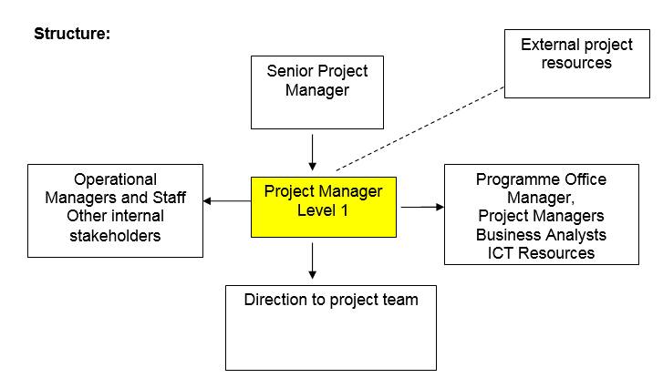
Job Description
Job purpose | The core focus of this job is to manage, with direction, the planning and implementation of designated projects and ensure they are delivered on time and within budget. This will involve coordinating project resources through the delivery stages of agreed projects using the council’s established project management methodology.
Operational management | - Be responsible for the delivery of agreed projects to the required cost, time and quality.  - Ensure that projects are delivered to relevant Council standards including agreed project management methodology.  - Produce regular progress reports and identify and manage project risks/issues.  - Work with other stakeholders to develop solutions in response to issues/risks and to manage and control project changes in line with established protocols.
Communications | - Build strong working relationships with principal stakeholders such as service area managers demonstrating awareness and sensitivity to the needs of key stakeholders.  - Manage conflict situations effectively and pro-actively seek to be creative in developing solutions in order to deliver win-win.
Partnership / corporate working | - Where required, work with partners in other organisations to deliver projects  - Work with colleagues in HR, ICT, Finance, Communications, Legal Services and other functions where required
Resource management | - Support the budget holder to ensure that allocated project budgets are effectively managed (under £100k).  - Within the constraints of the particular project, be responsible for directing the work of multi-skilled project teams
Systems and information | - Work with ICT colleagues to ensure that any system IT requirements to support business change are understood and progressed  - Use appropriate ICT tools to support the management and delivery of projects including Microsoft Office, Microsoft Project, Visio, Sharepoint and other specialist tools such as Project Vision

Person Specification
Essential upon appointment | Desirable on appointment
Knowledge  - Good understanding and practical application of project management processes  - Understanding of the principles underpinning quality management  - Knowledge of appropriate project management tools including Microsoft Project | - Appreciation of ITIL based change control processes and methodology  - Understanding of structured project management methodologies, e.g. PRINCE2
Experience  - Experience of delivering projects successfully  - Experience of working with a range of stakeholders to deliver successful outcomes | - Experience of delivering projects using a structure methodology
Occupational Skills
- Ability to demonstrate sensitivity to different needs of key Council stakeholders.
- Flexible approach with the ability to respond effectively to changing circumstances, without losing focus or direction
- Ability to manage own workload and prioritize effectively.
- Project working skills – Able to manage the delivery of projects using appropriate project planning techniques and organisational skills
- Persuading, influencing and negotiating skills – Successfully persuades, influences and/or negotiates with people
- Problem solving skills – effectively identifies workable solutions
- Analytical skills – Analyses information from a range of sources, probing for further information or a greater understanding when necessary
- Written communication skills – Communicates effectively in writing to produce documents in a range of formats and styles to suit a range of audiences
- ICT Skills – Good level of ICT skills across a range of office packages
- Literacy and Numeracy skills to Level 3.
Professional Qualifications/Training/Registrations required by law, and/or essential for the performance of the role  - Good standard of education to the equivalent of Level 3 | - Project management qualification (PRINCE2, APM or similar) or significant experience of using structured project management methodologies
Other Requirements
- Ability to travel across the County for work purposes
Behaviours | Link
NB – Assessment criteria for recruitment will be notified separately.
Optional - Statement for recruitment purposes: You should use this information to make the best of your application by identifying some specific pieces of work you may have undertaken in any of these areas. You will be tested in some or all of the skill specific areas over the course of the selection process.

