Service and job specific context statement
Directorate: | Central Services
Service: | Technology and Change
Post title: | Junior Developer
Grade: | G
Responsible to: | Lead Developer
Staff managed: | None
Date of issue: | May 2022
Job family: | P&T - Professional & Technical
Job context
Technology and Change provide technology and change services across the authority and increasingly to others through partnership or commercial arrangements. The Development team is one of the teams in the Technology and Change Service that forms part of the Digital Transformation Team.

The post holder will work within the Development Team providing support, development, testing and implementation, support services and documentation for the development of information and integration systems and customer facing products and services.

The post holder will work closely with other teams within the Technology and Change service, in particular the Digital Products and Services Team, to ensure that software products are supported and built within budget and to the agreed quality.

As this is a junior role in the team, there would be an expectation that the post holder would gain experience and additional skills whilst in the post, with the aim of progressing into the Developer role within the team. This would be dependent on the ability of the post holder to meet knowledge, skills and experience requirements of the Developer role; which would be progressed with a development plan.

Structure
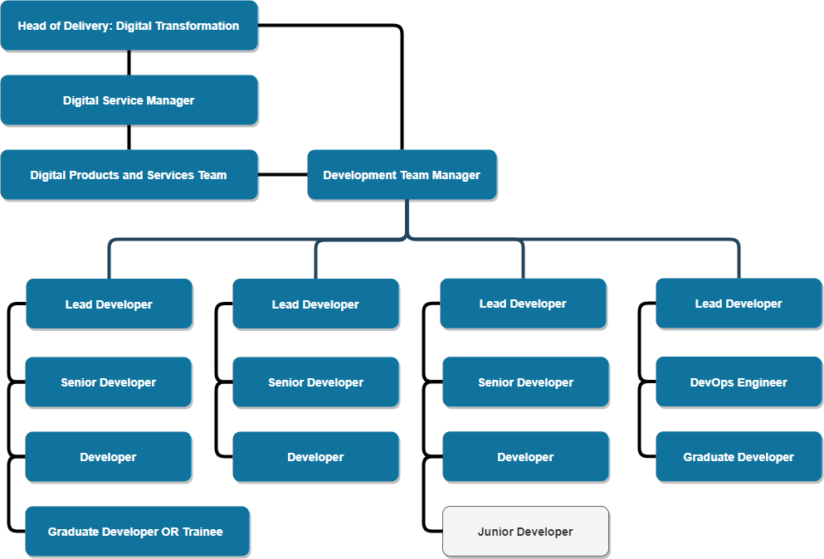

Job Description
Job purpose | The purpose of this job is to assist in providing software development products (and support) to the organisation, ensuring maximum benefit from that investment within the development strategy, specifications and standards.  The post holder will work closely with the Development Team Manager, Lead Developer and colleagues within T&C.
Operational management | - Support the Lead Developer in the development, testing, implementation and documentation of information system solutions utilising in-house developed components and bought in packaged software.  - Code, test, and correct documentation of programs and scripts from agreed specifications, and subsequent iterations, using agreed standards and tools, to achieve a well-engineered result.  - Fault finding and identification of problems in code that will result in potential fixes for products.  - Develop, document and implement changes based on requests for change. Apply change control procedures.  - Ensure release processes and procedures are maintained.  - Apply up to date, knowledge of database concepts, object and data modelling techniques and design principles, and a knowledge of database architectures, software and facilities available. Analyse data requirements, to establish, modify or maintain a data model.  - To be a first point of contact for triaging of incidents and requests, and following escalation procedure.
Communications | - Ensure that line managers and other team members are kept informed of task progress appropriately.  - Liaise with colleagues within and outside the service as required.  - Provide technical advice and guidance to other members of technical teams within T&C.
Partnership / corporate working | - Promote the use of Data Governance Services through collaborative working  - Develop and maintain positive and cooperative working relationships  - Share skills, knowledge and learning
Resource management | - Ensuring accurate time management.  - Providing estimates where required for significant support work.
Systems and Information | - Provide testing support for system updates in conjunction with other teams
Strategic management | - To actively consider new and innovative ways of doing things recognising and promoting the positive benefit of change to improve services and achieve goals.
SFIA Skills Reference | - Development and Implementation: Database Design – Level 2  - Development and Implementation: Programming Software Development – Level 2  - Development and Implementation: Software Design – Level 2

Person Specification
Essential upon appointment | Desirable on appointment
Knowledge  - Basic knowledge of object oriented programming languages, design patterns and development environments.  - Basic knowledge of current guidance and best practice in relation to software development particularly in respect of data security.  - Awareness of the business and technical issues associated with development and support of information and integration systems in a network environment.  - Awareness of testing best practices.  - Range of ICT knowledge. | - Awareness of the roles and functions of local government.
Experience  - Experience of information system applications using Web or database technologies  - Experience of working to and achieving deadlines and targets | - Experience of working in the Public Sector
Occupational Skills
- Good ICT skills.
- Ability to grasp new technologies, software and information.
- Ability to demonstrate technical knowledge and a ‘customer care’ approach to work.
- Ability to manage time and work to deadlines.
- Self-motivated.
- Good communication and presentation skills, both written and oral.
- Excellent attention to detail.
Professional Qualifications/Training/Registrations required by law, and/or essential for the performance of the role  - IT related qualification to Level 3 or equivalent  - Evidence of ongoing commitment to CPD. | - Relevant programming language or technology platform qualification  - Relevant software development practice certification  - ITIL Certificate
Other Requirements
- Ability to travel across the County as required by meetings or training.
- Ability to work to specified deadlines
Behaviours | Link
NB – Assessment criteria for recruitment will be notified separately.
Optional - Statement for recruitment purposes: You should use this information to make the best of your application by identifying some specific pieces of work you may have undertaken in any of these areas. You will be tested in some or all of the skill specific areas over the course of the selection process.

