Federation of
Skelton Newby Hall and Sharow CE Primary Schools
Candidate pack and job description:
KS2 Class Teacher
temporary position to cover maternity leave
Skelton Newby Hall CE Primary School

Dear Applicants,

Thank you for your interest in our vacancy. We hope the attached information will help you in deciding whether to apply for the position Class Teacher at Skelton Newby Hall CE Primary School.
The advertised post of Class Teacher is for a teaching commitment in KS2 at Skelton Newby Hall CE Primary School. Experience of teaching KS2 is essential.
Skelton Newby Hall CE Primary School is a small rural school in the beautiful village of Skelton on Ure. Our current role is 20. This allows us to know each child individually and creates a family feel to the school community.
We work in partnership with parents and the whole community, to help our children to enjoy learning and to become independent, self-disciplined, self-motivated and to achieve the highest standards of which they are capable.
Our Federation with Sharow CE School provides a strong and supportive community with a very nurturing and inclusive ethos, where all children and adults are highly valued. The teaching staff are highly committed and supported by a strong team of teaching assistants and other support staff who work closely to provide a warm and caring environment for our children.
We are committed to curriculum innovation and new ideas. All staff work collectively across the federation with a shared responsibility for bringing out better outcomes for our children and families.
All successful applicants will be notified and invited for interview. All unsuccessful applicants are thanked for their interest but will not be notified.

Should you wish to discuss the post further, or arrange to visit the school, then please do not hesitate to contact us.

Yours sincerely,

Jacqui Palmer
Executive Headteacher

JOB DESCRIPTION

JOB TITLE: Main Scale Teacher

GRADE: To be determined based on experience level

RESPONSIBLE TO: The Executive Headteacher

RESPONSIBLE FOR: Deployment of support staff allocated (where relevant)
JOB PURPOSE: Promote effective learning, appropriate achievement and educational, social and personal progress of all pupils for whom the teacher is designated as being responsible, consistent with the aims of the school and the unique needs of each individual.

JOB CONTEXT: This school is committed to safeguarding and promoting the welfare of our pupils and young people. We have a robust Child Protection Policy and all staff will receive training relevant to their role at induction and throughout employment at the School. We expect all staff and volunteers to share this commitment. This post is subject to a satisfactory enhanced Disclosure and Barring Service criminal records check for work with children.

KEY RESPONSIBILITIES:

1. Develop and maintain an up-to-date knowledge and understanding of the areas of teaching and pupil support for which post-holder is responsible

2. Plan work to meet the learning needs of allocated pupils in a consistent and effective way

3. Use appropriate teaching and classroom management strategies to motivate pupils and enable each to progress

4. Monitor the progress of pupils for whom the postholder is responsible to set expectations and give constructive feedback

5. Maintain appropriate records to demonstrate progress made by pupils

Participate fully in professional development activities to develop practice further, sharing the learning from these as appropriate

Make an active contribution to the policies and aspirations of the school

To fulfil all of the requirements and duties set out in the current Pay and Conditions Documents relating to the conditions of employment of teachers

To fulfil all of the responsibilities and duties required by the School’s policies on teaching and learning.

To achieve any performance criteria or targets arising from the School’s Performance Management arrangements

This job description will be reviewed annually.

Personal Specification
CRITERIA | ESSENTIAL | DESIRABLE
Educations achievements, qualifications  & training | Qualified teacher status  Certificate of Education or equivalent | Evidence of a commitment to further professional development
Experience, Knowledge and  Understanding | An excellent class teacher with experience of teaching year 6  Knowledge of assessment procedures for the end of KS2  Experience of planning and delivering the National Curriculum  Experience of teaching the full range of abilities, including those with special needs  Experience of analysing and developing planning through assessment  The knowledge to monitor, assess, record and report on pupil progress  Proven ability to work as part of an effective team  The statutory requirements concerning equal opportunities, Health & Safety, Inclusion and Child Protection | External recognition of high-quality practice  Evidence of an innovative and creative approach to curriculum design  Experience of teaching and evidence of inclusive practice throughout the primary phase  An understanding of what it is to be a reflective practitioner  Working in partnership with parents/community  Evidence of implementing whole school initiatives.  Ability to inspire, lead and motivate
PERSONAL QUALITIES
- Exemplifying high standards and expectations of behaviour of both pupils and staff at all times
- Empathy with the school community and to maintain a measured approach to potentially challenging situations
- Positive, enthusiastic attitude
- Organised, flexible and willing to support others

EQUAL OPPORTUNITIES
A commitment to the equality of access, provision and treatment of all staff and pupils regardless of their race, gender, culture, language, nationality, religion, disability, or any other differences.

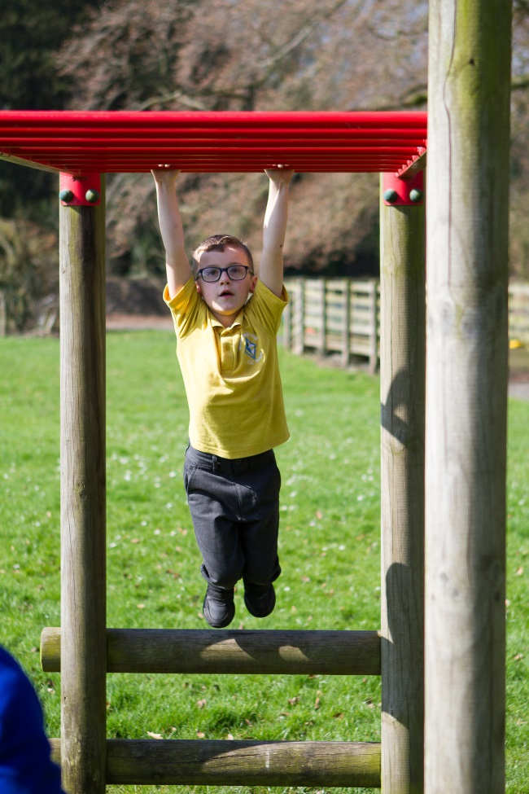

Thank you for your interest in our school

