Service and job specific context statement
Directorate: | Central Services
Service: | Resourcing Solutions
Post title: | Graduate Trainee – Resourcing Solutions
Grade: | E F G (6 months Grade E, 6 months Grade F, 12 months Grade G)
Responsible to: | Talent Acquisition Manager
Staff managed: | None
Date of issue: | August 2022
Job family: | P&T - Professional & Technical
Job context
All graduates are expected to participate in the ‘corporate graduate development programme’ – the content is as follows:-
- Corporate Induction
- Aspiring Managers Programme
- Senior managers seminars (led by the Chief Executive)
- Managers webinars programme
- Access to on line material, including Ashridge Management College
- Graduate Network membership, including ‘lunchtime learning’
- Mentor support
- Graduates will be offered the appropriate management skills training if they have staff to manage during their programme or to support their permanent placement following the graduate programme.

Resourcing Solutions deliver professional recruitment services to the Council and many varied partners and clients. The Team deliver a wide range of resourcing related projects on a portfolio basis including recruitment to the education sector and care sector, executive recruitment services, employability and careers programmes, volunteer recruitment, equality, diversity and inclusion and recruitment marketing.

With national policy and budget changes combined with the impact of Brexit and Covid, this has impacted on key workforce areas, the labour markets are increasingly scarce resulting in severe competition for talent, resourcing to NYCC and wider sectors has become very challenging, requiring robust and innovative resourcing solutions. The Team use a wide range of approaches to support Managers to engage, attract and recruit talent whilst also supporting a variety of employability related projects.

The post holder will be responsible for supporting resourcing colleagues with resourcing related projects and activities within an allocated portfolio. This will involve research and data analysis, project planning and delivery including customer correspondence (internal and external) and provision of support. The role will also involve monitoring the impact of the approaches taken including collating statistics and data to assess success.

The post holder will be required to work alongside resourcing colleagues who have experience of the relevant portfolio to gain specialist knowledge and deliver specific resourcing projects.

The post holder may need to contribute to other corporate Resourcing projects on a portfolio basis which will aid their understanding of the wider recruitment lifecycle.
Career progression
- The post is a 2 year development post which may have some opportunities to be tailored in part (within reason) to meet the career aspirations of the post holder.
- The first 6 months will focus on learning the business of the team. In the second 6 months the post holder would take on more independent project work, in the second year they will be expected to manage a project independently with oversight rather than close supervision. They will also fully understand the nature of the business and be able to suggest organisational/operational change/developments as part of the leadership team.
Pay progression will be based on performance review at 6 months and then 12 months as follows:
- Months 1-6 Grade E
- Months 7-12 Grade F
- Months 13-24 Grade G
Job specifics
Graduates who join NYCC are expected to:
- achieve the objectives set for them;
- ask for help/clarity where needed;
- develop their knowledge through self-directed study – further research, reading and questions;
- fully participate in all training opportunities through on the job experience, mentoring and coaching and formal training and learning;
- work toward becoming professional member/associate where appropriate;
- make the most of the opportunities available within NYCC; and
- demonstrate NYCCs expected behaviours of:
  - focussing on customers and communities;
  - taking responsibility;
  - working together;
  - acting with Integrity
  - building a culture of continuous improvement and innovation; and
  - leading by example.
Structure

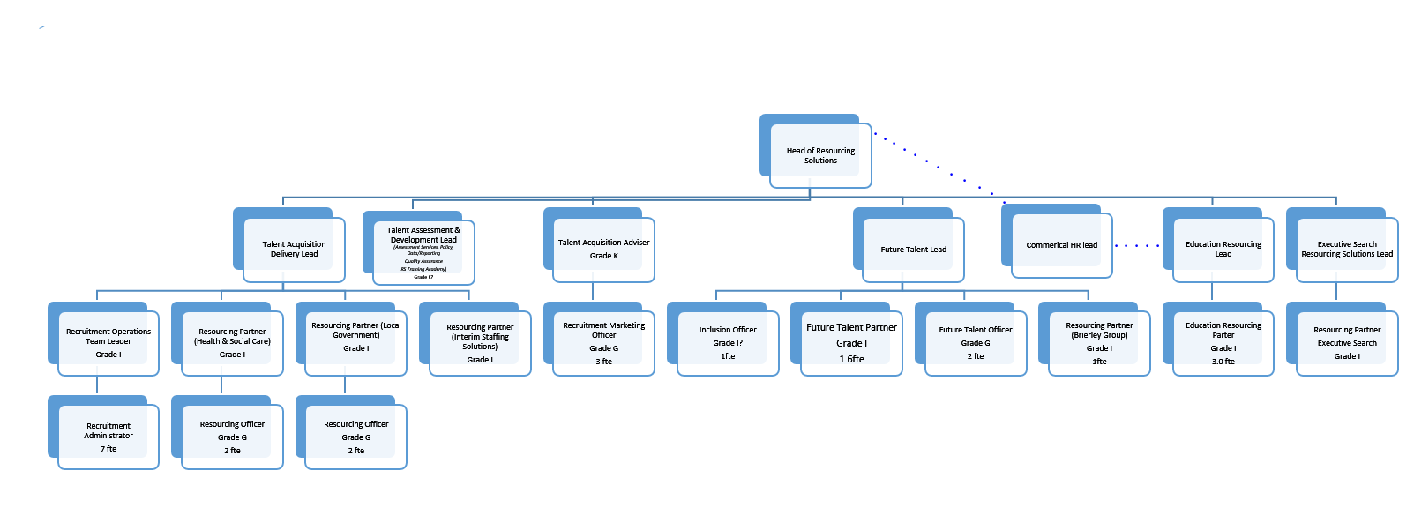

Job Description
Job purpose | The core purpose of this job is to support and deliver on a range of Resourcing Solutions projects at any one time to effectively meet the organisation’s and partners’ recruitment challenges in a fair and equitable way. The post holder will provide support to colleagues, to plan and deliver effective resourcing projects using a range of approaches.
Operational delivery | - Undertake project activities to assist in the delivery of Resourcing Solutions projects under the day to day direction of the Talent Acquisition Manager – Resourcing Solutions  - Support team colleagues with vacancy management including acquiring and maintaining specialist knowledge of the recruitment sectors, labour market information, target audiences and related policy and process, determining appropriate learning requirements and resources.  - Alongside Resourcing Solutions colleagues, support, coach and advise managers to achieve pro-active, timely and effective recruitment practice and challenging working practices as required;  - Raise the profile of the Council as an ‘Employer of Choice’ by positively promoting the benefits of working at the Council in adverts and media.  - Attending local and national events and networking with educational establishments to promote jobs and careers in NYCC  - Develop knowledge in order to provide advice and guidance on specific issues relating to Resourcing activity e.g. candidate and manager enquiries, vacancy promotion, and recruitment process  - Collect, collate and analyse data relating to recruitment activity in a consistent manner and record such data appropriately.  - Deliver a quality service to internal and external customers as required;  - Provide a complete ‘end to end’ service delivery, establishing ownership and closure as needed.  - Operate as a reflective practitioner in relation to personal skills and operating practices, as well as engaging in a peer review approach.
Communications | - Responsible for developing and maintaining effective relationships with HR colleagues, managers, partners and stakeholders.  - As appropriate, acts as a mentor/coach to other staff, leading on development activities for the team as required.  - Develop and build knowledge to provide proactive advice and guidance relating to effective marketing and promotional activities when working with managers, colleagues and stakeholders
Partnership / corporate working | - Working with staff from across the different services of the County Council and partner organisations in some cases to support the efficient and effective delivery of services and achievement of project objectives.  - Ensure links between the project and stakeholders are developed and maintained to provide an efficient service.  - Develop an understanding of the wider role of the County Council across North Yorkshire
Resource management | - Utilise and update data and statistics to facilitate achievement of objectives;  - Support colleagues with implementation of service developments as needed;  - Identify and recommend appropriate action to colleagues, and develop and implement guidance to enable and facilitate the delivery of key initiatives.
Systems and  information | - Requirement to use a range of computer systems including, MS Office, SharePoint, Intranet/Internet.  - Utilise web based HR systems to view, accurately record and implement recruitment projects.  - Adopt new ways of working when new systems are introduced, use systems to manage and progress projects, analyse and report on relevant data and to maintain effective communication.  - To utilise key HR systems i.e. Engage, MyView, Insight to gain relevant data to drive recruitment activity
Policy and projects | - Contribute to Resourcing policy development, consultation and implementation process;  - Contribute to and represent Resourcing Solutions and NYCC at working groups, meetings and corporate groups;  - Support on Directorate and Corporate projects as appropriate with support from relevant Resourcing Solutions colleagues.

Person Specification
Essential upon appointment | Desirable on appointment
Knowledge  - Good working knowledge of resourcing and recruitment employment legislation covering a wide spectrum of issues;  - Good understanding of how policies/procedures can be applied in practice to result in required outcomes | - Knowledge of Equality, Diversity and Inclusion  - Knowledge of employability programmes and mechanisms to support people into work  - Knowledge of media advertising, recruitment industry and professional recruitment practice  - Good working knowledge of local government or the wider public sector
Experience  - Experience of managing a busy workload within set deadlines  - Experience of liaising and communicating effectively  - Experience of producing clear and concise short reports  - Experience of successfully leading on projects and assignments  - Experience of completing research and/or data analysis and making recommendations based on findings  - Experience of delivering briefings and presentations | - Experience of working in a corporate and political context  - Experience of coaching and/or providing support to others with employability skills  - Experience of marketing and / or advertising  - Experience of volunteering or working with volunteers  - Experience of working on multiple initiatives/projects simultaneously
Occupational Skills

- Communication, presentation and interpersonal skills
- Problem solving skills and the ability to find innovative solutions
- Influencing and negotiating skills
- Commitment to the performance management culture with the ability to set high standards, deliver objectives and achieve targets
- Flexibility and ability to work with ambiguity
- Data collection, collation and analysis skills
- Basic planning and project management skills.
- Communication, presentation and interpersonal skills.
- IT skills across a range of office packages

Professional Qualifications/Training/Registrations required by law, and/or essential for the performance of the role  - Education to degree level | - Commercial / HR / Business module as part of degree
Other Requirements
- Resilient
- Ability to travel around the county and beyond
- Team worker/collaborative working
- Self-motivated
- Commitment to equal opportunities.
Behaviours | Link
It is important that in your application you address the following in the supporting/additional information section of the application form. We will use this to shortlist applications, in addition to any specific requirements listed for the role.

- Why you have applied to the NYCC graduate programme. (max 200 words)
- What you see as the key challenges ahead for Local Authorities, specifically North Yorkshire County Council.
- Referencing our behaviours framework, provide detailed evidence using examples of your ability to; (Max 200 words per bullet point (Total 1400 words)
> Focus on customers and/or communities;
> Take responsibility;
> Work collaboratively with others;
> Act with Integrity;
>Continuously improve and innovate;
> Lead by example: and
> above all, deliver high quality work with positivity and passion.

- What impact you think you will have if appointed to the programme. (Max 200 words)

