Service and job specific context statement
Directorate: | Central Services
Service: | Communications
Post title: | Graduate Trainee – Digital Content
Grade: | E, F and G
Responsible to: | Team Leader – Digital, Video and Design
Staff managed: | None
Date of issue: | June 2022
Job family: | P&T - Professional & Technical
Job context
The council’s Digital, Video and Design Team sits within the council’s Communications Unit. This is where the post holder duties will be carried out. The Communications Unit provides a communications service which covers media relations, web and internet (including social media), internal communications, marketing, consultation, campaigns, video production design and corporate identity and public information, working with all services, at all levels and with external organisations.

The Digital, Video Design and Design Team has responsibility for the council’s website, intranet, social media, surveys, video production and design. The post holder will initially support the projects to deliver the new website and intranet for the new council, with a focus on creating effective website/intranet content, before supporting the team more widely following their launch.

All graduates are expected to participate in the ‘corporate graduate development programme’ – the content is as follows:-
- Corporate Induction
- Managers Induction
- Aspiring Managers Programme
- Senior Managers Seminars (led by the Chief Executive)
- Middle Managers Programme
- Access to on line material, including Ashridge Management College
- Graduate Network membership, including ‘lunchtime learning’
- Mentor support
- Graduates will be offered the appropriate management skills training if they have staff to manage during their programme or to support their permanent placement following the graduate programme.
Job specifics
Working to the Team Leader for Digital, Video and Design and project leads:
- Populating content on the newly built sites and directories they contain in line with our corporate style and approach to online information and services, ensuring they meet all of our legal requirements
- Writing effective website/intranet content, with support from the project team, which prioritises the needs of residents, supports the customer journey and encourages channel shift
- Analysis of statistical data and feedback to ensure our content is driven by data
- Monitoring and reporting progress against deadlines to the project team on a regular basis
- Supporting the project team to complete and launch the sites
- Following the launch of the new sites, support the team in the maintenance and updating of the sites as well as gaining experience in the wider delivery of digital communications.

Graduates who join NYCC are expected to:
- achieve the objectives set for them;
- ask for help/clarity where needed;
- develop their knowledge through self-directed study – further research, reading and questions;
- fully participate in all training opportunities through on the job experience, mentoring and coaching and formal training and learning;
- work toward becoming professional member/associate where appropriate;
- make the most of the opportunities available within NYCC; and
- demonstrate NYCCs expected behaviours of:
  - focussing on customers and communities;
  - taking responsibility;
  - working together;
  - acting with integrity
  - building a culture of continuous improvement and innovation; and
  - leading by example.

Career progression
In house training would be available in the following areas
- Website and intranet content management systems
- Writing effective online content to deliver measurable results
- Google analytics and SEO optimisation

- The post is a 2 year development post which can be tailored (within reason) to meet the career aspirations of the postholder.
- The first 6 months will focus on learning the business of the team. In the second 6 months the postholder would take on more independent project work, in the second year they will be expected to manage a project independently with oversight rather than close supervision. They will also fully understand the nature of the business and be able to suggest organisational/operational change/developments as part of the leadership team.
Pay progression will be based on performance review at 6 months and then 12 months as follows:
- Months 1-6 spinal point 6, Grade E
- Months 7-12 spinal point 8, Grade F
- Months 13-24 spinal point 13, Grade G

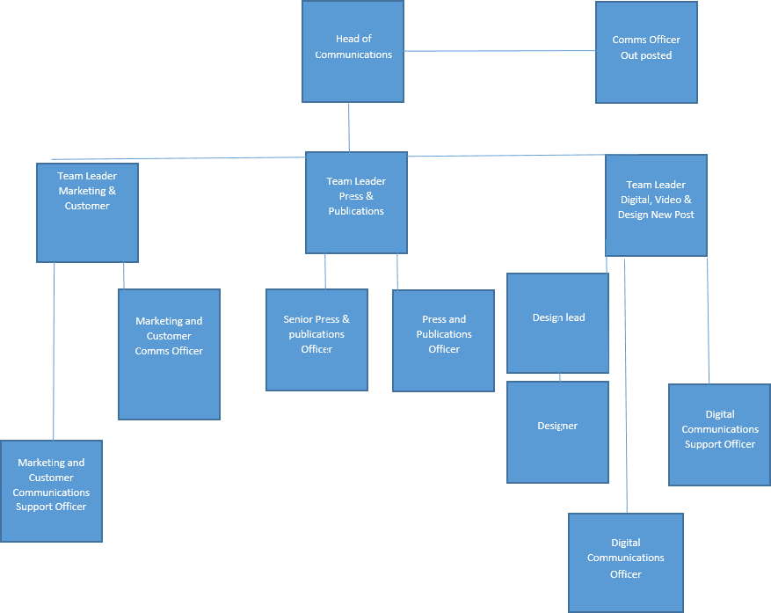
Structure

Job Description
Job purpose | Typical graduate placements are required to deliver a range of projects within an area of specialism within the County Council to effectively meet the organisation’s needs.
Operational management | - Deliver a quality service to internal and/or external customers as required;  - Provide a complete ‘end to end’ service delivery, establishing ownership and closure as needed.  - Support on the development, delivery and evaluation of interventions, including training and workshops to managers on the specifics for the project/service area.  - Support the corporate lead for a specialist subject area including acquiring and maintaining specialist knowledge, supporting on related policy and processes.
Communications | - Provide advice and guidance on the area of the service delivery the graduate is placed within as part of the project development and implementation.  - Clearly communicate the requirements of the project and prepare clear written reports on progress and analysis carried out.
Partnership / corporate working | - Working with staff from across the different services of the County Council and partner organisations in some cases to support the efficient and effective delivery of services and achievement of project objectives.  - Ensure links between the project and stakeholders are developed and maintained to provide an efficient service.  - Develop an understanding of the wider role of the County Council
Resource management | - Identify and recommend appropriate action to service manager, and develop and implement guidance and action plans to enable and facilitate the delivery of key initiatives.
Systems and information | - Utilise management information to facilitate achievement of objectives.  - Use a range of computer systems to manage and progress case work, analyse and report on relevant data and to maintain effective communication.  - Adopt new ways of working when new systems are introduced,
Policy and projects | - Contribute to policy development, consultation and implementation process.  - Support on Directorate and Corporate projects as appropriate with support from relevant service colleagues.

Person Specification
Essential upon appointment | Desirable on appointment
Knowledge  - Good understanding of how policies/procedures can be applied in practice to result in required outcomes.  - Understanding of the principles underpinning writing effective website content. | - Good knowledge of relevant legislation  - Knowledge of change management processes
Experience  - Experience of project work  - Experience of managing a busy workload within set deadlines  - Experience of writing for specific audiences to achieve demonstrable outcomes | - Experience of working in a corporate and political context  - Experience of writing content for websites  - Experience of using website CMS systems to create content (eg Sharepoint, Drupal, Wordpress)
Occupational Skills  - IT skills and ability to interpret and analysis data  - Communication, presentation and interpersonal skills  - Problem solving skills and the ability to find innovative solutions  - Influencing and negotiating skills  - Commitment to the performance management culture with the ability to set high standards, deliver objectives and challenge managers appropriately  - A coaching based approach to support managers and develop  - Delivering briefings and training to managers/other staff  - Flexibility and ability to work with ambiguity | - Policy formulation skills  - Coaching/mentoring  - Policy implementation skills
Professional Qualifications/Training/Registrations required by law, and/or essential for the performance of the role  - Education to first degree level  - Good standard of literacy and numeracy to level 2 or equivalent | - Education to degree level in a related subject
Other Requirements  - Team worker/collaborative working  - Self-motivated and commitment to equal opportunities | - Some roles will require the ability to travel across the County.
Behaviours | Link

