Service and job specific context statement
Directorate: | Health and Adult Services
Service: | Engagement and Governance
Post title: | Governance Co-ordinator
Grade: | G
Responsible to: | Governance Officer
Staff managed: | None
Date of issue: | July 2019
Job family: | P&T - Professional & Technical
Job context
- This post will work with the Governance Officer to deliver and implement aspects of the Health and Adult Service’s Governance Framework, working with NYCC Corporate and HAS Directorate staff to embed regulatory expectations for good governance into effective working practice
- The post holder will work with the Governance Officer to advise HAS Directorate staff on the monitoring of the agreed Governance Framework and the reviewing of processes in the respective areas and localities The postholder will support the wider requirements of the Engagement and Governance Team as required
- This role involves spoken and written communications in a range of formats and styles to suit a range of audiences, so a confident use of English language is required.
Job specifics
- Work alongside the Governance Officer to deliver elements of the Health and Adult Services annual Governance work plan
- Maintain computer and paper-based systems for storing and retrieving information for governance issues within HAS
- Liaise with Veritau and corporate colleagues and support the Directorate to effectively respond to Freedom of Information and Subject Access requests, and data breaches.
- Deal with enquiries, acknowledge receipt of requests and input data into the corporate management system
- Monitor the progression of the requests ensuring timescales and quality standards are met and escalating issues to the Governance Officer if necessary
- Work alongside Care and Support Leadership Team (CASLT) to ensure Serious Incidents are recorded accurately and effectively monitored. This entails collating updates from CASLT and attending the meeting monthly in order to provide HAS Leadership Team (HASLT) and the Executive Member with an updated report. This process needs to be robust and the quality of the data accurate
- Develop reporting methods to provide relevant performance information. Analyse and interpret the data and information some of which will be of a confidential and sensitive nature
- Identify themes and trends arising from the information and data received and prepare a Governance quarterly report for HASLT
- Link with the Quality and Improvement Sub-Group of the Safeguarding Adults Board to share and cross reference data provided to HASLT
- To be committed to safeguarding and, through the person being at the centre of any safeguarding response, delivering improved outcomes for adults at risk of harm or abuse in North Yorkshire.
- Health and Adult Services requires a commitment to equity of access and outcomes, this will include due regard to equality, diversity, dignity, respect, human rights and working with others to keep vulnerable adults safe from abuse and mistreatment.
- Health and Adult Services requires that staff offer the best level of service to their customers and behave in a way that gives them confidence. Customers will be treated as individuals, with respect for their diversity, culture and values.
Structure
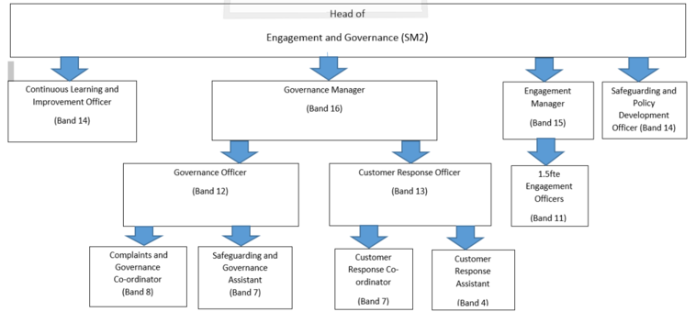
Job purpose | This post will work with the Governance Officer to deliver and implement aspects of the Health and Adult Service’s Governance Framework, working with NYCC Corporate and HAS Directorate staff to embed regulatory expectations for good governance into effective working practice  The post holder will work with Veritau and HAS colleagues to ensure the Directorate works within agreed timescales and provide advice, guidance and support regarding information governance enquiries in line with our statutory duties. The postholder will support the wider requirements of the Engagement and Governance Team as required
Operational management | - Disseminate information on Corporate Governance Policies and Procedures to HAS Senior Managers  - Implement audit and tracking systems to monitor compliance with the Governance Framework within the Directorate  - Liaise with Veritau and support the Directorate to effectively respond to Freedom of Information requests, drafting and co-ordinating responses.  - Liaise with Veritau and support the Directorate to effectively respond to Subject Access Requests  - Liaise with Corporate Data Governance colleagues and support the Directorate to respond to data breaches and take appropriate action following the outcome of reviews of breaches  - Undertake quarterly data breach audits and prepare a summary of the findings for the Head of Engagement and Governance  - Provide advice and guidance on Research Governance, including requests from within and external to the Directorate  - Provide information for Partnership Governance Annual Report to provide assurance regarding the governance arrangements of partnerships for HAS Directorate  - Proactively research government legislation and other external guidance to provide strategic intelligence for the Directorate by circulating a publications overview.  - Liaise with Directorate Senior Managers and staff to provide effective and timely reporting of Serious Incidents within the Directorate and commissioned services to the HAS Leadership Team  - Deal with enquiries from HAS colleagues, Data Intelligence colleagues and Veritau on Freedom of Information request, Subject Access Requests and data breaches  - Input data into the corporate management system relating to Freedom of Information requests and Subject Access Requests received in relation to the Directorate  - Work autonomously to analyse the data recorded on data breaches, FOIs and serious incidents and prepare reports for the Care and Support Leadership Team and HAS Leadership Team.  - Support the Governance Officer to commission and co-ordinate information for the Local Account.  - Support the wider requirements of the Engagement and Governance Team as required
Communications | - Complete accurate written records, communicating effectively using existing documents, formats and styles.  - Support open communication and engagement with people who use services, staff and other agencies/partners as appropriate  - Deal with enquiries, in a customer focussed manner  - Appraise the Governance Officer of any matters arising which are particularly sensitive in nature or are controversial.
Partnership / corporate working | - Liaise with NYCC corporate colleagues around the Health and Adult Services Governance arrangements to support decision making  - Work with NYCC staff and partners in the delivery of the procedure
Resource management | - Participate in team development to ensure that staff and partner organisations have the required skills and knowledge of the statutory complaints and representations procedure and Governance requirements for HAS where appropriate
Systems and information | - Maintain computer and paper-based systems for storing and retrieving information for governance issues within HAS  - Maintain accurate electronic and paper records dealt with through the Directorate’s statutory process.  - Request and co-ordinate relevant data for inclusion in reports to Health and Adult Services Leadership and Management Teams,  - Under the direction of the Governance Officer, publish information on the Governance Framework to customers and the general public as appropriate  - Comply with the County Council’s policies and supporting documentation in relation to Data Protection, Information Security and Confidentiality.
Strategic management | - Contribute to the effective implementation of national legislation, policies and guidance and Council policies  - Contribute to the production of a Governance team plan
Safeguarding | - Be committed to safeguarding and promote the welfare of children, young people and adults, raising concerns as appropriate.

Person Specification
Essential upon appointment | Desirable on appointment
Knowledge  - Knowledge and understanding of the Directorate and County Council’s published priorities  - Knowledge of social care services and safeguarding  - Knowledge of research and data collection methods.  - Good working knowledge of data analysis and presentation techniques.  - Knowledge of statutory requirements, including requirements in respect of equality and anti-discrimination legislation, maintaining a safe working environment, data protection and confidentiality across a multi-agency partnership.  - Knowledge and understanding of how Equality & Diversity, Dignity & Respect and Human Rights will apply to this role.  - Knowledge of Quality Assurance mechanisms | - Knowledge of Freedom of Information legislation  - Knowledge of the County Council’s democratic processes
Experience  - Experience of working within a social care setting, or knowledge of the public sector  - Experience of working with internal and external partners  - Experience of communicating effectively and in in a range of formats and styles to suit a range of audiences. | - Experience of using complaints management software for the recording and monitoring of Freedom of Information requests and Subject Access Requests
Occupational Skills
- Awareness of, and commitment to, the wider organisational objectives and priorities of NYCC and HAS
- Communicates effectively in writing to produce documents in a range of formats and styles to suit a range of audiences.
- Ability to undertake research and analyse information to make informed proposals;
- Assists with the organisation, planning and delivery of projects, taking responsibility for specific aspects where appropriate
- Successfully persuades, influences and/or negotiates with people.
- Ability to deal confidently with a range of stakeholders in the course of daily work
- Ability to prioritise work and demonstrate effective time management skills
- Ability to assimilate new initiatives, technology and software and interpret information.
- Excellent IT skills
Professional Qualifications/Training/Registrations required by law, and/or essential for the performance of the role  - Literacy and Numeracy skills to Level 3.  - NVQ Level 3 in Business admin or equivalent by experience | - Project management qualification
Other Requirements
- Ability to travel across the County
- Ability to attend meetings outside of normal business hours
Behaviours | Link
NB – Assessment criteria for recruitment will be notified separately.
Optional - Statement for recruitment purposes: You should use this information to make the best of your application by identifying some specific pieces of work you may have undertaken in any of these areas. You will be tested in some or all of the skill specific areas over the course of the selection process.

