Service and job specific context statement
Directorate: | Central Services
Service: | Technology & Change
Post title: | Lead Technician
Grade: | I
Responsible to: | Product Owner – Field Technicians
Staff managed: | None
Date of issue: | June 2020
Job family: | P&T - Professional & Technical
Job context
Technology Services is the technical and service delivery arm of Technology and Change; it under-pins all the council’s services and some of its partner’s services. The role includes working with regional and national partnerships on shared technology infrastructure and services.

The duties of Deskside Technicians range from physical deskside assistance to providing support over the telephone to troubleshooting issues that arise with an evolving range of desktop and mobile end user devices, IT equipment and software.

The convergence and use of communication devices with end user computing, requires the team to be constantly learning about new hardware and software technologies beyond the traditional Windows PC.

The service desk is the central point of contact between service providers and users/customers on a day-to-day basis. It is also a focal point for reporting incidents (disruptions or potential disruptions in service availability of quality) and for users making service requests (routine requests for services).

The team provides 2nd line support for the essential elements of the underpinning technology required to run the Council’s desktop and mobile solutions. The current customer base includes approximately 8000 NYCC staff plus partner organisations.

The post holder is required to utilise industry standard practices, processes and procedures aligned to the latest ITIL Service Management best practice framework and ISO/IEC 20000 standard for service management.

The post holder must comply with the policies and standards outlined in the Council’s Information Security Management System (ISMS) to ensure the integrity, confidentiality and availability of the Council’s information assets is maintained and accreditation to ISO/IEC 27001 is retained.

The post holder is responsible for reading, understanding and complying with the Councils Policies, especially IT related polices such as, but not limited to, Information Security, Computer Usage, Internet usage and Software policy.

The job specifics should be aligned with the Skills Framework for an Information Age (SFIA).

The Field Technicians work closely with colleagues both internal and external to North Yorkshire County Council, in particular Councillors, District Councils and suppliers.

Structure
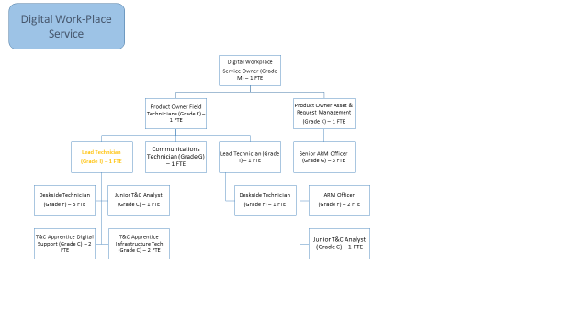
Job Description
Job purpose | ‘To act as a technical expert for both 1st (Service Desk) and 2nd line (Field Technicians) teams’
Operational management | - Act as the point of escalation for all technical matters from all members of the Service Desk and Deskside Technicians.  - Resolve incidents without the need to escalate beyond the team.  - Work with the Communications Technician to broaden expertise in communication technologies such as smartphones, Wi-Fi and other network technologies  - Mentoring and proactive training of all staff in related technology matters  - Identify gaps in the knowledge base and liaise with other technical teams to address the gaps, creating knowledge base entries as appropriate.  - Provide feedback and suggestions to the product owners and specialists to improve the stability, performance and functionality of the ICT equipment and software used in the estate.  - Provide customer feedback and suggestions for improvement to relevant teams and senior management  - To be the technical liaison between the Field Technicians and other T&C support teams.  - Using advanced problem solving techniques or through research, resolve complex incident and service requests, ensuring all work is recorded correctly and follows the relevant process and procedures.  - Follow FOI and Data protection policies.  - Research and develop technical solutions either through attending training courses, via seminar / webinars, self-development or working with service users.  - Support ITIL, ISO27001 and ISO20000 accreditation and other relevant accreditations.  - Maintain and adhere to the configuration management database and configuration management processes and procedures.  - Create and maintain relevant documentation for work undertaken.  - Operate at the effective SFIA levels for –  - Incident Management – Level 4  - Request Fulfilment – Level 3  - Problem Management – Level 3
Communications | - Relevant to allocated task and projects, act as subject experts in technical meetings, which may include delivering presentations or live demonstration to new technologies, to both colleagues and Senior Managers / Directors or other stakeholders within NYCC.  - Demonstrate functionality of supported devices and software to service users both individually and at team meetings.  - Keep all internal and external stakeholders updated and informed in a timely manner.  - Liaise with external suppliers to resolve incidents where their applications fail to work with NYCC desktop and mobile infrastructure
Partnership / corporate working | - Promote the use of Technology and Change throughout NYCC by attending user workshops advising on the best use of existing technology.  - Provide support, advice and guidance to County Councillors.  - Create and deliver technical training sessions for Deskside Technicians support staff for existing or newly implemented systems.  - Work with other T&C teams to complete service requests as required.  - Promote the use of T&C Services throughout the business.  - Provide technical advice and guidance for Business partners, Project Managers or other internal stakeholders.
Systems and information | - Responsible for ensuring Service Management system is updated in relation to the Deskside Technicians incidents and requests.  - To deliver the service within agreed service level targets for request fulfilment and incident resolution.  - Operating to agreed best practices, processes and procedures.  - Ensure all processes and standard operating procedures are documented, available and kept up to date.

Person Specification
Essential upon appointment | Desirable on appointment
Knowledge  - An excellent understanding of current and emerging end user technologies.  - A good understanding of IT industry best practises and procedures  - In-depth knowledge of Windows operating systems.  - Good working knowledge of current software packages – Microsoft Office etc.  - Broad technical knowledge of current end user technologies including but limited to pc’s/laptops/thin-clients/smartphones, peripherals and their architecture.  - Basic knowledge of communication technologies related to end user devices.  - A working knowledge of application packaging techniques, patch management techniques, deployment tools and configuration management. | - Knowledge of ISO27001 and ISO20000
Experience  - Experience of ICT incident and request resolution.  - Experience of maintaining desktop and mobile end user devices in an enterprise environment.  - Experience of application packaging.  - Experience of using a Configuration Management system.  - Experience of using a Security Management suite. | - Experience of change and problem management systems.  - Experience of working within desktop virtualisation solution.
Occupational Skills
- Excellent Analytical and Problem solving skills.
- Good communications skills both oral and written
- Good organisational and administrative skills
- Ability to prioritise workloads and delegate effectively
- Good interpersonal skills
Professional Qualifications/Training/Registrations required by law, and/or essential for the performance of the role  - A level 4 qualification, equivalent technical qualification or demonstrable relevant experience in a managed enterprise IT environment | - Technical training qualification – MCP, CNA or manufacturers accreditation  - Latest ITIL Foundation Certificate in IT Service Management
Other Requirements
- Ability to travel across the County
- Ability to respond to incidents outside of normal business hours

Behaviours | Link
NB – Assessment criteria for recruitment will be notified separately.
Optional - Statement for recruitment purposes: You should use this information to make the best of your application by identifying some specific pieces of work you may have undertaken in any of these areas. You will be tested in some or all of the skill specific areas over the course of the selection process.

