Service and job specific context statement
Directorate: | Central Services
Service: | Technology and Change
Post title: | Project Manager Level 2
Grade: | M
Responsible to: | Senior Project Manager
Staff managed: | Manage staff on a project/matrix basis (not direct line management)
Date of issue: | July 2014
Job family: | P&T - Professional & Technical
Job context
The council is embarking on a series of change programmes and projects required to move to new ways of working within increasingly challenging budget constraints.
This will include changes to organisational structures, business processes, technology, culture and ways of working and will impact on services across the council and partner organisations, large numbers of staff and have significant budget implications. Programmes will also involve working with partners, including district councils to look at delivering back office and frontline services in different ways
The post holder will manage the delivery of key projects which will require strong clear leadership and an ability to resolve challenging issues working with a wide range of stakeholders.
The post will be based at County Hall, Northallerton.
Structure
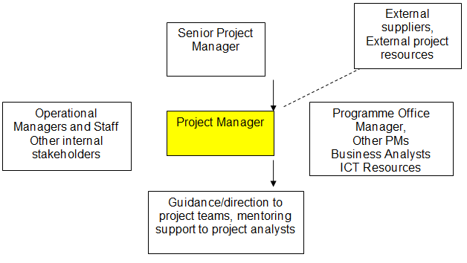

Job Description
Job purpose | The core focus of this job is to lead on the planning and implementation of designated projects and ensure they are delivered on time and within budget. In particular, this will involve close and ongoing liaison with the project sponsor, the project board and senior service area managers to design the business case and plan the various delivery stages of strategically important Council projects.  Lead a dedicated project team through the delivery stages of agreed projects. In particular, this will involve planning, setting up and monitoring of work-streams; planning work-stream and project implementation schedules; allocating roles and responsibilities; managing operational activity on a daily basis, using the council’s established project management methodology.
Operational management | - Be responsible for the overall direction, co-ordination, implementation, execution, control and completion of agreed projects ensuring strategic alignment with corporate priorities and standards.  - Be responsible and accountable for ensuring that the project overall, and all work-streams within it are delivered to requisite Council standards.  - Assume the role of Quality Manager throughout the lifecycle of the project and lead on the project review/lessons learnt process at the end of the project.  - Lead in compiling regular progress reports and identifying and managing project risks/issues.  - Collaborate with stakeholders to develop solutions in response to issues/risks and to manage and control project changes in line with established protocols.
Communications | - Successfully build strong working relationships at a strategic level to inspire confidence and support, demonstrating political awareness and sensitivity to the needs of key stakeholders.  - Manage conflict situations effectively and pro-actively seek to be creative in developing solutions in order to deliver win-win.  - Build strong working relationships with principal stakeholders such as service area managers, and lead in promoting the work of the project across the organisation.
Partnership / corporate working | - Ensure that implementation activities are aligned, where appropriate, with other changes taking place corporately and across Directorates  - Where required, work with partners in other organisations to deliver projects  - Work with colleagues in HR, ICT, Finance, Communications, Legal Services and other functions where required
Resource management | - Lead and manage the dedicated project management team on a daily basis, be responsible for managing allocated resources and ensuring project delivery.  - Ensure project budgets stay within agreed tolerances and any deviations are managed according to agreed procedures.  - Motivate, develop and empower staff to optimise their skills and output and to promote effective working relationships to ensure that project objectives and targets are appropriately met.
Systems and information | - Work with ICT colleagues to ensure that any system IT requirements to support business change are understood an progressed  - Use appropriate ICT tools to support the management and delivery of projects including Microsoft Office, Microsoft Project, Visio, Sharepoint and other specialist tools such as Project Vision
Strategic management | - Work with the Project Sponsor to set the vision and strategic direction for the project.  - Understand and appreciate the complexity of the working environment and ensure that solutions are practical, workable and conducive to the context.  - Constructively challenge existing perspectives/working practices at a strategic level and be capable of building a robust, evidence-based case for change.  - Pro-actively facilitate agreement and approval of project scope, goals, deliverables and benefits realisation plans; to define project tasks and resource requirements.

Person Specification
Essential upon appointment | Desirable on appointment
Knowledge  - Knowledge of both theoretical and practical aspects of project management  - Knowledge of project management techniques and tools  - Knowledge and understanding of the principles underpinning quality management  - Knowledge of appropriate project management tools including Microsoft Project  - Knowledge and understanding of an area of expertise relevant to the specific context of the role | - Awareness of ITIL based change control processes and methodology
Experience  - Significant experience of planning and delivering large projects with a range of stakeholders  - Significant experience of managing change resulting in measurable service improvements  - Demonstrable track record of leading, managing and inspiring project teams delivering high levels of performance | - Experience of financial management, budget control and monitoring
Occupational Skills
- Leadership and management skills.
- Good political awareness and ability to demonstrate sensitivity to different needs of key Council stakeholders.
- Flexible approach with the ability to respond effectively to changing circumstances, without losing focus or direction
- Ability to demonstrate critical awareness, analytical and problem solving skills.
- Ability to manage own workload and prioritize effectively.
- Project working skills – Oversees the delivery of strategic projects, reviewing and making amendments as necessary.
- Persuading, influencing and negotiating skills – Uses a range of techniques to successfully persuade, influence and/or negotiate with others in a range of situations
- Problem solving skills – takes responsibility for and produces a range of solutions to problems
- Analytical skills – Analyses information from a range of sources, probing for further information or a greater understanding when necessary
- Written communication skills – Presents/records difficult information in an accessible format suitable for a varied audience, reviews and measures the effectiveness of existing communications
- Financial, budget management skills – Coordinates, monitors and reviews the use of financial resources
- ICT Skills – Good level of ICT skills across a range of office packages
Professional Qualifications/Training/Registrations required by law, and/or essential for the performance of the role
- Project management qualification (PRINCE2, APM or similar) or significant experience of using structured project management methodologies
Other Requirements
- Ability to travel for work purposes.
Behaviours | Link
NB – Assessment criteria for recruitment will be notified separately.
Optional - Statement for recruitment purposes: You should use this information to make the best of your application by identifying some specific pieces of work you may have undertaken in any of these areas. You will be tested in some or all of the skill specific areas over the course of the selection process.

