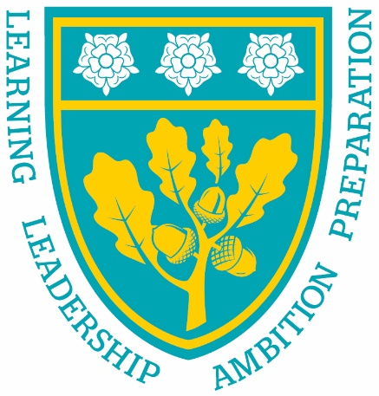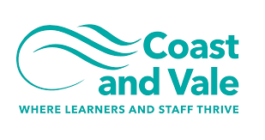

Being the best we can be

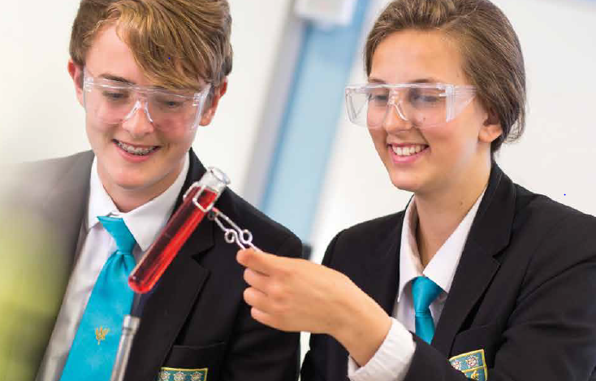

Teacher of French
Closing Date Monday 18th July 2022, 9am
Recruitment Information Pack
Scalby School
Fieldstead Crescent, Scarborough, YO12 6TH

Contents

Welcome from the Headteacher 3
Our results 4
Our schools 5-6
Application process and how to apply 7
Job Description/Person Specification 8-10

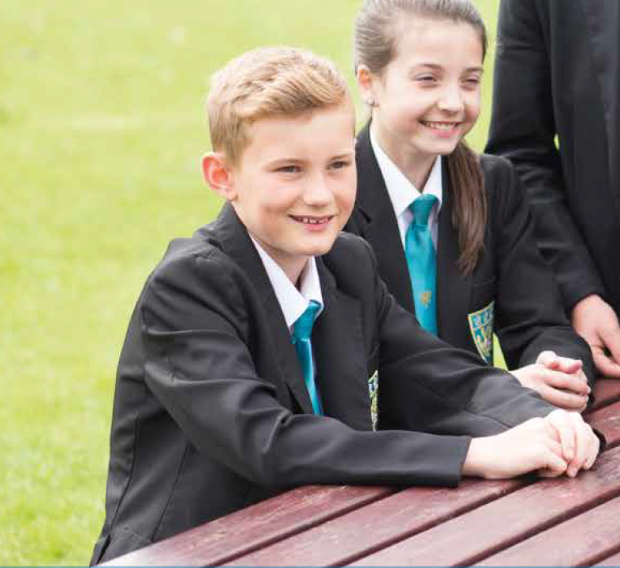

Dear applicant,

Allow me to extend a warm welcome from all governors, staff and students of Scalby School.

I was delighted to be appointed Head of School and while any Head will say their school is special – I truly believe Scalby is.

It is hard to encapsulate in words the full dynamism and vibrancy of our school. We are hugely proud of our students and privileged to serve them and this community. We see it as our professional and moral duty to prepare them as individuals to play their part as 21st century citizens – rounded and centred and aware of all they might contribute to the world. In practical terms, this commitment is manifested in the lessons we deliver, the extra-curricular opportunities we offer and in the wider opportunities we promote.
Scalby is a school with a strong academic tradition but we are equally committed to the Arts, to sport and to collective and individual achievement beyond the classroom. Our annual productions held at the Stephen Joseph theatre are testament to this, and over the years we have seen productions of Macbeth, Romeo and Juliet, Our House to name but a few.
We have developed and benefited from our partnerships within Coast and Vale Learning Trust, Scarborough Teaching Alliance and local secondary and primaries – a few reasons to join us!

In recent years enormous strides have been made to further increase learning standards. This hard work has seen results improve consistently and led to Ofsted rating our school as ‘Good’ in 2012 and in 2019. I truly believe we are a school with highly effective teachers and support staff producing outstanding outcomes for our students.

I hope you can see that this is an excellent time to join Scalby. If successful you will join a staff team of wonderful professionals who have ambition for our students and for themselves. I take pride in ensuring colleagues receive opportunities to develop their skills and experiences – and we have an enviable reputation for delivering high quality professional development.

I hope that you will take the time to come and see and experience for yourself the warm and welcoming atmosphere which makes our vision a reality.

Good luck with your application.

Chris Robertson
Head of School

Our results
Scalby School’s last set of externally examined GCSE results in 2019 were characterised by high levels of achievement. We have worked hard during COVID to ensure students have also achieved in line with these results in 2020 and 2021 when TAGs were awarded.

Our students consistently make significantly better progress than their peers did nationally. Results in English, Maths and Science are above the national averages at Grade 4 and Grade 5, with 36% of students achieving a Grade 7 or better in English, 28% achieving Grade 7 or better in Maths and 21% achieving Grade 7 or better in two sciences.

Recent results are particularly pleasing because of the high number of students who achieved Grade 8 and 9 across a number of subjects.

None of these fantastic results would have been possible were it not for the professionalism and dedication of our teachers and learning support teams. These results mean that our students leave us now being able to access a wide range of post-16 courses at college and they have the skills and knowledge valued by employers.”

Our success in our GCSE results follows our positive Ofsted inspection in February 2019. We are delighted that the high quality of education on offer has been doubly validated at a national level.

Our schools

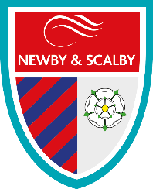
Newby and Scalby Primary School

We are one of the schools of choice in our community and we are within commutable distance of Whitby, Teesside, York and surrounding areas. Ofsted in 2018 judged us to be ‘good’ in all areas and as a school we are very much outward facing both in terms of teaching and learning and in constantly thinking about how we can improve.
Since our “good” Ofsted, we continue to build on our successes and we are a family and a team, where everyone is given the challenge and support to be the best they can possible be in a safe, welcoming and positive environment. Children and staff will work and play together developing skills so that we all become ambitious and reflective lifelong learners as well as being respectful and respected members of the community.
To learn more about us please visit us at:
Newby and Scalby Primary School - Home (coastandvale.academy)

Friarage Primary School
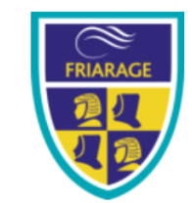
We are proud to serve the communities around the Castle Ward area of Scarborough as ‘Together we can’ make a real difference to the life chances of children and young people in Scarborough.

Children and staff will work and play together developing skills so that we all become ambitious and reflective lifelong learners as well as being respectful and respected members of the community.
We are committed to Restorative Practice Principles to nurture respect for all in our school community.

To learn more about us please visit us at: Friarage Community Primary School - Home (coastandvale.academy)

Scalby School
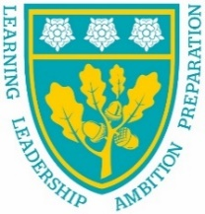
Scalby School is a successful and popular 11-16 community school and in recent years we have become the school of choice in our local community. We were judged ‘good’ by Ofsted in 2019 and in 2019 we celebrated sustained results. Our P8 score placed us in the top 20% of schools nationally. We are proud of our broad and balanced GCSE based curriculum.
To learn more about us please visit us at: Scalby School - Home (coastandvale.academy)

Lady Lumley’s School
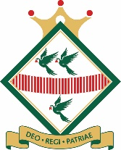
Lady Lumley’s School (11-18) in Pickering is on a transformational journey. We are a school that is popular with parents and is easily accessible across North Yorkshire, East Riding and Wolds and Vale. The communities we serve around the Pickering, Ryedale and wider Coastal area deserve and need our school to play a leading role in terms of teaching, learning, progress and outcomes.

In April 2020 we welcomed our new Headteacher Clair Foden who joined us at the same time we joined our Trust - Coast and Vale Learning Trust. Lady Lumley’s is on an ambitious journey of school improvement.

To learn more about us please visit us at Lady Lumley's School - Home (coastandvale.academy)

Scarborough University Technical College

Scarborough UTC is a growing University Technical College (year 9 to year 13) based in a new building, with fantastic technical facilities in the centre of Scarborough. As a University Technical College, we offer a high quality academic and technical education for our students through the specialisms of engineering, health and cyber security. Our unique approach provides students with an excellent range of opportunities including Combined Cadet Force (CCF Navy), strong links to our industrial partners, project-based learning and our flagship Career Development Programme for our Sixth Form students.

Our work with employers and universities ensure we are able to deliver an innovative blend of technical, practical and academic learning which ensures our students make good progress and go on to outstanding destinations.

Our staff are our greatest resource and we have invested in both our teaching and support staff teams which has ensured that educational standards have improved significantly. We have built a staff team of key support and teaching practitioners who are proud to work at our University Technical College.

To learn more about us please visit us at: https://www.scarboroughutc.co.uk

Application Process
The closing date for all applications is Monday 18th July 2022, 9am.

Interviews will be held as soon as possible after the closing date

Completed applications must be returned to Helen Poole at Helen.Poole@northyorks.gov.uk

If you think you’re the person for the job, please complete the enclosed application form and send to the email address above by the closing date.

An email will be sent to shortlisted candidates with details of the interview process. If you have not heard from us within a week of the closing date please assume your application has been unsuccessful.

Queries
Please contact Helen Poole at Helen.Poole@northyorks.gov.uk
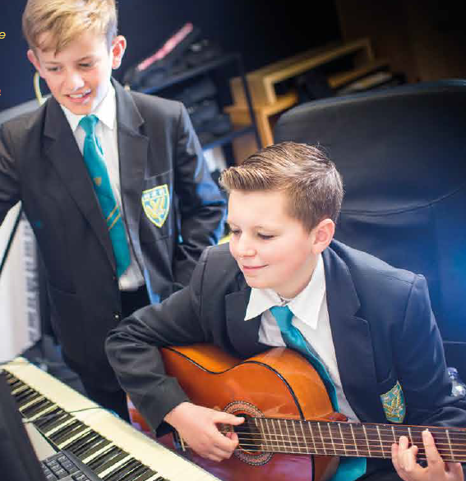

Job Description

JOB TITLE: Teacher of French

RESPONSIBLE TO: Head of French

RESPONSIBLE FOR: Deployment of support staff allocated (where relevant)

JOB PURPOSE: Promote effective learning, appropriate student achievement and educational, social and personal progress of all pupils for whom the teacher is designated as being responsible, consistent with the aims of the school and the unique needs of each individual.
KEY RESPONSIBILITIES:

1. Develop and maintain an up-to-date knowledge and understanding of the areas of teaching and student support for which post-holder is responsible

2. Plan work to meet the learning needs of allocated pupils in a consistent and effective way

3. Use appropriate teaching and classroom management strategies to motivate pupils and enable each to progress appropriately

4. Monitor the progress of students for whom the postholder is responsible to set expectations and give constructive feedback

5. Maintain appropriate records to demonstrate progress made by students

- Participate fully in professional development activities to develop practice further, sharing the learning from these as appropriate

- Make an active contribution to the policies and aspirations of the school

8. Safeguarding and Promoting the Welfare of Students

Working with the Designated Child Protection Person the post holder will:

- Identify and record any child protection concerns
- Contribute information as required for Common Assessment or Multi-Agency meetings
- Act at all times in line with the school’s Child Protection procedures.

9. To Comply with the School Policy on Health and Safety

10. To fulfil all of the responsibilities and duties required by the school’s policies
on Teaching and Learning.

11. To achieve any performance criteria or targets arising from the School’s
Performance Management arrangements

12. To fulfil all of the requirements and duties set out in the current Pay and Conditions Documents relating to the conditions of employment of teachers

Person Specification

CRITERIA | ESSENTIAL | DESIRABLE | ASSESSMENT
Qualifications | - Qualified Teacher Status  - Degree | - National Governing Body Awards  - 2:1 Degree
Experience | - Experience of Key Stage 3/4 French  - Experience of planning and delivering curriculum at relevant KS and/or subject(s) | - Experience of teaching in more than one school | - Application form  - Interview
Knowledge | - A thorough knowledge and understanding of all relevant aspects of the National Curriculum in relation to the post | - Willingness to engage in CPD activities in relation to learning and teaching | - Application form
Personal Qualities | - Ability to relate to and build relationships with pupils, parents and other members of the school community  - Enthusiasm and commitment to the aims and objectives of the school  - Good communication skills  - Take a full and active role in the extra curricular programme | - Willingness to participate fully in school life | - Interview  - Application form  - Reference

