Service and job specific context statement
Directorate: | Business and Environmental Services
Service: | Waste and Countryside Services
Post title: | Public Rights of Way Field Officer
Grade: | G
Responsible to: | Principal Public Rights of Way Officer
Staff managed: | None
Date of issue: | January 2015
Job family: | P&T - Professional & Technical
Job context
The role is based in the Public Rights of Way team. The PROW team and the Definitive Map Team make up the Countryside Access unit, which is part of Waste and Countryside Services.
The key activity for the PROW team is to discharge the County Council’s statutory duty to maintain the county’s network of public rights of way. Working with colleagues, partners, landowners and volunteers the role will contribute to the delivery of high quality access to the countryside.
The postholder will work across a large area ‘patch’. The role will entail significant travel across the county and outdoor working. Will be required to operate a company vehicle.
Structure
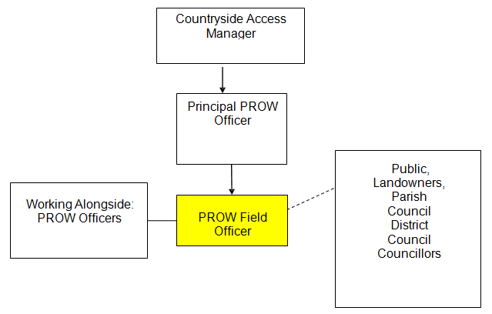

Job Description
Job purpose | The core focus of this job is to lead on inspecting and monitoring the condition of the PROW network, to identify maintenance requirements and enhancement opportunities, to provide initial service contact for landowners and complainants, and to monitor and supervise contractors and volunteers in their work on the network. The post holder will be the eyes and ears of the service on the ground.
Operational management | - Monitor the condition of public rights of way through regular inspections as appropriate, ensuring required data is recorded on the Public Rights of Way management information system.  - Identify basic maintenance and cyclic maintenance requirements, including the preparation of works instructions.  - Monitor and supervise contractor work programmes. Issue instructions to contractors as appropriate.  - Respond to and investigate complaints and/or reported defects relating to the condition of the public rights of way network to identify the necessary response and priority of any works having regard to standard working procedures.  - Carry out simple or temporary practical repairs on public rights of way e.g. repair/ replacement of stiles, cutting back of overgrowth and repairs to surface defects only where these are of an urgent nature in order to ensure public safety.
Communications | - Respond to requests for information on public rights of way including Planning Applications.  - Prevent obstruction through provision of advice for landowners/occupiers.  - Deal directly with members of the public, landowners, parish councils and other organisations on public rights of way matters.
Partnership / corporate working | - Engage with volunteer groups working on the network. Monitor, supervise and support them in delivering network maintenance and improvement.  - Assist colleagues within the Countryside service in the implementation of practical tasks to manage conservation sites.  - Work across all County Council teams to ensure coordinated and efficient service delivery.  - Liaise with Highways North Yorkshire in maintaining urban paths and Unsurfaced Unclassified Roads.
Resource management | - Monitor and supervise contractor work programmes. Issue instructions to contractors as appropriate.  - Engage with volunteer groups working on the network.  - Monitor, supervise and support them in delivering network maintenance and improvement.  - Monitor maintenance and materials contracts, to ensure efficient working.  - Quantify, manage and maintain materials, equipment, tools, machinery, and other resources.
Systems and information | - Prepare maps as required.  - Update and maintain rights of way databases and other records.

Person Specification
Essential upon appointment | Desirable on appointment
Knowledge  - Knowledge of reading and interpreting maps.  - Good basic knowledge of Countryside Access, Highways & Public Rights of Way legislation.  - Knowledge of basic horticultural/fencing tools and machinery.  - Knowledge of health & safety relevant to undertaking countryside tasks. | - In- depth knowledge of Countryside Access, Highways & Public Rights of Way legislation.  - Knowledge gained through Management qualification at HNC or higher, or relevant experience.
Experience  - Can demonstrate significant experience in dealing with enquiries from the general public.  - Can demonstrate experience of carrying out practical horticultural and fencing tasks.  - Can demonstrate experience of being able to lead and manage a team of volunteers and identify and delegate work to volunteers and contractors.  - Can demonstrate experience of managing a large and complex caseload. | - Can demonstrate practical experience of habitat management for conservation.
Occupational Skills  - Analyses information in a logical and systematic way.  - Makes decisions within own area of responsibility.  - Monitoring financial information.  - Monitoring and maintaining health and safety of self and others.  - Uses a range of techniques to successfully persuade, influence and/or negotiate with others in a range of situations.  - Takes responsibility for and produces a range of solutions to problems.  - Identifies possible causes of problems and implements solutions to minimise future occurrence.  - Assists with the organisation, planning and delivery of projects.  - Acts calmly during difficult circumstances and recovers quickly from setbacks.  - Communicates effectively in writing to produce documents in a range of formats and styles to suit a range of audiences.  - Intermediate ICT skills covering Microsoft Office and GIS.  - Literacy and numeracy skills at Level 2. | - Intermediate ICT skills covering map info and Public Rights of Way management systems
Other Requirements
- Current driving licence.
- Flexible attitude to working hours.
Behaviours | Link
NB – Assessment criteria for recruitment will be notified separately.
Optional - Statement for recruitment purposes: You should use this information to make the best of your application by identifying some specific pieces of work you may have undertaken in any of these areas. You will be tested in some or all of the skill specific areas over the course of the selection process.

