Service and job specific context statement
Directorate: | Business and Environmental Services
Service: | Highways and Transportation
Post title: | Cycle Trainer
Grade: | C
Responsible to: | Road Safety & Travel Awareness Officer
Staff managed: | None
Date of issue: | August 2013
Job family: | E - Education/School
Job context
The Road Safety and Travel Awareness Team provide and implement road user education, training and publicity to reduce casualties and to increase safe and sustainable travel.
The purpose of this role is to deliver Bikeability road user cycle training to school students.
The post holder will be required to liaise with school staff and colleagues to deliver two day courses within schools.
The work is mainly conducted outside in all weathers.
The post holder will need to be an active and regular on-road cyclist with experience of working with children.
The programme is government grant funded with conditions which must be achieved in order to obtain the funding for services provided.
This post has a casual relief contract.
This role involves spoken communications so a confident use of English language is required.
This post is restricted and does require DBS clearance.
Structure
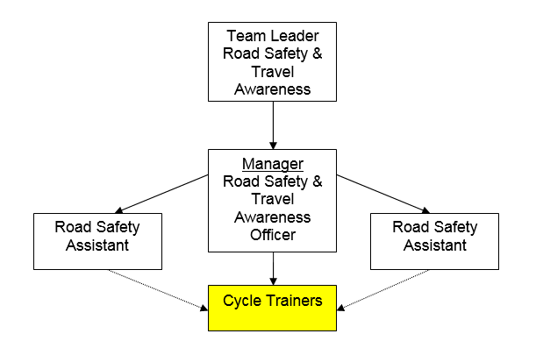
Job Description
Job purpose | To contribute to the delivery of road safety education, training and publicity.  To provide Bikeability cycle training in line with the current code of practice and instructor manual.
Operational management | - Liaise with local Road Safety Assistant and Road Safety and Travel Awareness Officer to delivery National Standard Bikeability cycle training courses.  - Instruct students to achieve National Standard Bikeability competencies.  - Conduct Risk Assessments before training sessions.  - Keep a register of attendees and check parental consent forms.  - Check that cycles are roadworthy, and helmets meet required standards and adjust helmet fit as necessary. Assess and rectify minor emergency adjustments/repairs as necessary.  - Manage on road sessions in line with the code of practice and site specific risk assessments.  - Conduct/arrange assessment of trainees and give appropriate feedback  - Manage training sessions to ensure appropriate implementation of health & safety and risk management policies and procedures  - Complete accurate written assessment reports for each student  - Keep up to date with mandatory corporate training and role specific Continuing Professional Development.
Communications | - To have good verbal communications with colleagues, school staff and the public  - Liaise with School Staff and colleagues  - Establish acceptable behaviour and maintain discipline within the group  - To promote road user training and embed cycling as a healthy and safe form of transport
Partnership / corporate working | - To work with colleagues to help provide a strong customer-focussed service
Strategic management | - Working within agreed objectives to achieve the defined outcomes

Person Specification
Essential upon appointment | Desirable on appointment
Knowledge  - Understanding of simple administrative tasks and report writing  - Understanding of the principles of safer cycling on the public highway | - Health & Safety  - Bicycle maintenance checks  - Conducting risk assessments
Experience  - Road user as a cyclist  - Regular and enthusiastic cyclist  - Working with children/young people | - Teaching/coaching cycling skills
Occupational Skills  - Good communication & interpersonal skills, both written and oral  - The ability to converse at ease with customers and provide advice in accurate spoken English is essential for the post.  - Willingness and ability to work as part of a team  - Willingness to undertake further training | - Providing instruction and demonstrations to groups of children
Professional Qualifications/Training/Registrations required by law, and/or essential for the performance of the role  - E.g. A professional… qualification e.g. …or equivalent (or demonstrable equivalent experience).  - Qualifications/training listed must be considered against statutory, mandatory or essential requirements for the job. | - National Cycle Training Standards Accreditation  - First aid qualification/experience
Other Requirements  - Ability to ride a bicycle confidently and competently on road.  - Ability to travel across the County using sustainable modes of travel where appropriate | - Current driving licence
Behaviours | Link
NB – Assessment criteria for recruitment will be notified separately.
Optional - Statement for recruitment purposes: You should use this information to make the best of your application by identifying some specific pieces of work you may have undertaken in any of these areas. You will be tested in some or all of the skill specific areas over the course of the selection process.

