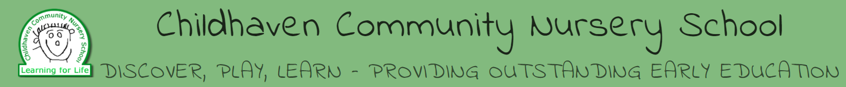
Childhaven Community Nursery School
General Teaching Assistant / General Teaching Assistant SEND
30 hours per week (11:15am – 5:45pm), term time only
Grade C (GTA, points 2 – 4) Monday to Friday
‘Everyone involved shares a strong vision for the school and believes passionately in the same values. Excellent teamwork is a key characteristic of this school’ Ofsted 2015
The Governors of Childhaven Nursery School are looking to appoint an additional member of staff.
Here at Childhaven Community Nursery School we provide a vibrant, welcoming and inspirational setting and serve the communities around the Scarborough Town. We are one of only 3 maintained nursery schools in North Yorkshire and we offer children a unique start to their education. Children aged between 2 and 4 play and learn together in our wonderful Victorian building and garden.
Our learning environment and education provision that is offered to our 75 children on roll is second to none and our teaching assistants play an important part in school life. Our team ethos helps make our school welcoming, calm and purposeful.
We are looking to appoint a motivated Teaching Assistant to join our school. You will work with individual and groups of children as part of our staff team.
As a lead school within the Scarborough Teaching Alliance we share best practice and are committed to training the next generation of teachers and support staff.
We encourage interest and applications from candidates who are interested in and would thrive in working within nursery education which offers reward, challenge and where no two days are the same.
The successful candidates must hold English and Maths GCSE level ‘C’ or above or equivalent. A minimum relevant Early Years Level 2 qualification is essential. A strong desire to nurture and support young children is essential and experience in supporting children with special educational needs would be advantageous. Training will also be provided as part of the role.

You will:
- Ideally have previous experience in this type of role or with children and young people
- Be able to support in the delivery of high quality learning experiences for all children, including those with SEND
- Have high expectations of learning and behaviour and inspire and motivate our children
- Be supportive, nurturing and understanding with high expectations.
- Seek to make learning exciting and a positive experience
- Work well as part of a team
- Demonstrate good communication skills both orally and written

We can offer you:
- A warm, happy school where we value everyone and have a philosophy of kindness and support for each other. Our approach is not always conventional but has the impact our children need- and deserve
- Happy, enthusiastic and well behaved children
- A school with exciting and attractive learning environments
- A leadership team who welcome fresh ideas, traditional values and a sense of teamwork
The date of commencement for this post is to start as soon as possible.
Closing date: Monday 6th December 2021 at 9am
Interviews will be held in the week beginning
We reserve the right to close this vacancy early should we receive an overwhelming response. All candidates are advised to refer to the job description and person specification before making an application.
For an informal conversation about the role, to arrange a visit and for an application pack please contact Garry Morrison at Resourcing Solutions (North Yorkshire County Council) at garry.morrison@northyorks.gov.uk or call 07814935700
Our school is committed to safeguarding children; this post will require an enhanced DBS check and suitable references. Your motivation and suitability to work with children will be assessed at interview.

