Service and job specific context statement
Directorate: | Business and Environmental Services
Service: | Highways and Transportation
Post title: | Transport and Development Engineer
Grade: | H I and K
Responsible to: | Team Leader Transport and Development
Staff managed: | None
Date of issue: | March 2022
Job family: | P&T - Professional & Technical
Job context
The Transport and Development Team sits within the Network Strategy section of the Highways and Transportation service. The Teams core functions are :
- Delivering the County Council’s Highways Development Management service
- Responding to significant and strategic planning application on behalf of the County council as local highway authority
- Providing strategic guidance to colleagues in other teams dealing with non-strategic planning applications on behalf of the County Council as local highway authority
- Managing developer funded amendments and additions to the highway network mainly through Section 278 Agreements and Section 38 Agreements on behalf of the County Council. Inputting to the CIL process on behalf of the County Council as Local Highway Authority
- Overseeing the Advance Payments Code procedure within North Yorkshire.
The post will be based at County Hall in Northallerton.
Some out of normal office hours may be necessary from time to time (e.g. Parish Council meetings).
Career progression
Entry level (Grade H)
The post holder will have successfully completed the Civil Engineering ONC and will then be enrolled on the HND/C in Civil Engineering
OR,
Will have achieved a degree in another relevant subject.
Mid level (Grade I)
To enable progression to Grade I the post holder will have successfully completed the Civil Engineering NC and the first year of the HND/C qualification (and will be continuing into year 2 of the qualification).
The post holder will be assessed by the Team Leader: Transport and Development to ensure they are undertaking the Grade H Job Description tasks fully, meeting the Person Specification criteria and have the required technical experience prior to progressing to Grade I.
OR,
Will have achieved a degree in another relevant subject and will be assessed by the Team Leader following a suitable time in post to ensure they are undertaking the Grade H Job Description tasks fully, meeting the Person Specification criteria and have the required technical experience prior to progressing to Grade I or be able to demonstrate previous work experience which demonstrates a similar level of capability.
Top level (Grade K)
To enable progression to Grade K the post holder will have successfully completed the Civil Engineering NC and HND/C qualification.
The post holder will be assessed by the Team Leader Transport and Development to ensure they are undertaking the Grade I Job Description tasks fully, meeting the Person Specification criteria and have the required technical experience prior to progressing to Grade K.
OR
Will hold a degree in another relevant subject and will be assessed by the Team Leader Transport and Development to ensure they are undertaking the Grade I Job Description tasks fully, meeting the Person Specification criteria and have the required technical experience prior to progressing to Grade K or will successfully demonstrate previous work experience which demonstrates a similar level of capability.
OR
Will have significant relevant experience in a related discipline, and will have achieved IEng status or will do so within 2 years of taking post.
Structure
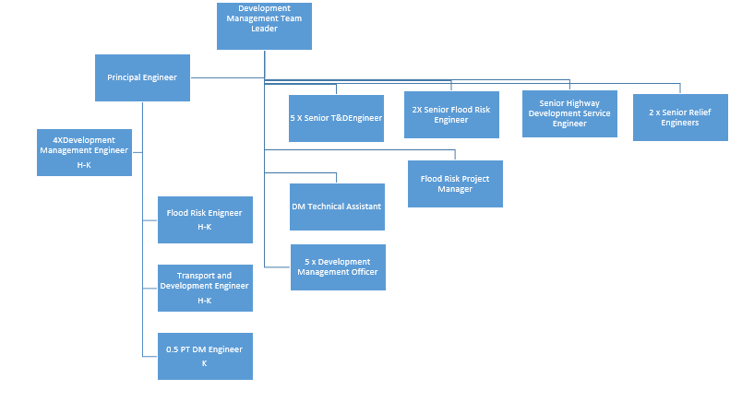
Job Description
Job purpose | Providing professional advice on development and transportation issues. Delivering the highways development management service.
Operational management | Entry Level:  - Assessing the transport impact of developments.  - Assessment of highway and transport schemes and other schemes in support of the LTP.  - Assisting in implementing the procedures in relation to Advanced Payment Codes and Private Streetworks.  - Preparing, implementing and monitoring of Agreements to control development.  - Assisting with Transport & Development input to the Streetworks Register.  - Ensuring their work complies with the Local Transport Plan and supplementary documents.
Mid Level all the above plus:
- Dealing with and directing consultants in the development and assessment of major highway and transport schemes and other schemes in support of the LTP.
- Advising on the highways and transportation aspects of major schemes.
- Implementing the procedures in relation to Advanced Payment Codes and Private Streetworks.
- Managing a specific portfolio of Agreements to control development.
Top Level all the above plus:
- Arranging non-standard Agreements to control development.
- Actively promoting and developing the service’s contribution to corporate priorities.
- Providing support and advice to Area staff on highways development management
Communications | Entry Level:  - Assessing highway aspects of planning applications and recommending a response to the local Planning Authority.  - Assisting with consultations on plans and initiatives.  - Assisting with the preparation of Committee reports.  - Responding independently to general correspondence.
Mid and Top Levels all the above plus:
- Assessing highway aspects of major planning applications and recommending a response to the local Planning Authority.
- Managing consultation on plans and initiatives.
- Preparing Committee reports.
Partnership / corporate working | Entry Level:  - Assessing development proposals including negotiating to secure developer's improvements to the highway network resulting in Agreements and Contracts for carrying out the works.  - Assisting in the provision of professional advice on matters relating to development and transportation.  - Liaising with Area Managers, other sections of the Directorate, other County Council Directorates, the Highways Agency and Planning Authorities on development and transportation matters.  - Assisting in the preparation of Local Planning Authority's LDFs.  - Liaising with representatives from the Local Area Office relating to the delivery of schemes in the Integrated Transport Capital Programme.  - Liaising with contract partners, colleagues, members and other stakeholders to ensure appropriate resolutions are achieved.
Mid Level all of the above plus:
- Assessing major development proposals including negotiating with all parties to secure developer's improvements to the highway network resulting in Agreements and Contracts for carrying out the works.
- Providing professional advice and direction on matters relating to development and transportation.
- Liaising with the public on matters relating to developments and transportation.
- Assisting in the preparation of Local Planning Authority's LDFs.
Top Level all the above plus:
- Representing the County Council at public meetings, Public Consultations and meetings of Local Planning Authorities, Parish Councils and other bodies.
Resource management | Entry Level:  - Monitoring revenue from superintendence fees and developer contributions.
Mid and Top Levels all the above plus:
- Collecting and managing revenue from superintendence fees and developer contributions.
- Managing the budget of schemes specifically delegated, liaising with partners as required.
Strategic Management | Entry Level:  - Assisting in the development and implementation of the County Council strategies in support of the Local Transport Plan on matters relating to development issues.  - Ensuring that the highway and transportation aspects of developments contribute to Local Transport Plan objectives and targets.
Mid Level all of the above plus:
- Assisting in the development of policies and protocols to guide development.
- Managing the delivery of new transport infrastructure to deliver development plan land allocations.
Top Level all the above plus:
- Ensuring that the highway and transportation aspects of major developments contribute to Local Transport Plan objectives and targets.
- Managing the delivery of major new transport infrastructure to deliver development plan land allocations.

Person Specification
Essential upon appointment | Desirable on appointment
Knowledge
Entry Level:  - Working knowledge of current Legislation and Guidance relating to the control of developments.  - Working knowledge of the current development plans procedures.  - Working knowledge of design and delivery highway improvement schemes | - Knowledge of committee procedures  - Awareness of local government administrative and financial procedures.
Mid level: - as above plus:
- Detailed knowledge of current Legislation and Guidance relating to the control of development
- Detailed knowledge of the current development plans procedures.
- Detailed knowledge of design and delivery highway improvement schemes
- Awareness of local government administrative and financial procedures.
Top Level: - as above plus:
- In depth knowledge of current Legislation and Guidance relating to the control of development
- In depth knowledge of the current development plans procedures.
- In depth knowledge of design and delivery highway improvement schemes
- An understanding of local government administrative and financial procedures.
Experience
Entry Level:
- Use of AutoCAD (Computer aided design).
- Experience of development management matters relating to transport.
- Experience of the development plan processes.
Mid level: - as above plus:  - Recent experience of using AutoCAD (Computer aided design).  - Demonstrable recent proven and effective experience of development management matters relating to transport.  - Recent experience of the development plan processes. | - Experience of delivery of highway improvement schemes and transport infrastructure.  - Experience of delivering civil engineering projects.
Top Level: - as above plus:  - Substantial recent proven and effective experience of development management matters relating to transport.  - Substantial recent experience of the development plan processes. | - Experience in attending Public Meetings
Occupational Skills – All levels
- Excellent oral and written communication skills.
- Customer care skills.
- Problem solving and the ability to find practical solutions.
- Analytical skills.
- Excellent organisational skills.
- ICT skills including the use of a number of different software packages, including Microsoft Office.
- Ability to work as a member of a technical team.
Professional Qualifications/Training/Registrations required by law, and/or essential for the performance of the role
Entry Level:
- ONC in Civil Engineering or equivalent relevant qualification/demonstrable proven experience which will be tested through the recruitment process or,
- Undertaking year 1 of HND/C in Civil Engineering or equivalent or
- Degree in other relevant discipline
Mid level: - as above plus:
- Undertaking year 2 of HND/C in Civil Engineering or equivalent relevant qualification/demonstrable proven experience which will be tested through the recruitment process or,
- Degree in other relevant discipline
Top Level: - as above plus:  - HND/C in Civil Engineering or equivalent relevant qualification/demonstrable proven experience which will be tested through the recruitment process and IEng status or,  - Degree in other relevant discipline or,  - Relevant significant transferable experience and IEng Status or will achieve this status within 2 years of taking post. | - Associate Membership (IEng) of relevant Institution.
Other Requirements
- Motivated and reliable.
- Ability to travel for work purposes including to remote sites
- Ability to attend some public meetings outside of normal business hours
Behaviours | Link
NB – Assessment criteria for recruitment will be notified separately.

