Service and job specific context statement
Directorate: | Central Services
Service: | Support Services
Post title: | Business Support Officer Level 4
Grade: | G
Responsible to: | Business Support Team Leader
Staff managed: | None
Date of issue:
Job family: | C&A - Customer & Administration
Job context
- The post-holder will work within one of the teams in the Business Support Service, either in one of the shared service teams providing services across NYCC or in a Business Support team providing support to a specific Directorate operational function. Post-holders will be line managed by a Team Leader in the Business Support Service. In some instances they will be tasked on a day to day basis by a manager in the operational team in which they are based.
- This role involves spoken communications so a confident use of English language is required.
Structure
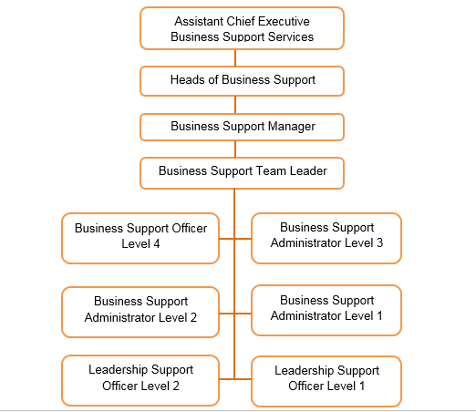
Job Description
Directorate: | Central Services
Service: | Support Services
Job purpose | The core focus of this post is to provide comprehensive administration and financial administration support to operational services or frontline services.
Operational management | - To undertake high level complex business support processes including complex or sensitive reports and correspondence, monitoring and reconciling large budgets, producing complex financial reports and statements as requested  - To be an authoritative source of advice and guidance, both for customers and colleagues on services, policies and processes including complex queries, cross referencing where relevant to service policies and procedures  - To research, create, manage and manipulate information whether relating to finance, staffing information, customers or any other service requirement or eligibility criteria,  - To produce bespoke and complex reports, presenting information in a variety of formats to contribute to key operational or strategic documents, reports or plans.  - Develop and maintain systems and processes to support the effective and efficient running of an operational service and to ensure the high quality of information held  - To manage key specific operational service databases, system and networks on behalf of professional staff and to support their functions  - To undertake a full range of financial management processes, including, resolving issues, budget monitoring, reconciling accounts, support closedown of year end accounts, assisting with financial returns and handling cash.  - Responsible for the organisation of high level/ multi-agency meetings and events.  - Undertake minute taking at high level meetings including statutory meetings and provide an accurate record.  - To contribute to, and lead where appropriate, the recruitment process, induction and training of staff.  - To support business support colleagues including demonstrating duties and day to day task supervision  - To collect and collate information to inform responses to complaints, FOI, Data Protection and Subject Access requests.
Resource management | - To open and close premises as required (not relevant to all posts  - To act as Fire Warden for the building & undertake risk assessments as appropriate.  - Carry out checks and maintain records of fire drills, fire alarm tests, emergency lighting.

Person Specification
Essential upon appointment | Desirable on appointment
Knowledge  - Knowledge of relevant NYCC policies and procedures including those relating to safeguarding, data protection and confidentiality.  - A sound knowledge of relevant business support systems and processes)  - Good literacy and numeracy skills to NVQ Level 3 or equivalent.  - Evidence of ongoing commitment to CPD | - Knowledge of working to statutory and legislative standards relevant to the position.  - Knowledge of operational issues relevant to the position.
Experience
- Experience of providing high level business support in a busy environment
- Experience of data management including manipulating large data sets and producing complex reports ensuring accuracy and where appropriate confidentiality
- Significant experience and competence using IT and common business support packages including word processing and spreadsheets
- Experience of developing admin systems to meet operational needs
- Experience of providing information to the public or customers
- The ability to converse at ease with customers and provide advice in accurate spoken English is only essential for some posts.
- Experience of monitoring budgets and providing financial data and reports
- Experience of using defined business processes and giving guidance on them to colleagues
- Experience of working to statutory and legislative standards where appropriate.
Occupational Skills  - Ability to provide authoritative advice and guidance to deal with complex queries and to induct and train staff  - Ability to co-ordinate and monitor the use of financial information.  - Ability to present/record difficult information in an accessible format suitable for a varied audience.  - Ability to set up filing systems and to store, retrieve and archive information  - Ability to produce a representative record of meeting discussion and actions.  - Ability to analyse, organise and present numerical data.  - Ability to identify possible causes or problems and implement solutions to minimise future occurrences  - Ability to assimilate and interpret information and act on own initiative | - Ability to supervise work and to support the development of other staff.
Other Requirements
- Able to attend occasional meetings outside of normal business hours
- Ability to travel around the County and willingness to work flexibly including evening and weekends (only essential for some posts).
Behaviours | Link
NB – Assessment criteria for recruitment will be notified separately.
Optional - Statement for recruitment purposes: You should use this information to make the best of your application by identifying some specific pieces of work you may have undertaken in any of these areas. You will be tested in some or all of the skill specific areas over the course of the selection process.

