Service and job specific context statement
Directorate: | Health and Adult Services
Service: | Prevention and Service Development
Post title: | Strategic Service Development Manager – Commissioning/Housing
Grade: | N
Responsible to: | Head of Service Development/Housing
Staff managed: | Manage a team of specialist professionals
Date of issue: | January 2022
Job family: | P&T - Professional & Technical
Job context
Strategic Service Development Manager - Commissioning
- The post holder will be responsible for the leadership of strategic commissioning and service development/transformation of health and social care services in a complex and challenging environment for the population of North Yorkshire, ensuring best use of resources, delivery of strategic outcomes and responsiveness to local need.
- The post holder will take strategic responsibility and leadership for a defined portfolio and responsibility to drive forwards service development and transformation using national best practice, evidence base and data to define service models and opportunities
- The post holder will oversee the co-production, engagement and consultation activity in relation to service change/transformation and will manage Service Development Project Officers work to ensure strategic portfolios are delivering against its defined outcomes
- The post holder will line manage the Senior Service Development Officer ensuring that strategic plans are aligned to locality-based priorities and that locality gaps in provision are identified with clear plans to increase capacity in the local area
- The post holder will play a pivotal role in the strategic planning of services within the jurisdiction of the portfolio and locality
- The post holder will have an excellent understanding of the current health and social care policy agenda and be able to interpret national policies to inform commissioning intentions, service development and transformation.
- The postholder will develop strong Countywide working relationships at a strategic level with Public Health, Clinical Commissioning Groups/Integrated Care Systems, Service providers, community and voluntary sector, commissioning support organisations and partners.
- The post holder will need to work closely with colleagues in the other Service Development teams applying matrix management to ensure consistent and responsive approaches are delivered across the localities and the customer groups
- The post holder will oversee service reviews, and strategically lead on procurements
- The role will play a key role in the contribution to complex partnerships with and influencing key stakeholders in the health and social care economy.

Strategic Service Development Manager - Housing

Housing is a major determinant of health and wellbeing. The ability of people using social care services to access suitable and safe housing that promotes reablement and personal development is a key element of supporting people to live independently.
The HAS Strategic Service Development Manager post will lead on a Strategic portfolio, planning and directing the commissioning and ongoing support of a range of Extra Care and / or Supported Accommodation services.
The postholder will be a key strategic leader and will lead the redesign and transformation services
The postholder will be responsible for the developing strong working relationships at a senior level across a complex group of stakeholders including District and Borough Councils, Housing Providers, Care Providers and NHS teams to ensure that the Housing needs of local communities are effectively met.
The postholder will line manage a team of Senior Service Development Officers, supporting them to deliver service reviews, procurements and improvement activity.
The postholder may also be required to line manage a Quality Officer with responsibility for the Contract and Quality Assurance of Supported Accommodation services.
The postholder will work closely with colleagues in the other HAS service areas to ensure consistent and responsive approaches are delivered across the localities and the customer groups
The postholder will work flexibly across the county as required, developing local relationships with NYCC locality teams and key stakeholders within their geographic area including District Councils and Housing providers.
Postholder will work closely with the Service Development team to develop locality plans and profiles as well as engaging with Care and Support to promote Extra Care and Supported Accommodation and offer a critical friend approach to decision making.

Strategic Service Development Manager – Prevention

Prevention is a key priority for Health and Adult Services and is defined in the Care Act Statutory Guidance (2016) as the care and support system actively promoting independence and wellbeing. This means intervening early to support individuals, helping people retain their skills and confidence, and preventing need or delaying deterioration wherever possible.
The post holder will take strategic responsibility for community targeted prevention, low level mental health and unpaid carers and will be responsible for driving service development and transformation using national best practice, national and local evidence base and data to define service models and opportunities. They will work with local partners and stakeholders to build community capital and make the most of the skills and resources already available in the area.
The post holder will work to proactively understand local needs and provision and work collaboratively with a wide range of partners. They will lead on developing a local plan that outlines new approaches to targeted prevention to create opportunities to prevent, reduce or delay social care need.
The post holder will be responsible for the leadership of strategic commissioning and service development/transformation in a complex and challenging environment, ensuring best use of resources, delivery of strategic outcomes and responsiveness to local need.
The post holder will be responsible for working in partnership with internal and external partners including Service Development, Public Health, CCGs/ICS and Stronger Communities.
The post holder will manage a commissioning budget for low-level prevention contracts, low-level mental health contracts and unpaid carers and will be responsible for ensuring best use of resources with key stakeholders.
As the portfolio holder for unpaid carers, the post holder will be responsible for developing and commissioning the offer for unpaid carers across North Yorkshire and leading a local carers alliance with key partners and stakeholders.
The post holder will oversee the co-production, engagement and consultation activity in relation to service change/transformation
The post holder will manage a Senior Service Development Officer with responsibility for a personalisation portfolio, with specific responsibility for developing Direct Payments and Personal Health budgets. They will provide leadership and strategic guidance and have an excellent knowledge of personalisation in health and social care.
The post holder will have an excellent understanding of the current health and social care policy agenda and be able to interpret national policies to inform commissioning intentions, service development and transformation.
The post will need to work closely with colleagues in the other Service Development teams to ensure consistent and responsive approaches are delivered across the County

Structure – Commissioning
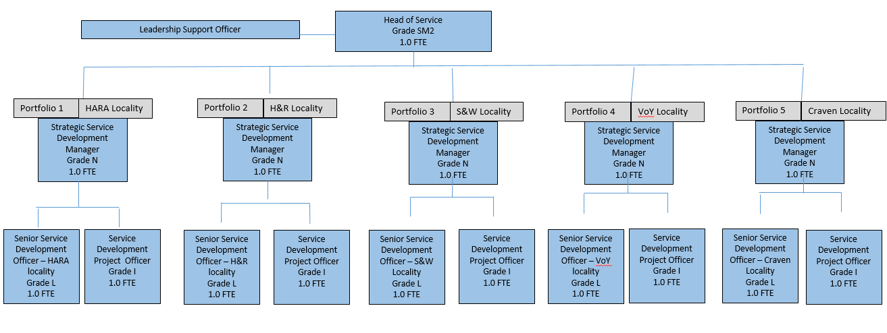
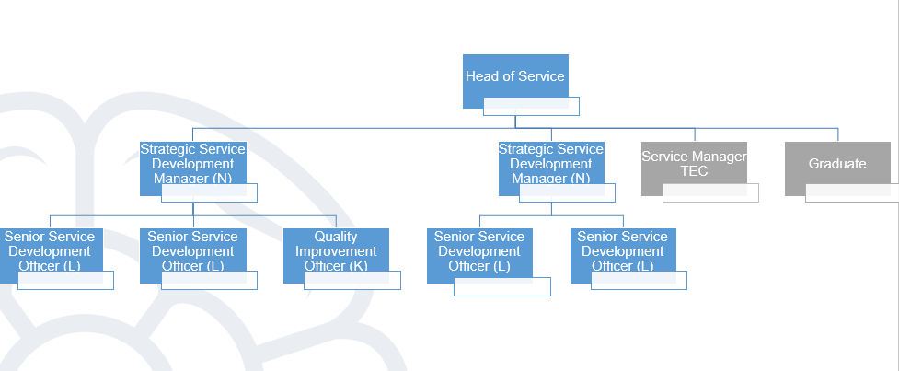
Structure – Targeted Prevention
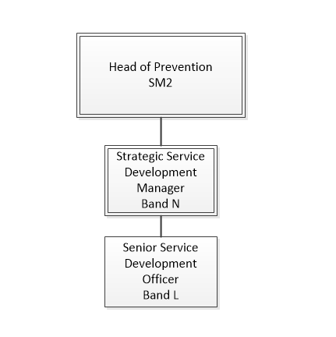
Job Description
Job purpose | Reporting to a Head of Service, the post holder will:  - Work collaboratively across the HAS Directorate to inform commissioning; Service Development; policy development; service planning and redesign at a strategic level.  - To work with providers and people using services and their carers, locally or at a county wide level to develop services together (co-production)
Operational management | - To lead a comprehensive and collaborative response to complex social care, housing and health issues at either a locality or a county wide level, through the development, delivery, monitoring, performance management and evaluation of a range of evidence-based strategies and action plans in line with national and local context.  - To be aware of and respond to relevant practice developments/research findings to deliver evidence-based services, ensuring these are shared with colleagues, being clear on actions to be taken  - To analyse and evaluate qualitative and quantitative data and effectiveness of health and social care services  - To ensure that Directorate and integrated health and social care resources are used in a planned way to maintain efficient and cost-effective services which take full account of changing needs and resource availability.  - To work closely with NYCC Public Health and other internal stakeholders to ensure that services are strategically placed as part of a wider network and inter-link where appropriate.  - To contribute to the evaluation of local health and social care services, initiatives and programmes to commission a comprehensive range of integrated, high quality, responsive and efficient services for North Yorkshire in line with service development and population health strategies and plans.  - Engage with people using services, their carers and communities to ensure their direct contribution to development of services and assessment of quality.  - To work autonomously within own levels of expertise and authority, taking responsibility to seek expert advice when appropriate.  - To be the lead Service Development Manager for identified localities and / or portfolios across North Yorkshire working with CCGs/ICS, and with Hospital Trusts and other partner agencies in line with national and local policies.  - To support the Heads of Service Development in the strategic planning and delivery of the commissioning functions and responsibilities of the Directorate and any commissioning partnerships and deputise for the Head of Commissioning as required
Communications | - Provide information, written and oral in an extensive range of formats to an extensive range of audiences whilst being sensitive to the nature of the transformation and the audience, ensuring the end goal is achieved effectively  - Negotiate and influence others whilst leading on complex transformation projects  - Represent the Directorate and any service development partnerships at appropriate inter and intra agency meetings, promoting, liaising, consulting and engaging with managers, staff, people who use our services and their carers and other stakeholders in challenging situations  - To coordinate and manage complex stakeholder engagement events including community and residents’ consultation, liaison with District and other Local Councils, NYCC elected members etc.  - Respond to media enquiries, MP requests and complaints as requested by the Assistant Director and Corporate Director Health and Adult Services and appraise them of any matters arising which are particularly sensitive or controversial in nature  - To write reports and deliver presentations on complex issues to a variety of audiences as required.  - To produce content for press releases or other publicity and actively seek good news stories to highlight the positive impact of the work of the Council on people’s outcomes and independence.  - To ensure and promote effective community/public involvement in the planning, development of services.
Partnership / corporate working | - Represent the Directorate and service development partnerships at policy, organisational, co-ordination and consultation forums with external agencies, other Council Directorates within the Service Area or wider Directorate and within partner organisations  - Build and maintain constructive relationships with a broad range of internal and external stakeholders, for example: Voluntary and community sector, Independent Contractors, CCGs/ICS, health providers, District Councils.  - To develop strong professional relationships with current and potential providers at a senior level to maximise opportunities within the care market.  - To build strong senior level relationships with internal NYCC services, including Provider Services, Procurement and Public Health  - Identify and work effectively with all relevant stakeholders within each transformation project  - To work collaboratively with other staff and partner agencies to influence an integrated and co-ordinated approach to achieving key targets.  - To build partnerships with relevant bodies in the statutory, non-statutory and private sector to facilitate the joint delivery objectives.  - To facilitate multi-agency work.  - Support the development of joint commissioning activities
Resource management | - The post holder will be responsible as a budget holder within the Council’s scheme of Delegation of financial performance of the post holders unit, ensuring a balanced budget and meeting any efficiency targets agreed.  - Ensure the monitoring of allocated budgets, ensuring that they are used appropriately and efficiently and that there are robust and relevant monitoring systems in place  - Seek out and identify areas for efficiency and improvement and making the most effective use of resources when commissioning, through identifying, assessing and evaluating different approaches and reviewing the evidence base and utilising value for money criteria to demonstrate cost effectiveness.  - Contribute to an on-going programme of quality assurance of commissioned services  - The post holder will provide leadership, motivation and regular supervision, appraisal and development to those staff for whom they are responsible in line with Directorate’s Supervision and Appraisal procedures  - The post holder will be responsible for ensuring the effective performance of all members of their team  - The post holder will ensure their behaviours and those of their team comply with the Council’s Behaviour and Skills Framework
Systems and information | - The post holder will be required to provide IT information and statistical reports to illustrate transformational plans and progress  - To prepare the necessary reports and briefing papers to key stakeholders including reports to Senior Management and Elected Members. These will include narrative updates, Highlight reports and detailed business cases.  - The ability to compile, analyse complex data and information to inform transformational decision making is a key aspect to this role, this includes programme level reporting, performance statistics and other information requirements  - To perform periodic quality control audits on information held by the team  - The post holder must utilise the current business processes in relation to record keeping, financial monitoring and ICT.  - To formulate and utilise information management systems e.g. to collate and compile records and to convey information  - To oversee and ensure the operation of effective document control systems and quality systems to facilitate easy access to appropriate documents and information for programme and management and performance purposes  - To ensure robust Project and Programme Management systems are in place and adhered to  - To ensure compliance with GDPR including ownership of the Information Asset register
Strategic management | - Effectively implement national legislation, policies and guidance and Council policies  - Contribute to the development of strategic plans, at both a locality and county wide level.  - Improve and modernise business processes  - Evaluate transformation which has taken place to ensure lessons are learnt and used to improve further transformation  - Contribute to the annual Service Performance Plan  - Make a strong contribution to developing North Yorkshire County Council’s and commissioning partners’ vision, strategic direction and values to build a culture of a learning organisation committed to high quality care and support continuous improvement.  - Promote an environment of openness and innovation where people understand proposals and can make positive contributions and suggestions.  - Ensure that best practice is identified and, as appropriate, work with external partners on collaborative opportunities and initiatives  - Identify areas for improvement/development within the allocated portfolio(s) which improves services for the population of North Yorkshire and the locality and provides value for money  - Use of JSNA and Public health data and intelligence to inform long term strategic planning  - Ensure all commissioned contracts and service specifications clearly define key performance indicators and outcome measures which are reportable.  - Establish robust development and performance management reporting for the allocated portfolio(s) and /or localities including action planning and service development across directly provided and commissioned services.  - Report progress on service redesign, provider performance and other areas. Provide high quality reports on plans to implement changes to services.  - Maintain and implement work plans for the delivery of service redesign to support strategy, including implementing projects in line with North Yorkshire County Council’s and commissioning partners commissioning plans, the Health and Wellbeing Board and national requirements.  - Support the development of commissioning strategies and other major strategic programmes as they relate to allocated portfolios and localities.  - Participate in the HAS On-Call rota
Safeguarding | - The postholder will ensure the safety of vulnerable people in line with the North Yorkshire Multi Agency Safeguarding Adults Procedures, and Health and Adults Services operational guidance.

Person Specification
Essential upon appointment | Desirable on appointment
Knowledge  - Significant knowledge of commissioning and partnership working in a social care and / or health care environment.  - An understanding of Public Procurement processes and requirements  - In-depth knowledge of Key legislation and guidance relating to Adult Social Care and / or Housing including the relevant national, local and Council strategies.  - Substantial knowledge of current policy and good practice standards both at local and national level.  - Significant knowledge of user and community engagement  - Knowledge of adult social care provision.  - Significant knowledge of commissioning and partnership working and relevant legislation.  - Knowledge and understanding of the Directorate and County Council’s published priorities.  - Knowledge and understanding of how Equality & Diversity, Dignity & Respect and Human Rights will apply to this role  - Demonstrable knowledge of care management functions  - Significant demonstrable knowledge of statutory requirements, including requirements in respect of carers, equality and anti-discrimination legislation, maintaining a safe working environment, data protection and confidentiality  - Understanding of respective roles of CCGs/ICS and Local Authorities  - Where appropriate for Housing roles - Knowledge of planning policies and how this relates to the development of Local Plans and Housing Strategies by District/Borough Councils and the understanding of how this relates to land availability/suitability for the development of extra care housing and supported housing. | - Knowledge and understanding of the challenges faced by services
Experience
- Significant experience of working within Adult Social Care, Housing or Health environments or other complex organisation in a commissioning or service development role.
- Where appropriate to the job context - Extensive experience of the Extra Care Housing or Supported Housing model, its ethos, design standard, service delivery and benefits to the community
- Experience of interagency and partnership working
- Experience of chairing groups or committees
- Experience of managing resources
- Significant experience of commissioning a range of services and developing opportunities for the market in relation to meeting the needs of adults and older people.
- Significant experience of managing programmes and projects as a project lead in a changing organisational environment within time and budget parameters.
- Significant experience of interpreting and preparing performance agreements.
- Significant experience of facilitating and managing service redesign and change in a health or social care setting.
- Experience of policy development and management in a local authority, health setting, major independent service organisation or equivalent.
- Experience of information management and ability to analyse and interpret information.
- Supervisory/management experience
- Experience of developing organisational culture in line with strategic and operational objectives
- Proven experience of successful community involvement and engagement with service users and carers
Occupational Skills
- Excellent project management and organisational skills.
- Excellent report writing skills
- Ability to assess and mitigate risk to area of work
- IT skills and ability to use a range of software.
- Ability to motivate people from diverse backgrounds and organisational levels
- Ability to demonstrate a flexible approach to problem solving.
- Influencing and negotiation skills
- Analytical and Problem solving skills
- Leadership skills
- Sound judgement and accountability
- Able to work equally well alone and as part of a team
- Tact and diplomacy
- Political awareness and ability to provide timely and appropriate information when working with Members
- Demonstrable ability to manage a range of portfolios to deliver strategic objectives.
- Ability to interpret national policy and best practice to inform commissioning and policy development.
- Excellent communication and engagement skills with internal and external stakeholders; and understanding of techniques to keep stakeholders informed and engaged.
- Financial management skills, including analysis of complex financial information.
- Ability to manage own time and that of others.
Professional Qualifications/Training/Registrations required by law, and/or essential for the performance of the role  - Evidence of on-going Continued Professional Development.  - A good general education including Maths and English Grade A-C or equivalent.  - Education to degree level or demonstrable equivalent experience | - Commissioning / Procurement / Housing qualification
Other Requirements
- Flexible approach to work
- Ability to travel across the County
Behaviours | Link
NB – Assessment criteria for recruitment will be notified separately.
Optional - Statement for recruitment purposes: You should use this information to make the best of your application by identifying some specific pieces of work you may have undertaken in any of these areas. You will be tested in some or all of the skill specific areas over the course of the selection process.

