Service and job specific context statement
Directorate: | Health and Adult Services
Service: | Prevention and Service Development
Post title: | Senior Service Development Officer – Commissioning/Housing
Grade: | L
Responsible to: | Strategic Service Development Manager
Staff managed: | None
Date of issue: | January 2022
Job family: | P&T - Professional & Technical
Job context – team specific
Senior Service Development Officer - Commissioning
- The post holder will be responsible for managing service development projects and commissioning of health and social care services in a complex and challenging environment for the population of North Yorkshire within a defined locality, ensuring best use of resources, delivery of strategic outcomes and responsiveness to service user needs
- The postholder will develop strong working relationships with Public Health, Clinical Commissioning Groups/Integrated Care Systems, providers, community and voluntary sector, commissioning support organisations and partners at a locality level
- The post will need to work closely with colleagues in the other Service Development teams to ensure consistent and responsive approaches are delivered across the localities and the customer groups
- The post will oversee service reviews, and support procurements
- The role will play a key role in supporting complex partnerships with and influencing key stakeholders in the health and social care economy.
- Experience of project management approaches – lead and drive projects within locality / portfolio area
- The post holder will act as service development lead within a locality with liaison with other locality colleagues and local providers.
- The post holder will be responsible for identifying gaps in service provision or areas for further service development or transformation within the locality

Senior Service Development Officer - Housing
- Housing is a major determinant of health and wellbeing. The ability of people using social care services to access suitable and safe housing that promotes reablement and personal development is a key element of supporting people to live independently.
- The HAS Senior Service Development Officer post will work in a geographic locality delivering the commissioning and ongoing support of a range of Extra Care and / or Supported Accommodation services.
- The postholder will contribute to the process of redesigning and transforming services, supporting the Head of Service and Strategic Service Development Manager
- The postholder will be responsible for the developing strong working relationships across a complex group of stakeholders including District and Borough Councils, Housing Providers, Care Providers and NHS teams to ensure that the Housing needs of local communities are effectively met.
- The postholder will oversee service reviews, and lead on procurements, supported by the Strategic Service Development Manager
- The postholder will work closely with colleagues in the other HAS service areas to ensure consistent and responsive approaches are delivered across the localities and the customer groups
- The postholder will work flexibly across the county as required, developing local relationships with NYCC locality teams and key stakeholders within their geographic area including District Councils and Housing providers.
- Postholder will work closely with the Service Development team to develop locality plans and profiles as well as engaging with Care and Support to promote Extra Care and Supported Accommodation and offer a critical friend approach to decision making.
Structure
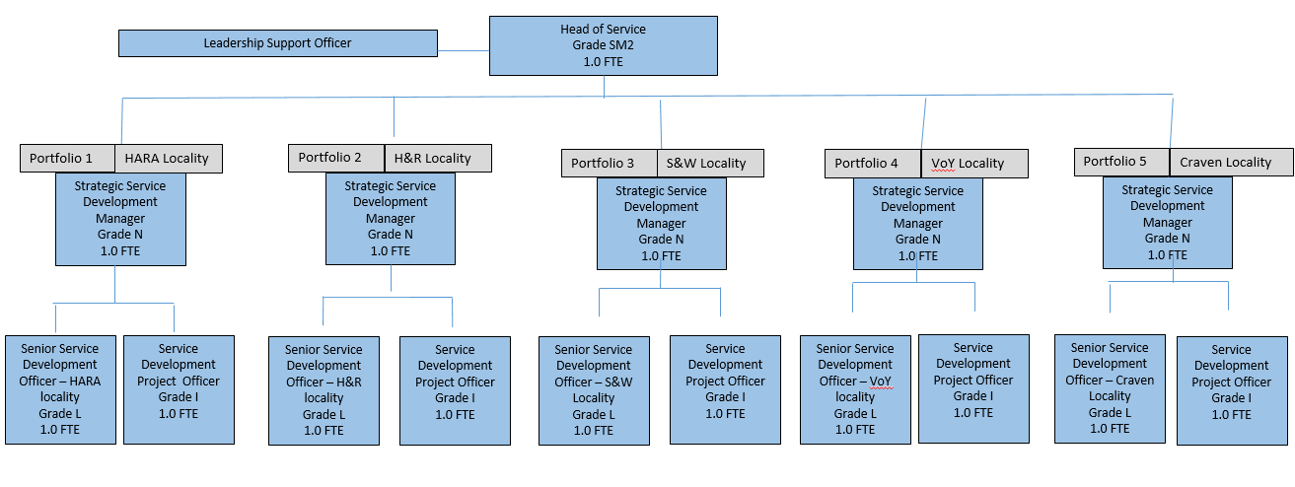
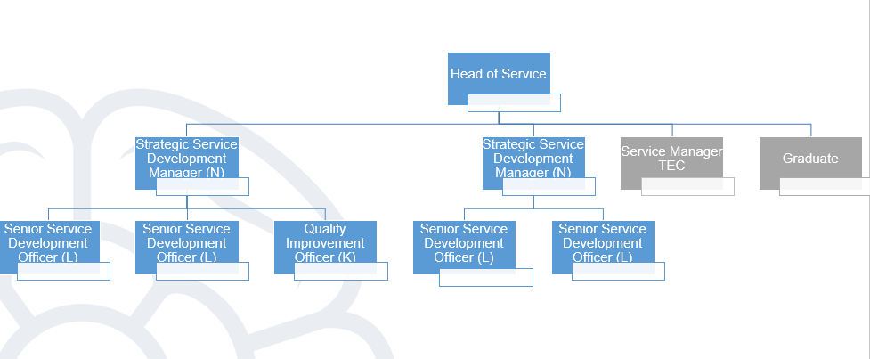

Job Description
Job purpose | Reporting to a Strategic Service Development Manager, the post holder will:  - Manage and deliver collaborative work across the HAS Directorate to inform commissioning; policy development; service planning and redesign.  - To work flexibly and collaboratively to understand and respond to changing need and demand  - Lead, as directed on the development, implementation, performance management and evaluation of a range of social care services and / or housing services, at a locality level.  - Lead on individual projects in relation to a defined portfolio or locality  - Support senior managers and practitioners to facilitate joint commissioning arrangements particularly with Clinical Commissioning Groups / ICSs,  - Work with District Councils as well as a range of statutory, non-statutory, voluntary and private sector agencies.  - To work with providers and service users, locally or at a county wide level to develop services together (co-production)
Operational management | - To project manage, with support from the Service Development Manager, Procurement and Quality and Market Improvement, relevant commissioning and service development activity relating identified need at a locality and Countywide level quality,  - Development of outcome-based service specifications, and quality frameworks and all associated documentation in line with HAS Commissioning and NYCC procurement requirements.  - To lead operational implementation groups as part of the development of any new scheme or service, in complex situations this will be supported or led by the Service Development Manager  - To support the Service Development Manager in the preparation of necessary reports and briefing papers to key stakeholders including reports to Senior Management and Elected Members.  - To actively engage with people using services, providers, communities and other interested stakeholders to ensure that services are person centred and based on actual need.  - To work closely with NYCC Public Health and other internal stakeholders to ensure that services are strategically placed as part of a wider network and inter-link where appropriate.  - To develop strong professional relationships with providers and potential providers to maximise opportunities within the market.  - Maintain strong relationships with Care and Support teams across the County to ensure effective joint working  - To work with Public Health to develop needs-based service and funding formulas to ensure that services meet need and do not replicate existing provision.  - To undertake regular Service Development meetings with providers, focussing on ensuring services are meeting the desired strategic need and exploring opportunities for innovation or efficiency.  - To work effectively and constructively within the wider Directorate and across the Council to ensure a coordinated and mutually reinforcing approach.
Communications | - To develop and deliver comprehensive communication plans and ensure all key internal and external stakeholders are fully aware of key milestones and pending communication requirements  - To ensure the work of the team is highlighted within NYCC to ensure visibility, including attending Area Management Teams and other local forums.  - To coordinate and facilitate necessary stakeholder engagement events including community and residents’ consultation, liaison with District and other Local Councils, NYCC elected members etc.  - To be responsible for liaison and ongoing communication with internal and external stakeholders and colleagues e.g. Care and Support, finance, policy, HR, IT, members of the public and people using services etc. with regard to ongoing projects  - To maintain strong on-going relationships with providers and other key partners  - To produce timely and accurate reports on progress on the Projects as well as appropriate written information for reports, plans and general information purposes  - To be responsible for making arrangements for formal publicity events, liaising with housing partners, local Councillors, Members and senior management
Partnership / corporate working | - To develop strong professional relationships with providers and potential providers to maximise opportunities within the locality.  - To work closely with key locality stakeholders from a range of settings including Local Government, Health, Community and Voluntary Sector.  - To work closely with local community groups, interested parties and members of the public to ensure that services are understood and concerns are raised where appropriate  - To build strong local relationships with internal NYCC services, including Provider Services, Procurement and Public Health
Systems and information | - To operate document control systems and quality systems to ensure easy access across the project team to appropriate documents and information  - Analyse business and activity information to provide insight into ongoing or emerging trends in the market or service delivery.  - To work with Contracting, Market Improvement and Business Intelligence teams to compile routine or ad hoc summary performance statistics and information relating to the delivery of projects  - To present and analyse data for use in commissioning or service development activity including timely distribution of plans, maps, geographical based data sets and spreadsheets as required using GIS and other IT based data systems  - To establish accurate information/records relating to current accommodation provision for learning disability across the county.

Person Specification
Essential upon appointment | Desirable on appointment
Knowledge  - Knowledge of key legislation and guidance relating to Adult Social Care and / or Housing including the relevant national, local and Council strategies.  - An excellent understanding of the current health and social care policy agenda and be able to interpret national policies to inform commissioning.  - An understanding of Public Procurement processes and requirements  - Knowledge of Commissioning processes and cycles  - Knowledge of adult social care provision.  - Knowledge and understanding of how Equality & Diversity, Dignity & Respect and Human Rights will apply to this role  - Understanding of respective roles of CCGs and Local Authorities  - Understanding of the principles of effective community engagement  - Awareness of current issues affecting adult health and social care and community services | - Understanding and experience of landlord/tenant/support and care providers/managing relationships and responsibilities
Experience  - Experience of working within Adult Social Care, Housing or Health environments or other complex organisation  - Where appropriate to the job context - experience of the Extra Care Housing or Supported Housing model, its ethos, design standard, service delivery and benefits to the community  - Experience of partnership working and networking in a multi-agency context  - Experience of how equality, diversity, dignity and respect and human rights agendas will apply to this role  - Experience of information collection, analysis and interpretation  - Experience of working in a fast moving change environment  - Experience of multi-agency, cross Council or partnership work of a social care or housing related nature | - Experience of project management in a housing or commissioning context
Occupational Skills  - Ability to demonstrate a flexible approach to problem solving.  - Positive team player  - Good communication and presentation skills on a personal level such as at information and consultation events and when managing enquiries and requests for information  - Ability to analyse and interpret financial and performance information  - Partnership working skills including inter agency collaboration  - ICT Skills in Word, Excel, E-mail, Project Management systems and internet for web-based research  - Makes decisions within own area of responsibility  - Ability to make effective decisions and sound judgements and to be accountable for those decisions and judgements  - Ability to assess and mitigate risk to area of work  - Processes and/or monitors financial information  - Keeps track of any budget relating to the project and provides timely and accurate records to Strategic Service Development Manager  - Workload/resource management skills  - Information management/data analysis/interpretation  - Research, analysis and solution based presentation  - Leads on the organisation, planning and delivery of projects  - Ability to establish and prioritise work within a clear framework of timetabled tasks and to meet deadlines  - Effectively copes with conflicting and complex demands | - Project management and planning  - Negotiation skills especially with external partners
Behaviours | Link
NB – Assessment criteria for recruitment will be notified separately.
Optional - Statement for recruitment purposes: You should use this information to make the best of your application by identifying some specific pieces of work you may have undertaken in any of these areas. You will be tested in some or all of the skill specific areas over the course of the selection process.

