Service and job specific context statement
Directorate: | Central Services
Service: | Legal and Democratic Services
Post title: | Lawyer / Solicitor
Grade: | K and M
Responsible to: | Head of Legal (People Services) or Head of Legal (Corporate Services)
Staff managed: | None
Date of issue: | 24 February 2017
Job family: | P&T - Professional & Technical
Job context
The Legal Service is part of Legal and Democratic Services (‘LDS’) within the Chief Executive’s Group. NYCC provides a range of services to the County of North Yorkshire, and the role of the Legal Service is to support the provision by providing a comprehensive and efficient legal service to the Directorates, the Council’s Executive, full Council, Committees and Members, and external clients. The nature of the work requires a flexible and versatile approach as it will change from time to time in response to the changing needs of the Council, and its developing initiatives. The post is required to work with colleagues and Members at every level within the organisation, with external clients and partners, and to manage the performance of staff within its responsibility. The budget of the service is in part dependent on income from external sources and the post must play its part in ensuring successful income generation, and in ensuring compliance with Law Society Professional Standards, and the achievement of Lexcel accreditation.

The postholder must have a practising certificate.
Career progression
Progression from Grade K to Grade M will be subject to approval by the Head of Legal (Corporate/People Services) and will follow the progression process attached.

 | Job specifics
 | Legal advice, support and representation working within one of the teams shown below:
 | People Services
 | Adult Social Care | Information Law |  | Education and Employment
 | - Safeguarding adults, community care, human rights assessments, mental health, mental capacity and best interests  - Deprivation of Liberty applications  - charging and deprivation of assets  - applications to the Court of Protection for best interests decisions  - Court applications under S29 Mental Health Act  - disputes relating to Ordinary Residence  - Judicial review | - The Freedom of Information Act 2000  - The Environmental Information Regulations 2004  - The Data Protection Act 1998/Subject Access Requests  - data privacy and data sharing |  | - special educational needs including advising, negotiating, mediating and defending appeals against refusal to assess and statements of special educational need and representation at tribunal hearings for appeals against statements of special educational need  - assistance with complaints handling  - Judicial Reviews  - screening of pupil’s educational files in respect of criminal proceedings  - parental responsibility for education  - school admissions, attendance and exclusion  - support on school governance  - schools’ legal advice helpline
 | Children Social Care | Employment |  | Debt Recovery
 | - cases under the Children Act 1989 and the Adoption and Children Act 2002 including judicial review  - applications for Care, Supervision, Emergency Protection, Secure Accommodation and Placement Orders  - responding to applications for special guardianship, adoption, contact with a child in care and in discharge of care order applications  - Section 7 and Section 37 applications | - unfair dismissal  - all aspects of discrimination  - redundancy and re-organisation  - TUPE  - the conduct of claims to the Employment Tribunal and Employment Appeal Tribunal  - disciplinary and grievances  - termination of employment  - equal pay  - whistleblowing |  | - letter before action  - considering and advising on the merits of continuing with any action  - completing and submission of claim form  - enforcement of the debt
 | Corporate Services
 | BES |  | Property |  | Commercial Partnerships and Procurement
 | - planning, in particular, advising on applications, appeals, inquiries and Judicial review Section 106 Agreements and planning enforcement  - highways, in particular, maintenance and improvement, adoption of roads, traffic and transport, compulsory purchase, public rights of way, and town and village greens  - statutory orders, including footpath orders, speed limits, parking schemes etc  - waste management (advising the Council’s waste management service on all aspects of its functions)  - environmental law and regulation  - flooding and drainage |  | - commercial conveyancing  - commercial leases  - the taking or grant of an easement  - the approval of the terms of tenancy agreements involving the Council  - dealing with the grant of a lease to an academy trust in cases where a school converts to academy status  - the disposal of property by way of auction  - the registration of a restriction or charge against the title of a property in third party ownership.  - the variation or discharge of covenants  - the surrender or termination of a lease of property which the Council no longer requires  - ownership of property, rights and liabilities relating to such ownership, and the acquisition or disposal of property  - Right to buy applications |  | - all aspects of commercial contracts for supplies, works and services (we advise upon suppliers’ terms and conditions, draft contract and project agreements and we oversee the drafting of NYCC’s procurement manual)  - the law relating to contracts and procurement, especially NYCC’s own Contract and Property Procedure Rules and the Public Contract Regulations 2006  - advising on and drafting procurement documentation  - projects and partnerships  - the legal aspects of insourcing and outsourcing of services  - intellectual property rights such as copyright and trademarks  - the legal aspects of education, joint use projects and academisation
Regulatory

- all aspects of housing law including possession applications and housing disrepair claims
- all aspects of Licensing law, including advising at Council Committees and hearings
- environmental health law including issuing notices, prosecuting cases, civil proceedings
- general prosecution work including all preparation, attending at court and conducting your own advocacy
- advising on and making of byelaws
- advising on information governance including data protection, FOI and EIR.
The specific tasks will vary dependent upon the legal teams primarily supported by the Lawyer and may change from time to time.

Legal and Democratic services is a flexible unit and although the Lawyer will be assigned to a particular portfolio, it is foreseeable that the postholder will be required to work within different areas as the demands of LDS dictate and they must demonstrate such flexibility and the ability to undertake a diversity of legal work within the overall framework of the post. The flexibility extends, if required, to assisting with urgent enquiries outside normal office hours. Every reasonable effort will be made to ensure that this requirement is only exercised in cases of genuine urgency; this will usually be confined to adult and child protection issues but it could also apply to emergencies in other service areas.

- Undertaking research and providing written or verbal advice and support and liaison to Members and officers of NYCC (and other LDS clients if required) in respect of legal matters.
- Attending meetings with officers and/or Members of NYCC and other organisations as required and giving legal advice as necessary.
- Provide legal advice and guidance on the range of legal issues within the specialist area of law under supervision and guidance
- Assistance with preparation of cases relating to property for Courts, Tribunals and Inquiries.
- Instructing and attendance with Counsel at level appropriate to post and in appropriate cases under supervision of the Legal Manager (People Services) and/or the Senior Lawyer
- Advocacy in court/tribunal in straightforward cases
- Advice, preparation and advocacy on small claims and other litigation matters
- Advice on Local Government Ombudsmen complaints.
- Be responsible for court/tribunal cases up to moderate complexity with supervision and guidance
- Interviewing witnesses and taking statements of evidence including more complex statements with supervision and guidance.
- Advise on applications for disclosure in accordance with Public Interest Immunity Policy.
- Drafting and advice on Committee reports and minutes, if directed to do so by the Head of Legal Services or the Senior Lawyer.
- Drafting of and negotiation and advice upon a wide range of agreements.
- Negotiate terms of straightforward agreements/settlements with guidance
- Advise upon commercial issues and risks.
- Consideration of the merits of cases and their financial implications, and advising on appropriate action including settlement.
- Respond to unexpected situations with guidance except in the case of straightforward legal problems
- Responsibility for own caseload with supervision when required by the Senior Lawyer.
- To contribute (under the supervision of the Senior Lawyer in the team as appropriate), to the solution of difficult problems and to apply the experience proactively to avoid a recurrence.
- To make recommendations relating to decisions which involve careful analysis of legal risk under the supervision of the Senior Lawyer in the team as appropriate.
- Assistance with preparation and delivery of training sessions on legal matters and other relevant issues.
Structure
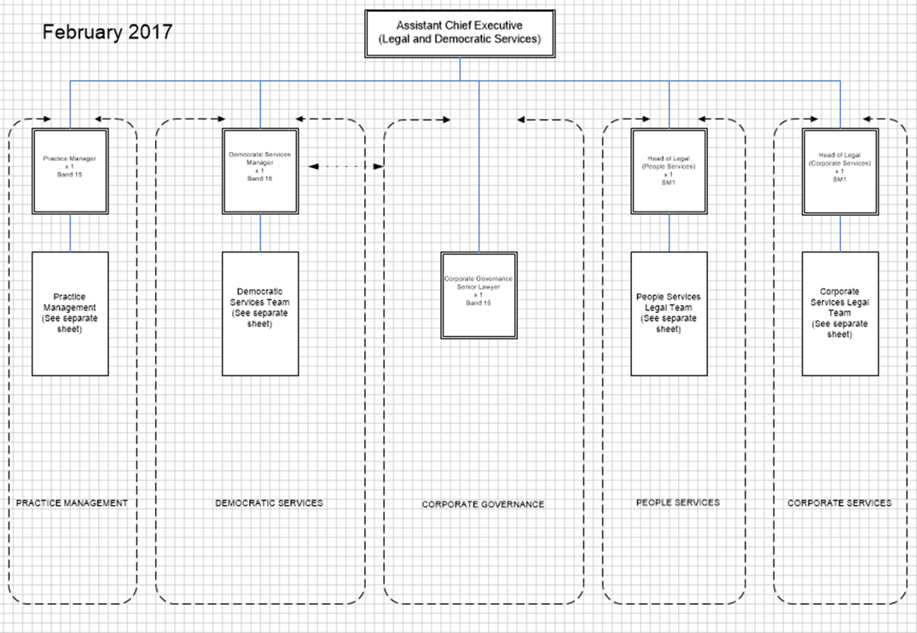
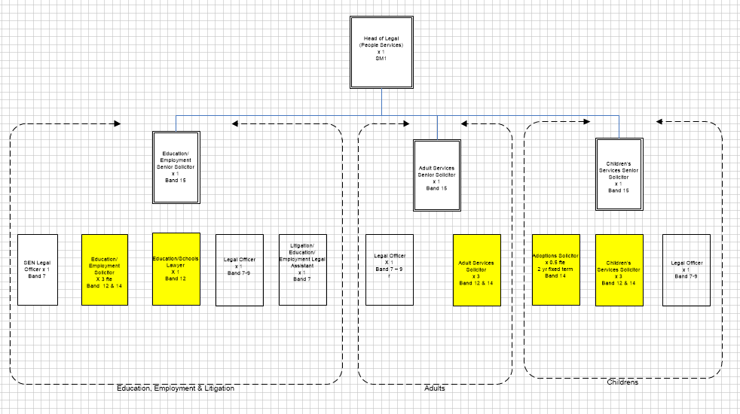
Or
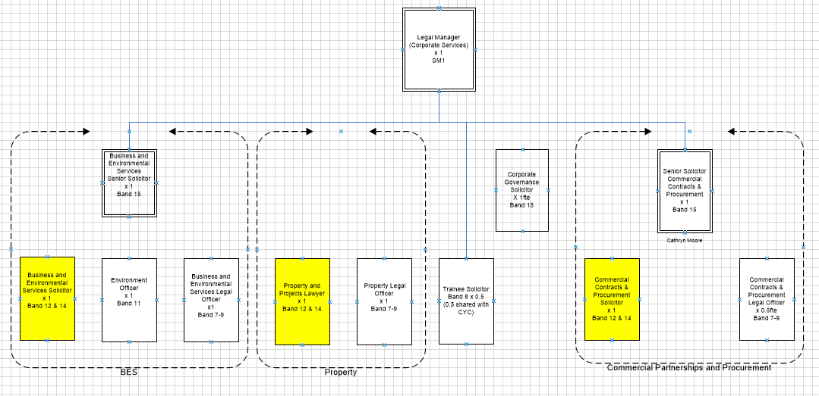
Job Description
Job purpose | To assist the Head of Legal (People Services) or Head of Legal (Corporate Services) and the relevant Senior Lawyer to provide a comprehensive legal service to the Council, Directorates, Committees and Members including legal advice and representation:-
People management | - Supervision of Paralegal and support staff when assisting the Legal Team
Legal Services management | To contribute to the development and management of Legal and Democratic Services by:  - Participation in team meetings.  - Attendance at training courses.  - Participation in staff development process.  - Contribution to LDS Service Plan.  - Contribution to the development of LDS Practice Manual.  - Assistance to the Head of Legal (People Services)/(Corporate Services) and other members of the Legal Team in preparing briefing papers, newsletters and training sessions for Directorates and other Legal and Democratic Services clients.
Quality Control and Customer Care | - To play an active part in ensuring that Legal and Democratic Services provides a quality service to clients. This responsibility includes:  - Compliance with:  - Law Society Practice Management Standards and other professional requirements including the Law Society Professional Conduct Rules.  - Lexcel standards.  - Legal and Democratic Services quality standards.  - Participation in quality standard audits.  - Compliance with and operation of Legal and Democratic Services Risk Management Policy. This obligation applies to postholder’s duties generally but with particular relevance to risk assessment being undertaken on each item of casework.
Professional Duties | - Responsible for assisting the Head of Legal (People Services) or Head of Legal (Corporate Services) and the other members of the Legal Team under supervision where appropriate in ensuring that Legal and Democratic Services provides a comprehensive legal service.  - Communication (in person, email and correspondence) with:  - NYCC professional staff.  - NYCC consultants and contractors engaged on property valuation work.  - Legal advisers to third parties.  - Client representatives within and outside NYCC.  - General assistance to the Heads of Legal relating to legal matters  - Provision of advice and support to Members and officers of the Council and external clients of Legal and Democratic Services including the undertaking of research in respect of legal matters generally in the relevant portfolio.  - Prepare and present simple cases of lower levels of complexity in Court and other cases commensurate with the grade of the post.
ICT | - To assist LDS in the achievement of all e-Government policies and practices and, in particular, is required to use ICT systems including:  - Legal and Democratic Services time costing and case management system.  - Outlook  - Internet.  - Legal research tools e.g. PLC
Planning and Organising | - Assist the Head of Legal (People Services) or Head of Legal (Corporate Services) under the supervision of the Senior Lawyer within the Team in ensuring the legality of the Council’s operation.  - Participate in corporate groups as necessary.

Person Specification
Essential upon appointment at Grade K  See progression criteria to progress from Grade K to Grade M | Desirable on appointment
Knowledge  - Demonstrable knowledge of law in one of the areas within the portfolios. A more in depth knowledge of the specific portfolio would be required for the top level of the role.  - Awareness of the political structure and functions of the Council  - A working knowledge of Court procedures and of attending Court if relevant to the portfolio assigned. | - Knowledge of local government law  - Familiarity with ICT systems including research tools, internet and time costing systems
Experience  - Demonstrable experience of legal work in one of the areas within the portfolios.  - Risk management in a legal environment | - Experience of Local Government Law  - Some supervisory experience
Occupational Skills  - Ability to communicate effectively in writing to produce documents in a range of formats and style to suit a range of audiences and produce a representative record of meeting discussion and actions.  - An ability to interact positively with colleagues, clients and elected Members.  - Good presentation and interpersonal skills.  - To critically analyse diverse information presented in a variety of formats.  - Good ICT skills to use case management system and online research.  - Ability to analyse legal risks under the supervision of the Senior Lawyer in the team  - To work productively under pressure to achieve deadlines and targets, and help others to do so, and effectively cope with conflicting demands despite setbacks and challenges.  - Negotiation skills  - Ability to be a team player  - Ability to organise own workload and caseload with minimal supervision and guidance | - Time management skills
Professional Qualifications/Training/Registrations required by law, and/or essential for the performance of the role
- Qualification as a Lawyer, barrister or FILEX
Other Requirements  - Professionally represent the role within the service  - Ability to travel across the County | - Flexible approach to working practices  - Understanding of and commitment to public sector values.
Behaviours | Link
You should use this information to make the best of your application by identifying some specific pieces of work you may have undertaken in any of these areas. You will be tested in some or all of the skill specific areas over the course of the selection process.

