Service and job specific context statement
Directorate: | Central Services
Service: | Technology and Change
Post title: | DevOps Engineer
Grade: | L
Responsible to: | Lead Developer
Staff managed: | None
Date of issue: | May 2022
Job family: | P&T - Professional & Technical
Job context
Technology and Change provide technology and change services across the authority and increasingly to others through partnership or commercial arrangements. The Development team is one of the teams in the Technology and Change Service that forms part of the Digital Transformation Team.

The post holder will work closely with other teams in the service (in particular the infrastructure teams) to ensure software products are configured and deployed on time, within budget, and to the agreed quality.

Work with other teams within T&C including business change, solution analysts and technical teams to develop proposals for solution options, assess technical feasibility, develop estimates, and identify costs, risks, issues, and benefits.

The post holder will lead in providing their technical expertise to ensure the technical competence of colleagues is maintained.

Structure
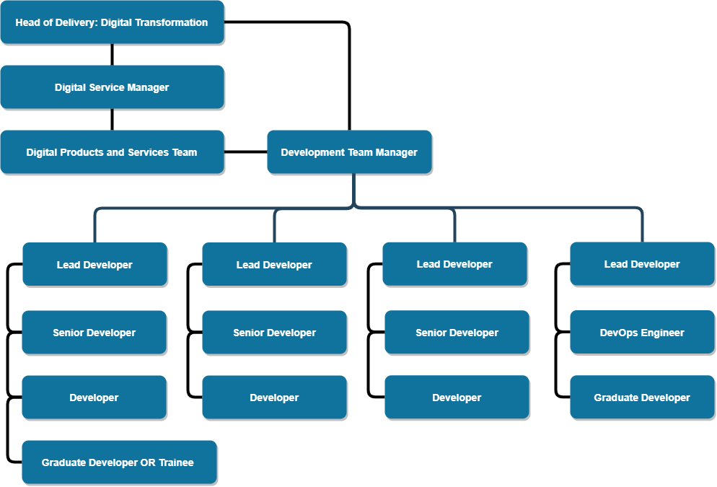

Job Description
Job purpose | The core focus of this job is to drive the delivery of software products to the organisation by designing and building automations and configurations that meet required specifications and standards.  Guiding and advising members of the Development and Infrastructure teams in DevOps practices to ensure close collaboration in development projects.
Operational | - Support the Head of Delivery: Digital Transformation and Development Team Manager by working in a way that delivers the Objectives, Actions and Performance Measures of the Digital Transformation team.  - To contribute to the analysis, design, testing, implementation, configuration, automation, deployment and documentation of information system solutions using in-house developed components and bought-in packaged software.  - Continuous learning, building up knowledge and understanding of automation and configuration tools used to deploy, configure and secure software built by the development team.  - Follow predefined standards for the testing, deployment and securing of information systems.  - To undertake duties and tasks allocated by Project Managers and the Development Team Manager to achieve delivery schedule targets.  - Research and establish a DevOps tool chain within parameters set by the Enterprise Architect.  - Setup, and maintain a DevOps tool chain.  - Ensure deployment strategies for products are repeatable, scalable and reliable.  - Manage Configuration Items (CIs) and related information. Investigate and implement tools, techniques and processes for managing CIs and verify that related information is complete, current and accurate.  - Apply change control procedures.  - Ensure release processes and procedures are maintained.  - Engage with technical design and project and product managers to ensure correct products are produced in a timely fashion. Evaluate the quality of project outputs against agreed service acceptance criteria.  - Recommend/design structures and tools for systems that meet business needs, and take into account target environments, performance security requirements and existing systems.  - Take responsibility for integrity of testing and acceptance activities and coordinate the execution of these activities.  - Provide authoritative advice and guidance on any aspect of test planning and execution.  - Define and communicate the test strategy for the project.  - Manage all test processes, including test plans, resources, costs, timescales, test deliverables and traceability.  - Identify process improvements, and contribute to corporate testing standards and definition of best practice.  - To monitor assigned tasks/projects against agreed delivery schedule.  - Attend training courses where appropriate for both technical and non-technical personal professional development.  - Attend Team Meetings  - To undertake such other duties as the Authority may reasonably require.
Communications | - Promote the use of DevOps practices within the Technology and Change service.  - Establish and maintain a close working relationship with the infrastructure teams within the Technology and Change service.  - Provide advice and guidance to customers in the use of software to ensure continued system effectiveness against a background of changing business requirements and technological improvements.  - Promote best practice in the use of technology throughout the Authority, including the identification of improved business processes.  - Liaise with other teams within Technology and Change to provide an effective and efficient service to customers.  - Provide technical expertise to development team members across a broad spectrum of technologies.
Partnership / corporate working | - Strive to be fully aware of the customer’s current and future technology requirements.  - As appropriate, act as a technical expert for other Technology and Change staff and customers.  - Support Solution Analyst in identifying technical solutions and options, the production of estimates and in identifying benefits, risk and costs
Resource management | - Give advice on training and DevOps requirements to the Development Team Manager.  - Provide mentoring to team members.  - Train new personnel in appropriate skills.  - Promoting and monitoring the use of DevOps methods with team members.  - Work with other members of the team to broaden knowledge and technical expertise and to keep up to date with changes in technology assessing potential benefits and promoting awareness.  - Actively promote a culture of exceptional customer care.  - Assist in the process of recruitment and selection of staff.
Systems and information | - Provide, or assist in, the delivery of second line support to users of information systems supported by the team.  - Ensure that agreed SLA’s and OLA’s for support or other services are adhered to. Providing timely information and updates on progress and resolution to the Development Team Manager.  - Provide advice and guidance to the Development Team Manager, and Head of Technology Solutions or Head of Delivery: Digital Transformation.  - Provide details of progress of tasks/projects to the Development Team Manager.  - Maintain high standards of documentation and change control.
Strategic management | - Be aware of Technology and Change business goals and assist in implementing of Technology and Change strategy as appropriate.  - To keep abreast of emerging technologies, standards and management methods.

Person Specification
Essential upon appointment | Desirable on appointment
Knowledge  - Extensive knowledge of trends and developments in information systems hardware and software.  - Good knowledge of source control systems.  - Good knowledge of DevOps lifecycle tools (e.g. GitLab).  - Good knowledge of provisioning and configuration management tools (e.g. Ansible).  - Good knowledge of a scripting language (e.g. Powershell).  - Knowledge of Windows and Linux Servers and their configuration and provisioning.  - Good understanding of the business and technical issues associated with development and support of information and integration systems in a network environment and across multiple domains.  - Basic knowledge of current guidance and best practice in relation to software development particularly in respect of data security.  - Knowledge of Office Systems.  - Good knowledge of operating systems and internet technologies.  - Good Knowledge of testing best practices | - Good understanding of the roles and functions of local government.  - Some knowledge of project estimating, planning and management.  - Good knowledge of containerisation technologies, such as Docker.  - Good knowledge of Cloud Computing platforms and services, including SaaS (Software as a Service) and PaaS (Platform as a Service).  - Some knowledge of the Drupal framework (including the PHP dependency manager, Composer).  - Some knowledge of the .Net Framework including msbuild.
Experience  - Extensive experience of designing, automating and testing the deployment and maintenance of information system applications using Web or database technologies.  - Extensive experience of managing information system projects within a multi-user enterprise scale environment. | - Systems administration experience in Linux and Windows server.  - Experience of working in Agile environments.
Occupational Skills
- Ability to quickly grasp and assimilate new technologies, software and information.
- Ability to lead and motivate others.
- Display a mature and confident disposition
- Ability to demonstrate technical expertise and a ‘customer care’ approach to work.
- Uses creativity and innovation to generate solutions for difficult issues.
- Takes responsibility for and manages specific aspects of a project as requested by a Team Manager.
- Ability to manage time and work to deadlines
- Self-motivated and self-disciplined.
- Excellent communication and presentation skills, both written and oral.
Professional Qualifications/Training/Registrations required by law, and/or essential for the performance of the role  - IT related Degree/HND standard or equivalent technical qualification or relevant technical experience.  - Evidence of ongoing commitment to CPD in DevOps. | - ITIL Certificate  - Relevant Microsoft, AWS or Google certification.
Other Requirements
- Ability to travel across the County as required by meetings or training.
- Professional values and attitudes
- Ability to work both on own initiative and as part of a team
- Ability to work to specified deadlines
Behaviours | Link

