Service and job specific context statement
Directorate: | Children and Young People's Service
Service: | Inclusion Service
Post title: | Senior Resource Centre Worker (Shift Lead)
Grade: | I
Responsible to: | Deputy and Registered Manager
Staff managed: | Manage operational frontline staff
Date of issue: | February 2016
Job family: | C&S - Care & Support
Job context
In April 2015 Children’s Resource Centres became part of the Inclusion Service. We are committed to providing good quality services to support children and young people with disabilities and their families and our aim is always to put children and young people at the centre of all our work. The services provided by Children’s Resource Centres follow from specific Government legislation, including the Children Act 1989 and the Children Act 2004, The Children’s Homes Regulations 2015 and The SEND agenda. The post requires an enhanced DBS check. This role involves spoken communications so a confident use of English language is required.
Structure
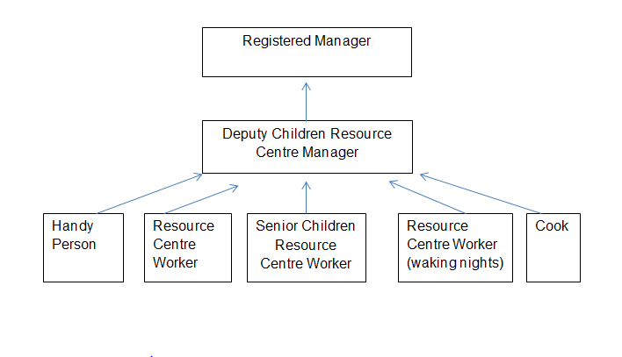
Job Description
Job purpose | In line with Directorate’s statutory obligations, support disabled children with the most complex needs in a variety of different settings. This involves working with children and young people with a wide range of disabilities as part of a team responsible for direct care in residential settings, in children’s own homes and in other settings.  To contribute to all aspects of the physical and emotional care of the children and young people so as to promote their welfare whilst working in partnership with their family and other professionals. To take responsibility for the day to day leadership and support of care staff whilst on shift.
Operational management | - Lead a shift as per the duty rota, with the on call support of either a Registered or Deputy Manager.  - Assist the Deputy Manager in the implementation of all designated areas of the children’s care plan in accordance with LAC or other reviews.  - Contribute to the effective and efficient use of the physical and financial resources.  - Supervise students and relief/sessional staff plus assisting with the induction and post-appointment assessment of new staff members as required, in accordance with agreed procedures.  - Contribute towards the maintenance of the fabric of the Home and ensuring that its grounds and equipment are in a safe and satisfactory condition.  - Take key-worker responsibility for the more demanding and complex cases and to assist less experienced members of staff in developing key-worker skills, including the implementation of care plans and the administration of medication.  - To undertake sleeping in duties as per the rota.  - Contribute to care planning, participating in reviews and other meetings as required, and to assist in the formation and implementation of care plans  - Support transitions across environments and activities.  - Take responsibility as a senior member of the staff team for demonstrating a high level of primary, social and emotional care to the children and young people accessing the service.  - Contribute to the assessment of the individual’s needs and circumstances and in the development, provision and review of care programmes which meets these.  - Contribute to the implementation and evaluation of specific programmes which provides a framework for the prevention and management of individual’s behaviour.  - Enable and support children to participate in recreation and leisure activities.
Communications | - Ensure that all records are properly monitored and maintained in conjunction with organisational requirements, data protection and human rights legislation and regulation.  - Ensure that confidentiality is maintained at all times in respect of organisational policies in respect of young people and staff.  - Ensure effective shift planning and the communication of plans to colleagues on duty.  - Ensure there is timely and effective communication with parents, families and professionals as necessary throughout a shift.  - Ensure key issues are effectively communicated across shifts through handovers.  - Talk and listen to children, to observe their behaviour and record significant features  - Ensure familiarity with the use of a variety of communication tools e.g. Makaton.  - Establish, sustain and disengage appropriately from relationships with service users and their families.  - Promote people’s equality, diversity, rights and responsibilities  - Ensure the education of each young person is positively promoted
Partnership / corporate working | - As a Senior Worker participate in the development and analysis of information from across settings to inform service risk assessments and children’s plans, this may be done through visits or gathering of information from files and talking with key involvements  - Develop and sustain effective working relationships between workers and the local community, colleagues and other agencies so as to promote collaborative working and partnerships.  - Work in a team context, forging and sustaining relationships across agencies and respecting the contribution of others working with children, young people and families.  - Work jointly with Social Workers, Education, Inclusion and Health colleagues within assessment and care planning  - Maintain effective working relationships with colleagues in the team, in the Directorate and with other agencies  - Work across various settings, school, family home, community and resource centre.
Resource management | - Manage the deployment and coordination of staff throughout a shift ensuring there is equity of tasks across all staff.  - Take a lead responsibility to ensure that adequate planning, coordination and preparation is in place for each shift.  - Supervise students and relief/sessional staff plus assisting with the induction and post-appointment assessment of new staff members as required, in accordance with agreed procedures.  - Contribute towards the maintenance of the fabric of the Home and ensuring that its grounds and equipment are in a safe and satisfactory condition.
Systems and information | - Check and monitor all staff records in relation to daily tasks, housekeeping and health and hygiene  - Maintain confidentiality and observe data protection guidelines.  - Ensure information across a shift is recorded in line with the Children’s Homes Regulations 2015  - Participate and take a lead in team meetings as required  - Be responsible for the sharing of information in an appropriate and timely manner to support smooth transitions for young people across settings.  - Be aware of own and others’ professional boundaries
Safeguarding | - Be responsible for promoting and safeguarding the welfare of children and young people that you are responsible for and come into contact with.  - Contribute through shift planning and leadership to the effective physical, social and emotional environment for group care which provides a safe, nurturing and stimulating environment in which children and their families can be offered the support, care and guidance they need.  - Be alert to signs of distress or abuse, and to ensure that the children and young people are monitored and protected. Participate in assessing risks and producing action plans in relation to Challenging Behaviour, Safeguarding and general Health and Safety.  - Monitor and ensure that prescribed medication is administered in line with health care plans and procedures and checking the competency of the Resource Centre Workers administering medication.  - Contribute to the protection of children from abuse; evaluate the risk of abuse, failure to protect and harm to self and other people and ensure that all matters regarding the care and management of young people are reported in line with departmental policy and procedure.  - Ensure staff on shift promote the child’s health and social well being  - Conduct and / or ensure risk assessments are carried out in respect of any activity undertaken by the children/ young people and staff in relation to their duties.  - Provide direct personal care for disabled children in a variety of settings  - Plan and negotiate safe and appropriate activities to ensure young people experience balanced high standards of care  - Assist and supervise activities with young people

Person Specification
Essential upon appointment | Desirable on appointment
Knowledge
- Sound knowledge of the welfare and development of children and young people
- Children’s Homes Regulations 2015
- Children’s Act 1989 and 2004
- Knowledge of and committed to the protection/safeguarding of children and young people
- Familiarity with behaviour management technique
- Familiarity with the use a variety of communications tools e.g. Makaton, PECS
Experience  - Extensive experience of working with children and families  - Experience of joint working with colleagues in other agencies | - Knowledge of staff management, implementing change and motivational techniques  - Work with disabled children with the most complex needs  - Experience of working in a residential setting working on a shift basis
Occupational Skills
- Ability to provide verbal and written reports
- Ability to share knowledge and skills in assisting colleagues in working with children and young people
- Ability to communicate effectively and creatively with children, young people and their families
- The ability to converse at ease with customers and provide advice in accurate spoken English is essential for the post.
- Ability to handle complex and challenging situations, often in circumstances involving risk and challenge poor practice
- Ability to deliver safe practice in the context of personal care
- Ability to demonstrate clear commitment to equality of opportunity in the delivery of service
- Ability to plan and organise work
- Capable of working under pressure and acting decisively when required
- Receptive to new ideas and approaches, positive approach to managing change
- Committed to team work
- Ability to use initiative
- Apply child-centred approaches to practice
- Ability to use IT systems to carry out duties in the most efficient and
- effective way
- Experience and resilience in working with young people with complex needs
- Solution-focused
- Ability to provide leadership through positive role modelling.
Professional Qualifications/Training/Registrations required by law, and/or essential for the performance of the role
- QCF Level 3 Diploma , Caring for Children and Young People
- Undertaken relevant safeguarding and equality training
Other Requirements
- Must be prepared to work flexibly and out of hours as and when required including evenings, waking nights, weekends, bank holidays and school holidays.
- Flexibility to work across different environments such as residential and school settings, the community, and family homes
- Ability to meet the travel needs of the post across the geographical area
- Be able to demonstrate willingness to respond at all times in accordance with the values of the Directorate and the best practice of child care, equality and diversity, confidentiality and Data Protection.
Behaviours | Link
NB – Assessment criteria for recruitment will be notified separately.
Optional - Statement for recruitment purposes: You should use this information to make the best of your application by identifying some specific pieces of work you may have undertaken in any of these areas. You will be tested in some or all of the skill specific areas over the course of the selection process.

