Total Rewards
North Yorkshire County Council Total Rewards
We want North Yorkshire to be an even better place for everyone to live, work or visit
We offer a comprehensive total rewards package for our staff, consisting of competitive pay, generous annual leave, employee assistance programme and more. We also offer various benefits via salary sacrifice, providing tax and national insurance savings of up to 40%. This brochure focuses on total rewards under NJC Terms and Conditions. Variances apply for Soulbury and JNC staff, see page 8. Staff on Teachers’ Terms and Conditions have different benefits.
Performance-based
Competitive Pay Flexible working
pay progression
Financial Wellbeing Salary Sacrifice Salary Sacrifice
Programme Childcare Vouchers Cycle to Work Scheme
Interest-free travel Discounts on local Discounted gym season ticket loan and national retailers memberships
Up to 33 days Employee Assistance Career-Average annual leave Programme pension scheme
Salary Sacrifice Green Salary Sacrifice
Relocation scheme
Car Scheme for Qualifications
Maternity, Paternity Extended career
Training and Learning
and Adoption leave break scheme
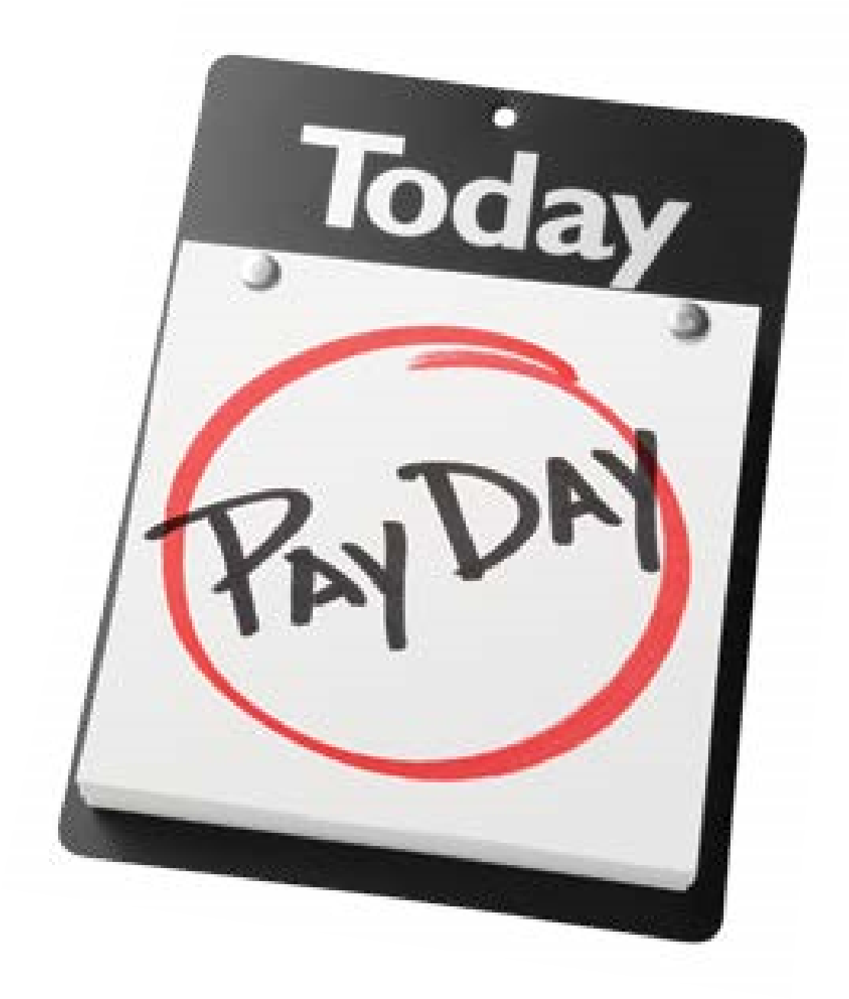
North Yorkshire County Council
Total Rewards
Rewarding you at work
NYCC offers market-competitive pay with annual incremental
progression based on good performance. Pay levels are set
using recognised job evaluation schemes, providing fairness and
transparency in pay decisions. We offer unsocial hours payments
for staff working regular
weekends, nights and on
call. We have various ways
of rewarding exceptional
performance:
Thank you
payments
Honorariums
Acting up

payments
Accelerated

Incremental

progression
Total Rewards
North Yorkshire County Council
Rewarding you outside

of work
The Everybody Benefits platform gives you access to many money-
saving offers and discounts at local and national retailers, including
supermarkets. Savings are available on automotive, financial and
professional services, entertainment, gifts, home and garden,
sports, beauty and health, travel and more. You can also access
local gym memberships at a discount.

North Yorkshire County Council Total Rewards
Rewarding you in the future
NYCC employees are automatically enrolled into the Local Government Pension Scheme (LGPS), one of the few remaining defined-benefit pension schemes in the UK. There are many benefits to the LGPS, which include:
•
you get tax relief on all your contributions;
•
you can take a tax-free lump sum payment on retirement;
•
each year you will build up a pension based on your pay and inflation
increases will be added to ensure that your pension keeps up;
•
protection should you have to
retire early due to ill health;
•
life cover of 3 times your
pay from the first day you
join the scheme;
•
dependents benefits
payable if you die so
your pension does not
die with you; and
•
there are no hidden
management fees
or hidden costs, you
simply pay a percentage
of your salary.
• On average NYCC pays over twice as much as staff towards each pension;
Total Rewards
North Yorkshire County Council
North Yorkshire
County Council is a
very rewarding place
to work. I can make
a real difference
to the day to day
lives of those in the
community using my
service, whilst also
meeting my goals as
a parent, friend and
member of my own
community
North Yorkshire County Council Total Rewards

Variety of career pathways available
As a large employer, NYCC is able to offer a wide variety of career pathways for employees. With more than 200 vacancies across schools and services (on average) advertised at any one time, there are a wealth of opportunities for career development along many different pathways in the organisation.
Committed to professional development
NYCC provide a range of high quality training, learning and development interventions, linked to Council priorities, which challenge and stimulate learners. We offer training online, in the classroom, via webinars, job shadowing, coaching and mentoring.
Employees have open access in their own time to a suite of resources; watch & go videos, pocket books, learning guides, video clips; audio clips etc. You can also take advantage of a special home-use licence for Microsoft Office 2013, to help you become familiar with the software. We have worked with Microsoft to provide access to the Office Professional suite of products at a substantially reduced price of around £10.
Commuting or relocating?
Should you need to commute on public transport, we offer an interest free season ticket loan so you can spread the cost. For driving, why not consider a low emission fuel efficient salary sacrifice car?
If you need to re-locate or fancy moving to beautiful North Yorkshire, NYCC’s comprehensive relocation scheme offers expensed relocation up to £8,000, subject to eligibility.

Maternity, Pate
Adoption l
Total Rewards
North Yorkshire County Council
Salary-Sacrifice Benefits
The following benefits involve a series of deductions from your pay before
tax, providing you with savings of up to 40% through reduced tax and
national insurance and in some cases, pension.
Green Car Scheme

Drive a brand-new low emissions car in return for monthly
salary deductions. Insurance, servicing and road tax is
covered - just add fuel!
Cycle to Work Scheme

Receive a voucher for a bicycle and equipment up to the
value of £1500 to be exchanged at cycle shops across

the County.
Childcare Scheme

You could save up to £78 a month by joining our childcare
voucher scheme.

Qualifications

Spread the cost of qualifications related to your career
through monthly payments from salary.
*All of the above subject to eligibility criteria
North Yorkshire County Council Total Rewards
Driving benefits
NYCC recognise that in order to provide services across such a broad geographical area, the need to drive for work is important to many jobs. There are a number of benefits the Council has in place for staff to access discounts for driving – these are not only restricted to work, but also for personal driving benefit:
- Low cost loan through the financial wellbeing scheme
- Discounted car insurance and MOT/ service and breakdown cover for cars through Everybody Benefits
•
Provision of a lease car for eligible
frontline care support and
enforcement workers driving
over 4,000 miles per annum
to undertake work in

the community
•
Green Lease Car salary
sacrifice scheme
•
Pool cars are available for
staff who are required to
drive long distances for work
- Liftshare enables car sharing for staff to travel to work and to appointments. It provides the platform to help people who make the same journeys together save money on commuting and business travel.

North Yorkshire County Council
Rewards for well-being

Holidays
Enjoy holiday entitlement starting at 23 days rising to 33 days per year with continued service (plus public holidays). Up to 10 days extra leave can be purchased at any time. Extended unpaid leave is available for career breaks subject to business needs.

Health and Wellbeing Services
Staff can benefit from a whole range of health and wellbeing resources, including a free individual online health assessment, along with nutrition, exercise and fitness advice and resources. Free and confidential counselling services are available and able to support through a wide range of issues. Health and Wellbeing works on feedback from you, via the intranet forum to deliver health and wellbeing information, and workplace events.
Total Rewards

Family-friendly policies
Maternity and adoption leave is available for up to 52 weeks with occupational or statutory pay dependent on length of service. Foster carers are eligible for an extra 5 days of paid leave in the first year and 2 days in successive years. Unpaid leave is available for a variety of situations. Shared parental leave and pay is available for parents within the first year of the birth or adoption. See also Flexible Working on page 10.
10

North Yorkshire County Council Total Rewards
Flexible working at NYCC
Flexible working is available in many roles, subject to business needs and requirements. You may be able to participate in a Flexi-time scheme, home-work occasionally or vary start/finish times.
Home and Varying start/
Flexi-time scheme
mobile working finish times
Other benefits available at NYCC
NYCC offers the best in modern technology to enable you to do your job well whether from home or the office. Most buildings across the county have WIFI for quick and easy connectivity. Depending on location there are catering facilities and free car parking. People can keep in touch using skype for business, and through staff forums via the intranet.
Communication is key at NYCC - the Chief Executive keeps staff up to date on what’s happening via a fortnightly message and welcomes feedback from all staff.

Variances applicable under Soulbury and JNC Terms and Conditions
Job evaluation does not apply to staff on Soulbury or JNC terms and conditions and annual leave entitlements differ. For further information please contact HRSharedServiceTeam@northyorks.gov.uk

11 11
12
North Yorkshire County Council
Total Rewards
Everybody
Benefits is a
fantastic staff
benefits scheme.
It’s my go-to place
for shopping, travel
and automotive
needs. I have made
considerable savings
to date - my salary
goes further for me
and my family!

If you would like this information in another language or format

such as Braille, large print or audio, please ask us.
Tel: 01609 780 780
Email: customer.services@northyorks.gov.uk
Contact us
North Yorkshire County Council, County Hall, Northallerton,

North Yorkshire, DL7 8AD
Our Customer Service Centre is open Monday to Friday 8.00am - 5.30pm,
Saturday 9.00am - 5.00pm.
Tel:
01609 780 780

email:
customer.services@northyorks.gov.uk

Or visit our website at:
www.northyorks.gov.uk
68374
03/
17

