Service and job specific context statement
Directorate: | Business and Environmental Services
Service: | Travel, Environmental and Countryside Services
Post title: | Countryside Access Technical Officer
Grade: | E
Responsible to: | Countryside Access Manager
Staff managed: | None
Date of issue: | February 2017
Job family: | P&T - Professional & Technical
Job context
The Countryside Access Service is part of Transport, Waste and Countryside Services and is comprised of two small teams – The Access Maintenance and Definitive Map Teams.

Key activities for the Countryside Access Service are to discharge the County Council’s statutory duties to maintain and where possible develop the county’s network of public rights of way; and to administer, prepare and maintain the county’s Definitive Map and Statement.

Working with colleagues, partners both internal and external to the county council, landowners, volunteers and other stakeholders the role will contribute to the delivery of high quality services and access to the countryside to a range of customers.

The post is based at County Hall, Northallerton but travel around the county will be required.
Structure

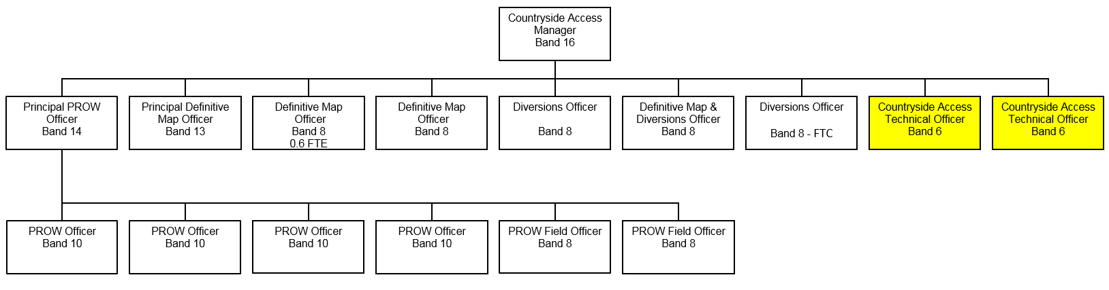

Job Description
Job purpose | The core focus of this job is to provide technical support to colleagues within the Countryside Access Service and co-ordinate the delivery of key Public Rights of Way (PROW) maintenance work programmes and to develop and maintain an accurate and up-to-date Definitive Map and Statement by the analysis and transfer of spatial data
Operational management | - Accountable for data quality within the Countryside Access Service’s Management  Information System (MIS).  - Assisting the development of strategic maintenance and enhancement work programmes.  - Assist in the development of procurement specifications and management of contracts.  - To be accountable for analysis of data and resolution of conflicts between different sources of original data, and digital mapping.  - Processing applications made under highways legislation affecting PROW.  - Respond to public rights of way questions on local land charge searches.  - Respond to planning applications affecting public rights of way.
Communications | - Provision of advice for landowners/occupiers.  - Responding to customer enquiries and requests for information on public rights of way.  - Liaison with colleagues in managing data quality.  - Assist with PROW user group liaison meetings.  - Regularly review and edit the Countryside Access Service web pages to ensure that they are accurate and up to date.
Resource management | - To organise small scale maintenance and repairs by liaison with and supervision of contractors and suppliers to ensure all requirements are undertaken in a timely, professional manner.  - Assist in the purchasing of assets including signage, materials and other infrastructure.  - Developing and maintaining data quality protocols.  - Documenting, updating and development of practices and processes to ensure the continuous improvement of the Service.
Systems and information | - Undertaking updates and configurational changes to the MIS.  - Liaising with third party supplier and ICT to ensure efficient performance of the MIS.  - Record changes to the network using the Countryside Access Service’s Geographical Information System (GIS) following confirmation of path orders.  - Maintain related databases and produce reports from those databases as required.  - Preparation of maps and plans as required.  - Developing and providing management information reports.

Person Specification
Essential upon appointment | Desirable on appointment
Knowledge
- Basic knowledge of Countryside Access, Highways & Public Rights of Way legislation.
- Knowledge of reading and interpretation of modern and historical maps.
- Knowledge of Microsoft Office.
- Basic knowledge of the Planning process.
Experience  - Can demonstrate experience in dealing with enquiries from the general public.  - Can demonstrate experience of managing a varied work load.  - Experience in the collection, interpretation and provision of statistical information.  - Experience in the use of MapInfo or Arc GIS/CAD.  - Experienced in database administration/management. | - Can demonstrate experience in structuring spatial data files, and presenting spatial data analysis results effectively.
Occupational Skills  - Critically analyse diverse information presented in a variety of formats.  - Make decisions within own area of responsibility.  - Successfully persuades, influences and negotiates with people.  - Presents/records difficult information in an accessible format suitable for a varied audience | - Intermediate ICT skills covering MapInfo and Public Rights of Way management systems
Professional Qualifications/Training/Registrations required by law, and/or essential for the performance of the role  - Good general education, demonstrating literacy and numeracy skills to level 2. | - To be a member of IPROW.  - Qualification in the use of GIS.
Other Requirements
- Ability to travel across the County
Behaviours | Link
NB – Assessment criteria for recruitment will be notified separately.
Optional - Statement for recruitment purposes: You should use this information to make the best of your application by identifying some specific pieces of work you may have undertaken in any of these areas. You will be tested in some or all of the skill specific areas over the course of the selection process.

