|  |  |
| --- | --- |
| Service and job specific context statement | |
| **Directorate:** | Central Services |
| **Service:** | Technology & Change |
| **Post title:** | Senior Project Manager |
| **Grade:** | N |
| **Responsible to:** | Programme Manager |
| **Staff managed:** | Manages a team of specialist professionals |
| **Date of issue:** | September 2020 |
| **Job family:** | **P&T - Professional & Technical** |

|  |
| --- |
| Job context |
| * This post is based within Technology and Change. This service provides ICT, digital, business analysis, projects and customer services across the council and increasingly to external organisations. The council is investing in digital and transformation delivery teams to deliver a transformation programme for the organisation and also plays a key role in driving digital transformation across the sector working closing with partner organisations. Following the implementation of the One Council Programme the council is now embarking on the next series of change programmes required to move to new ways of working within increasingly challenging budget constraints. * Change initiatives include changes to organisational structures, business processes, technology, culture and ways of working and will impact on services across the council and partner organisations, large numbers of staff and have significant budget implications. Projects will also involve working with partners, including district councils to look at delivering back office and frontline services in different ways * The post holder will manage the delivery of key projects which will require strong clear leadership and an ability to resolve challenging issues working with a wide range of stakeholders. * The post holder will manage a number of posts within the projects and programmes team. * The post is politically restricted and will be based at County Hall, Northallerton. |

|  |
| --- |
| **Structure** |

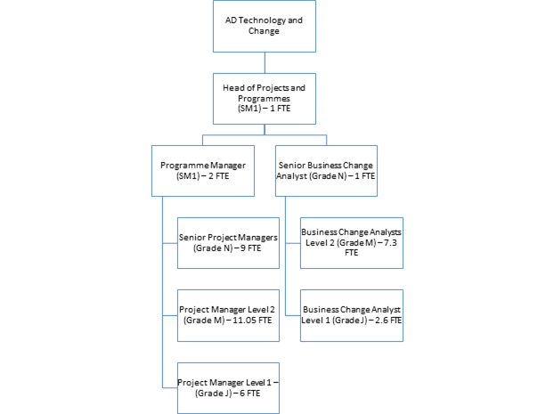

|  |  |
| --- | --- |
| Job Description | |
|  |  |

|  |  |
| --- | --- |
| Job purpose | The core focus of this job is to lead the implementation of large, complex projects ensuring a coherent and coordinated approach to activities. The post holder will work closely with a wide range of internal and external stakeholders, including senior managers and staff across the organisation, to ensure the successful delivery of projects. Direct support and coaching of those involved in the service delivery of managing change will be a core activity, requiring excellent inter-personal communication skills. |
| Operational management | * Lead the development and implementation of business change as specified by project boards * Lead the development of new ways of working that maximise efficiency and effectiveness. * Coordinate and participate in the activities of project boards to ensure that implementation meets with required objectives and desired outcomes. * Coordinate all aspects of planning in relation to individual workstreams and combine to form a coherent plan for the project. * Develop, own and maintain project plans and associated documentation * Produce consolidated progress reports for the project board, steering groups and senior stakeholders as and when required * Produce reports on specific topics relevant to the project as and when required. * Monitor quality of deliverables, acceptance and sign-off processes * Hold regular progress meetings with stakeholders of the project and ensure that appropriate records of meetings are maintained * Maintain project issues and risks registers and escalate as necessary to ensure that timely and effective solutions are found * Maintain project level documentation including highlight reports, and project plans |
| Communications | * Ensure timely and appropriate communication and engagement with key stakeholders. * Ensure timely and appropriate communication and consultation with staff impacted by the proposals and with unions. * Develop and deliver a range of communications including website material, Q&As, management briefings and presentations, working with the corporate communications team |
| Partnership / corporate working | * Ensure that implementation activities are aligned, where appropriate, with other changes taking place corporately and across Directorates * Design and implement new models of service delivery, working with senior managers in partner organisations * Work with colleagues in HR, ICT, Finance, Communications, Legal Services and other functions where required |
| Resource management | * Manage the relationships between 3rd parties and internal project teams * Advise on skill and resource requirements for the project * Ensure that appropriate training and development is identified and made available to all managers and staff impacted by new arrangements included those working within the new services and customers. * Inspire and motivate others to achieve, providing support to improve performance and meet project/programme objectives * To be responsible for the management and development of line managed staff including monitoring workloads, coaching/ mentoring and undertaking appropriate supervisions and appraisals. * Responsible for managing the overall project budget and monitoring specific project budgets in line with overall expectations * Ensure that resources required to support business change are identified and work with senior managers to secure these as required. |
| Systems and information | * Ensure that modelling and analysis of data and information is carried out to progress areas of business change and to benchmark operating costs and service levels against which benefits realisation can be measured. * Ensure that system IT requirements to support business change are understood and progressed, working with ICT services and others |

|  |  |
| --- | --- |
| Person Specification | |
| Essential upon appointment | **Desirable on appointment** |
| Knowledge   * Excellent understanding and practical application of project and change management methodologies * Awareness of local authority policies, procedures and relevant legislation * Knowledge and understanding of HR policies and procedures relating to organisational change * Understanding of the complexity and diversity of the organisation’s transformation agenda | * Knowledge of working with PRINCE2 or similar structured methodologies |
| Experience   * Experience of operating at a senior level to implement cross-service change initiatives. * Successful implementation of change through the development of services and/or projects. * Extensive experience of planning and delivering large, complex projects. * Experience of managing diverse programme and project teams * Experience in negotiating and resolving conflicts. * Experience and understanding of techniques to keep stakeholders informed and engaged. | * Coaching/ mentoring experience * An awareness of ITIL * Local government experience * Experience of successful partnership working |
| Occupational Skills  Project Management Competency   * You have the ability to oversee the delivery of strategic projects, reviewing and making amendments as necessary.   Persuading, Influencing and Negotiation Skills   * You confidently use persuasion, influencing and/or negotiation techniques to influence others in difficult situations.   Problem Solving   * You use creativity and innovation to generate solutions for difficult issues. * You identify possible causes of problems and implements solutions to minimise future occurrence.   Analytical Skills   * You break information into component parts to identify trends and projections. * You pinpoint key information from large amounts of complex data to influence well-reasoned conclusions.   Decision Making Skills   * You are able to make effective decisions and sound professional judgements and be accountable for those decisions and judgements.   Budget Management Skills   * You are able to co-ordinate, monitor and review the use of financial resources. |  |
| Professional Qualifications/Training/Registrations required by law, and/or essential for the performance of the role   * Recognised Management/Administrative qualification. * Educated to degree level or equivalent experience. * Evidence of ongoing commitment to CPD. | * Prince 2 Practitioner |
| Other Requirements   * Ability to travel for work purposes. |  |
| Behaviours | [Link](http://www.northyorks.gov.uk/article/23524/What-you-should-know-before-applying-for-a-job) |

NB – Assessment criteria for recruitment will be notified separately.  
Optional - Statement for recruitment purposes: You should use this information to make the best of your application by identifying some specific pieces of work you may have undertaken in any of these areas. You will be tested in some or all of the skill specific areas over the course of the selection process.