Service and job specific context statement
Directorate: | Children and Young People's Service
Service: | Adult Learning and Skills Service
Post title: | Adult Education General Teaching Assistant
Grade: | B
Responsible to: | Area Manager for Adult Learning
Staff managed: | None
Date of issue: | November 2021
Job family: | E - Education/School
Job context
The Adult Learning and Skills Service’s key priority is to deliver learning which meets the needs of local communities and businesses with a focus on apprentices, adults in employment who wish to improve their skills, adults seeking work and those furthest from the labour market. It also supports learners with health issues that are a barrier to their participation in the workforce and their community.

The Adult Learning and Skills Service is funded by the ESFA for learners and apprentices aged 19+ and apprentices aged 16-18. The ESFA also funds learners aged 16-18 and learners aged 19-25 with a learning disability as identified in an Education, Health and Care Plan.

- This role is to work with teachers to support teaching and learning by working with individual learners or small groups of learners under the direction of teaching staff and may involve responsibility for some learning activities within the overall teaching plan
- Enhanced Level DBS Disclosure may be required on appointment to this post
- This role involves spoken communications so a confident use of English language is required
Job specifics
- Work closely with the course teacher in identifying individual educational needs
- Support the class teacher in achieving the aims and objectives of the lesson
- Be aware of the needs of individual learners and respond with appropriate learning support programmes
- Maintain a professional approach with an awareness of learners’ confidentiality
- Ensure that equality and diversity issues underpin all adult and community learning and to challenge inappropriate behaviour
- Follow guidelines and procedures agreed by North Yorkshire County Council, Adult Learning and Skills Service and the teacher

Structure

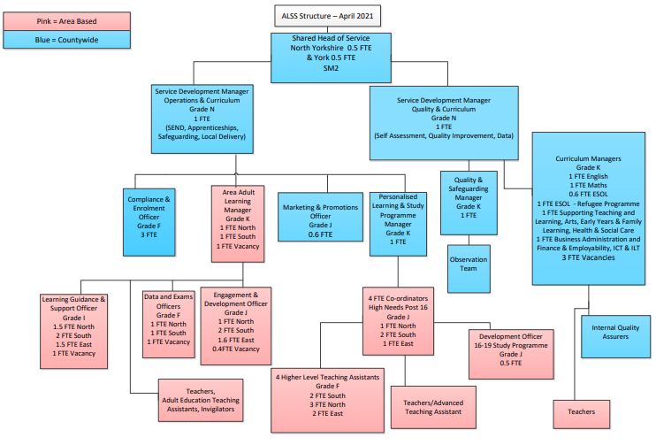

Job Description
Job purpose | To work under the direction of the teacher and follow their guidance to to support teaching and learning by working with individuals or  small groups of adult learners.
Operational management | - Support pre planned learning activities as directed by the teacher  - Provide feedback to the teacher on learning, behaviour, participation and achievement, to support the planning and evaluation of the learning process for groups or individual students  - Interact with learners in ways that support the development of their ability to think and learn independently  - Assist teachers in the implementation of appropriate behaviour management and teaching and learning strategies  - Support learners in their social and emotional wellbeing  - Support learners during online sessions and remotely on a one to one basis when required
Communications | - Under the general direction of the teacher participate in establishing and maintaining effective relationships with learners
Partnership / corporate working | - Actively participate in training sessions and continuing professional development activities in line with the roles and responsibilities of the post
Safeguarding | - To be committed to safeguarding and promoting the welfare of adults , raising concerns as appropriate

Person Specification
Essential upon appointment | Desirable on appointment
Knowledge  - An awareness that individuals have differing needs  - Current support practices used within further education or schools  - An understanding of equality and diversity issues that underpin all adult learning  - The application of IT and Digital skills within learning | - An awareness of issues affecting adults with a range of mental health issues  - Good understanding of barriers to learning experienced by adult learners
Experience  - Working with young people or adults who have a learning difficulty  - Supporting learning in an education setting (either school or FE)  - Providing support one to one and in a group setting  - Experience of using on line communication portals e.g. Microsoft Teams and or Zoom | - Experience of working in a learning environment  - Experience of supporting on line and remote learning
Occupational Skills
- Good written and verbal communication skills: able to communicate effectively and clearly and build relationships with a range of people
- The ability to converse at ease with customers and provide advice in accurate spoken English is essential for the post
- Good reading, writing and numeracy skills
- Good ICT skills and ability to use Outlook and Teams
- Ability to demonstrate awareness of needs specific to this client group
- Ability to organise self and others
- Ability to plan effectively
- Manage time effectively
- An empathy for equality & diversity
Professional Qualifications/Training/Registrations required by law, and/or essential for the performance of the role  - Level 2 qualification in English and maths | - An appropriate qualification in Supporting Teaching and Learning  - Qualification in ICT
Other Requirements | - Ability to travel across the County
Behaviours | Link
NB – Assessment criteria for recruitment will be notified separately.
Optional - Statement for recruitment purposes: You should use this information to make the best of your application by identifying some specific pieces of work you may have undertaken in any of these areas. You will be tested in some or all of the skill specific areas over the course of the selection process.

