Service and job specific context statement
Directorate: | Children and Young People's Service
Service: | Inclusion Service
Post title: | Resource Centre Worker
Grade: | F - G
Responsible to: | Resource Centre Manager
Staff managed: | None
Date of issue: | February 2016
Job family: | C&S - Care & Support
Job context
The Children’s Resource Centres provide overnight short breaks care for children with disabilities, complex health care needs and autism within our resource centre as well as provision of day care and outreach support within the community. The service is open predominantly at weekends and school holiday periods therefore you need to be flexible in your working hours as this post carries a requirement to work shifts, such as evenings, weekends, bank holidays, waking night duties. Allowances are currently paid for sleeping in, waking nights enhancement and weekend working.

An enhanced DBS clearance is a requirement of the post

The allocation of duties by Resource Centre Managers will take account of the level of qualification and experience of the Resource Centre Worker, and where possible aptitudes and interests.

There is also a requirement :
- To participate in regular supervision sessions
- To undertake all necessary training as directed and plan self-development work with line manager to be able to confidently discharge all relevant duties and tasks.
- To have a commitment to shared values and the common purpose of developing a culture if interagency working; including statutory bodies, third and private sector organisations.
- To ensure that strategic visions are translated into local plans in collaboration with professionals, partners and service users.
- This role involves spoken communications so a confident use of English language is required.
Career progression
- Employees who can demonstrate childcare experience yet do not hold a level 3 diploma (formerly NVQ 3) will commence on Grade F, with a bar point at the top of Grade G. Progression to Grade G is subject to successful completion of the Level 3 diploma qualification.

Structure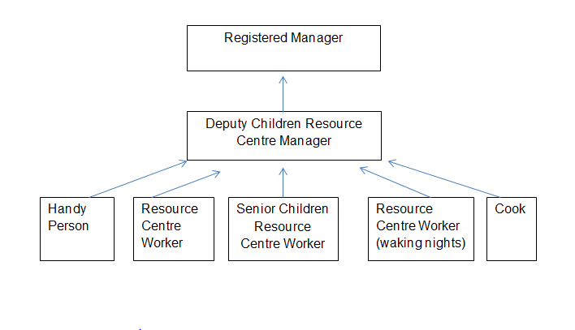

Job Description
Directorate: | Children and Young People's Service
Service: | Inclusion Service
Responsible to: | Resource Centre Manager
Staff managed: | None
Job purpose | In line with Directorate’s statutory obligations, support disabled children with the most complex needs in a variety of different settings. This involves working with children and young people with a wide range of disabilities as part of a team responsible for direct care in residential settings, in children’s own homes and in other settings. Work will be under pinned by the Directorate’s policies, procedures and value base.
Operational management | - To contribute to the planning and implementation of the day-to-day individual care needs of the young people  - To contribute to the normal development of the children and young people though the provision of a variety of appropriate stimulating activities in an individual or a group basis.  - To be sensitive to the needs of the individual children, taking account of race, culture, language and religion  - To observe a child and young person’s behaviour, understand its context, and notice any unexpected changes  - Assist in the implementation of appropriate behaviour management strategies where required  - To monitor and administer prescribed medication in line with health care plans and procedure  - To contribute to care planning, participating in reviews and other meetings as required, and to assist in the formation and implementation of care plans  - To work within the Directorate’s Business Plan, making contributions through team meetings to the on-going development of disabled children’s services  - Supporting transitions across environments and activities.
Communications | - To contribute to the care plan of children receiving a service in line with the assessed need of the young person and their family.  - To talk and listen to children, to observe their behaviour and record significant features  - To be familiar with the use of a variety of communication tools e.g. Makaton
Partnership / corporate working | - To work in a team context, forging and sustaining relationships across agencies and respecting the contribution of others working with children, young people and families.  - To work jointly with Social Care, Education and Health colleagues within assessment and care planning  - To maintain effective working relationships with colleagues in the team, in the Directorate and with other agencies  - To work across various settings, school, family home, community and resource centre.
Systems and information | - To work in line with the Directorate’s policies and procedures and in line with Children’s Home Regulations 2015 to maintain appropriate information and records.  - To participate in team meetings as required  - To be aware of own and others’ professional boundaries
Safeguarding and promoting welfare of the child | - To provide direct personal care for disabled children in a variety of settings  - To plan and negotiate safe and appropriate activities to ensure young people experience balanced high standards of care  - To be alert to signs of distress or abuse and to ensure that the children and young people are monitored and protected  - To assist and supervise activities with young people  - To be responsible for promoting and safeguarding the welfare of children and young people that you are responsible for and come into contact with
Health and Safety | - To contribute to relevant risk assessments e.g. moving and transferring children, undertaking activities  - To be aware of and implement your health and safety responsibilities as an employee and where appropriate any additional specialist or managerial health and safety responsibilities as defined in the Health and Safety policy and procedure

Person Specification
Essential upon appointment | Desirable on appointment
Knowledge  - Knowledge of current philosophy in child care  - Knowledge of safeguarding and protecting children from harm  - Familiarity with the use a variety of communications tools e.g. makaton  - Understanding of issues of confidentiality | - Children’s Homes Regulations 2015  - Children’s Act 1989 and 2004
Experience  - Proven experience of working with children and families | - Work with disabled children with the most complex needs  - Experience of working in a residential setting working on a shift basis
Occupational Skills  - Ability to relate to children and young people and their families  - Planning and organization  - Ability to work as a member of a team  - Self-management and motivation  - IT skills  - Ability to maintain written records  - Report writing skills  - Ability to communicate effectively and creatively with children, young people and their families  - The ability to converse at ease with customers and provide advice in accurate spoken English is essential for the post.  - Ability to deliver safe working practice in the context of personal care | - Familiarity with behaviour management technique
Professional Qualifications/Training/Registrations required by law, and/or essential for the performance of the role  - Commitment to gain Level 3 Diploma in caring for children and young people | Level 3 Diploma , Caring for Children and Young People
Other Requirements
- Availability to work flexibly and out of hours as and when required including evenings, waking nights, weekends, bank holidays and school holidays.
- Flexibility to work across different environments such as residential and school settings, the community, and family homes
- Ability to meet the travel needs of the post across the geographical area
- Ability to meeting the physical demands of the role e.g. moving and transferring children and conducting activities
Behaviours | Link
NB – Assessment criteria for recruitment will be notified separately.
Optional - Statement for recruitment purposes: You should use this information to make the best of your application by identifying some specific pieces of work you may have undertaken in any of these areas. You will be tested in some or all of the skill specific areas over the course of the selection process.

